**Spark Applications**

Spark Applications consist of a driver process and a set of executor processes. The driver process runs your main() function, sits on a node in the cluster, and is responsible for three things: maintaining information about the Spark Application; responding to a user’s program or input; and analyzing, distributing, and scheduling work across the executors (discussed momentarily). The driver process is absolutely essential—it’s the heart of a Spark Application and maintains all relevant information during the lifetime of the application.

The executors are responsible for actually carrying out the work that the driver assigns them. This means that each executor is responsible for only two things: executing code assigned to it by the driver, and reporting the state of the computation on that executor back to the driver node.

**Here are the key points to understand about Spark Applications at this point:**

Spark employs a cluster manager that keeps track of the resources available.

The driver process is responsible for executing the driver program’s commands across the executors to complete a given task.

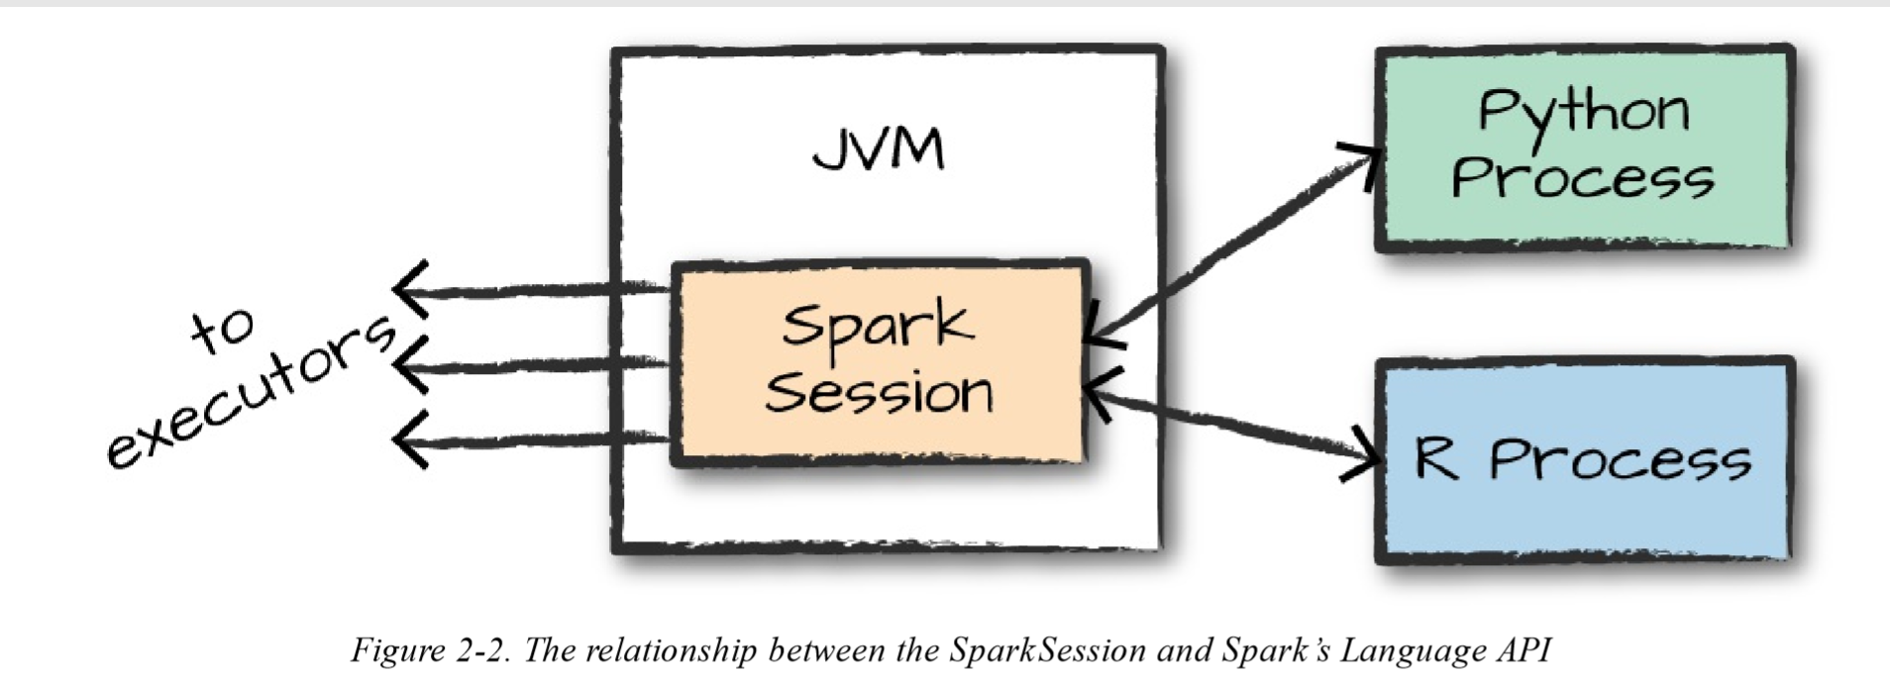

There is a SparkSession object available to the user, which is the entrance point to running Spark code. When using Spark from Python or R, you don’t write explicit JVM instructions; instead, you write Python and R code that Spark translates into code that it then can run on the executor JVMs

As discussed in the beginning of this chapter, you control your Spark Application through a driver process called the SparkSession. The SparkSession instance is the way Spark executes user-defined manipulations across the cluster. There is a one-to-one correspondence between a SparkSession and a Spark Application

Let’s now perform the simple task of creating a range of numbers. This range of numbers is just like a named column in a spreadsheet:

# in Python

myRange = spark.range(1000).toDF("number")

This range of numbers represents a distributed collection. When run on a cluster, each part of this range of numbers exists on a different executor. This is a Spark Dataframe.

**Partitions**

To allow every executor to perform work in parallel, Spark breaks up the data into chunks called partitions. A partition is a collection of rows that sit on one physical machine in your cluster. A DataFrame’s partitions represent how the data is physically distributed across the cluster of machines during execution

If you have one partition, Spark will have a parallelism of only one, even if you have thousands of executors. If you have many partitions but only one executor, Spark will still have a parallelism of only one because there is only one computation resource.

**Transformations** are the core of how you express your business logic using Spark. There are two types of transformations: those that specify **narrow dependencies**, and those that specify **wide dependencies**

Transformations consisting of narrow dependencies (we’ll call them narrow transformations) are those for which each input partition will contribute to only one output partition. In the preceding code snippet, the where statement specifies a narrow dependency, where only one partition contributes to at most one output partition

A wide dependency (or wide transformation) style transformation will have input partitions contributing too many output partitions. You will often hear this referred to as a shuffle whereby Spark will exchange partitions across the cluster

With narrow transformations, Spark will automatically perform an operation called pipelining, meaning that if we specify multiple filters on DataFrames, they’ll all be performed in-memory. The same cannot be said for shuffles. When we perform a shuffle, Spark writes the results to disk

In Spark, instead of modifying the data immediately when you express some operation, you build up a plan of transformations that you would like to apply to your source data. By waiting until the last minute to execute the code, Spark compiles this plan from your raw DataFrame transformations to a streamlined physical plan that will run as efficiently as possible across the cluster

An example of this is something called **predicate pushdown** on DataFrames. If we build a large Spark job but specify a filter at the end that only requires us to fetch one row from our source data, the most efficient way to execute this is to access the single record that we need. Spark will actually optimize this for us by pushing the filter down automatically.

# in Python

flightData2015 = spark.read.option ("inferSchema", "true").option ("header", "true").csv ("/data/flight-data/csv/2015-summary.csv")

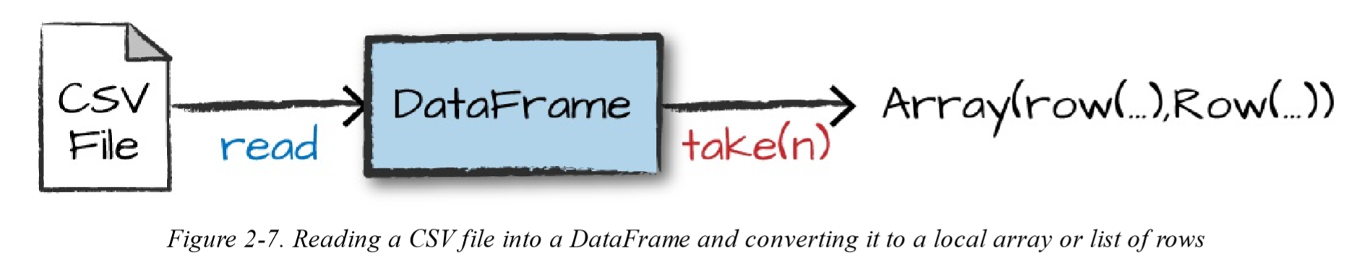

Remember, sort does not modify the DataFrame. We use sort as a transformation that returns a new DataFrame by transforming the previous DataFrame

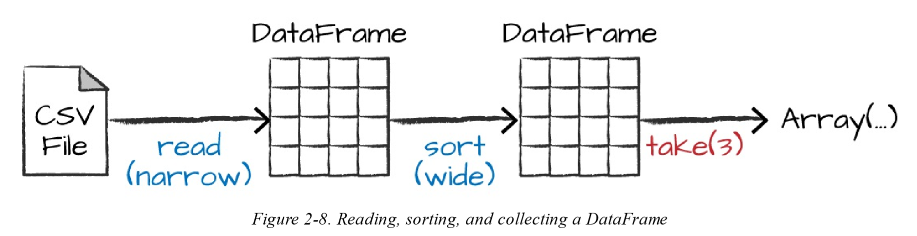

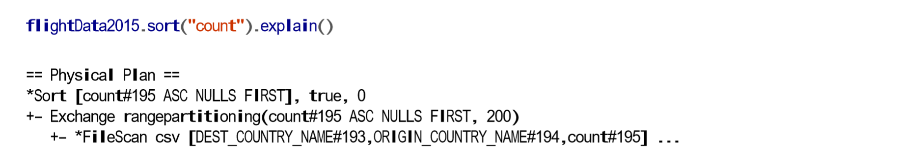

You will see sort, exchange, and FileScan. That’s because the sort of our data is actually a wide transformation because rows will need to be compared with one another.

**By default, when we perform a shuffle, Spark outputs 200 shuffle partitions**

spark.conf.set("spark.sql.shuffle.partitions", "5")

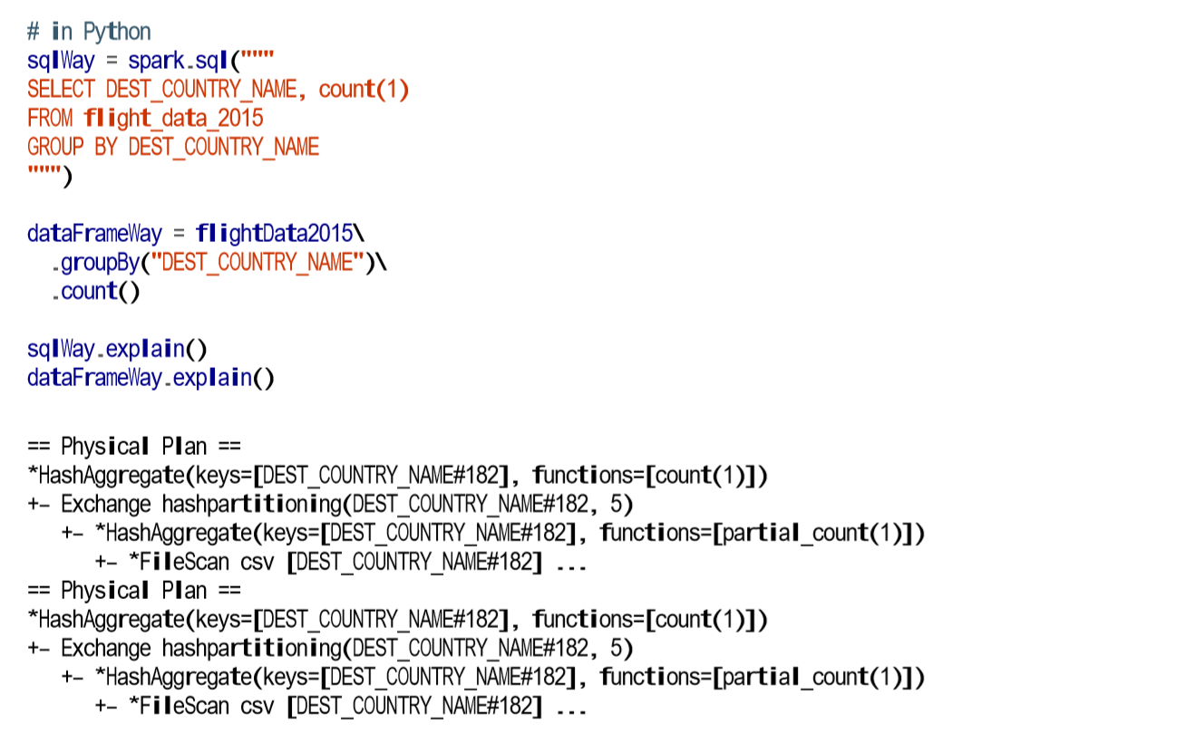

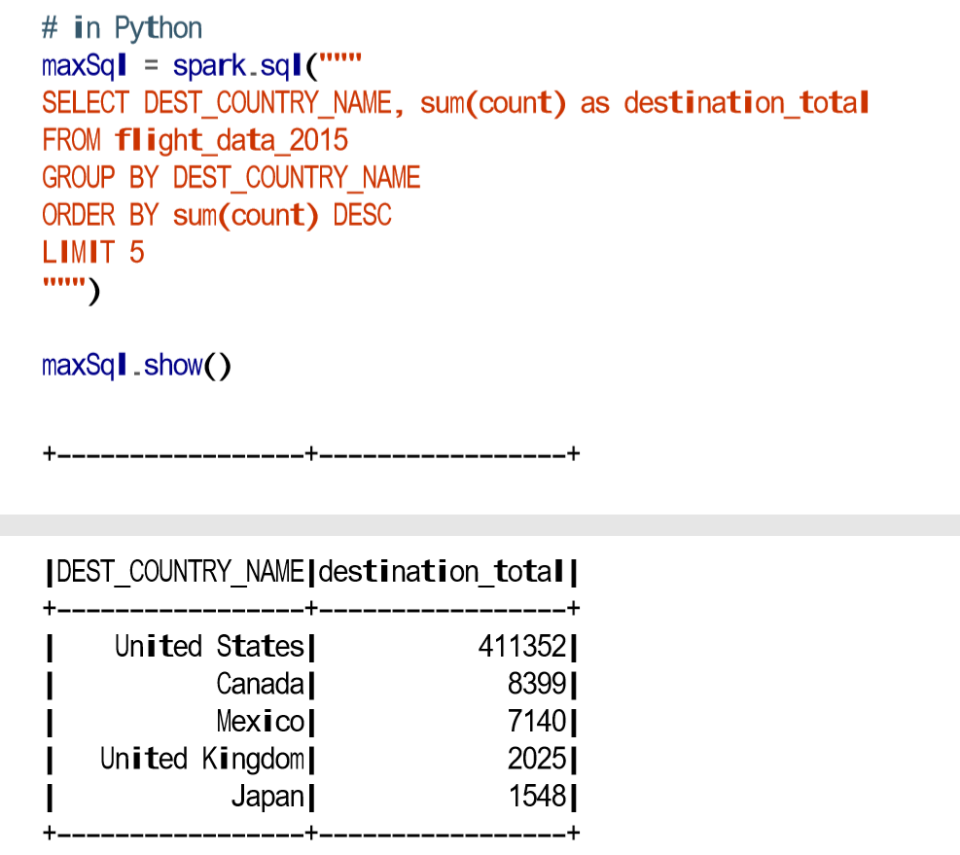

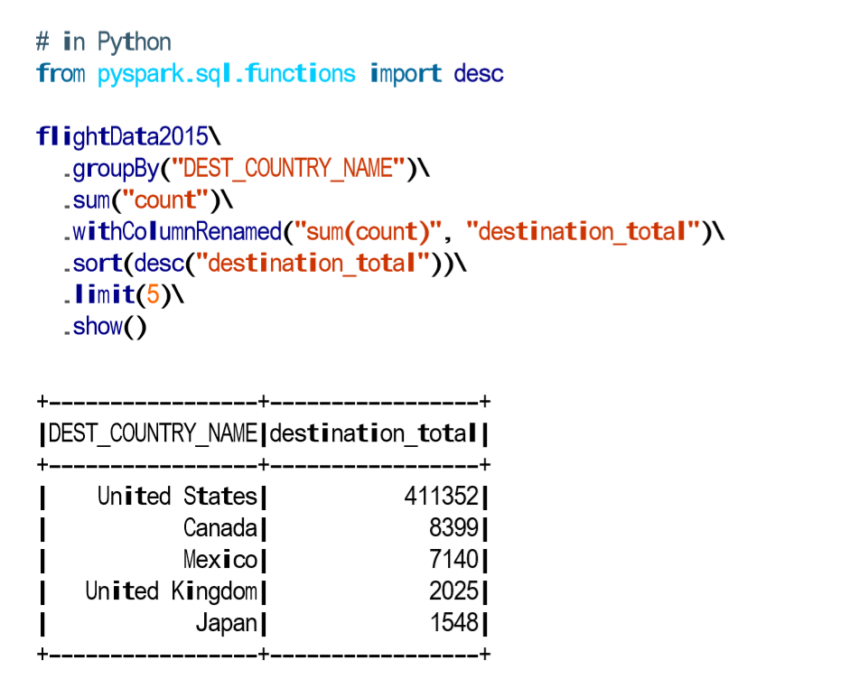

The first step is to read in the data. We defined the DataFrame previously but, as a reminder, Spark does not actually read it in until an action is called on that DataFrame or one derived from the original DataFrame.

The second step is our grouping; technically when we call groupBy, we end up with a RelationalGroupedDataset, which is a fancy name for a DataFrame that has a grouping specified but needs the user to specify an aggregation before it can be queried further. We basically specified that we’re going to be grouping by a key (or set of keys) and that now we’re going to perform an aggregation over each one of those keys.

Therefore, the third step is to specify the aggregation. Let’s use the sum aggregation method. This takes as input a column expression or, simply, a column name. The result of the sum method call is a new DataFrame. You’ll see that it has a new schema but that it does know the type of each column. It’s important to reinforce (again!) that no computation has been performed. This is simply another transformation that we’ve expressed, and Spark is simply able to trace our type information through it.

The fourth step is a simple renaming. We use the withColumnRenamed method that takes two arguments, the original column name and the new column name. Of course, this doesn’t perform computation: this is just another transformation!

The fifth step sorts the data such that if we were to take results off of the top of the DataFrame, they would have the largest values in the destination_total column.

You likely noticed that we had to import a function to do this, the desc function. You might also have noticed that desc does not return a string but a Column. In general, many DataFrame methods will accept strings (as column names) or Column types or expressions. Columns and expressions are actually the exact same thing.

**Structured API Overview**

The Structured APIs are a tool for manipulating all sorts of data, from unstructured log files to semi-structured CSV files and highly structured Parquet files

Spark uses an engine called Catalyst that maintains its own type information through the planning and processing of work

# in Python

df = spark.range(500).toDF("number")

df.select(df["number"] + 10)

This addition operation happens because Spark will convert an expression written in an input language to Spark’s internal Catalyst representation of that same type information. It then will operate on that internal representation

In essence, within the Structured APIs, there are two more APIs, the “untyped” DataFrames and the “typed” Datasets. To say that DataFrames are untyped is aslightly inaccurate; they have types, but Spark maintains them completely and only checks whether those types line up to those specified in the schema at runtime. Datasets, on the other hand, check whether types conform to the specification at compile time. Datasets are only available to Java Virtual Machine (JVM)–based languages (Scala and Java) and we specify types with case classes or Java beans. For the most part, you’re likely to work with DataFrames. To Spark (in Scala), DataFrames are simply Datasets of Type Row. The “Row” type is Spark’s internal representation of its optimized inmemory format for computation. This format makes for highly specialized and efficient computation because rather than using JVM types, which can cause high garbage-collection and object instantiation costs, Spark can operate on its own internal format without incurring any of those costs. To Spark (in Python or R), there is no such thing as a Dataset: everything is a DataFrame and therefore we always operate on that optimized format.

**Columns** represent a simple type like an integer or string, a complex type like an array or map, or a null value. Spark tracks all of this type information for you and offers a variety of ways, with which you can transform columns. You can think about Spark Column types as columns in a table.

A **row** is nothing more than a record of data. **Each record in a DataFrame must be of type Row**, as we can see when we collect the following DataFrames. We can create these rows manually from SQL, from Resilient Distributed Datasets (RDDs), from data sources, or manually from scratch

**To work with the correct Python types, use the following:**

from pyspark.sql.types import *

b = ByteType()

Page 59 for all python types

Here’s an overview of the steps:

* Write DataFrame/Dataset/SQL Code.
* If valid code, Spark converts this to a Logical Plan.
* Spark transforms this Logical Plan to a Physical Plan, checking for optimizations along the way.
* Spark then executes this Physical Plan (RDD manipulations) on the cluster.

To execute code, we must write code. This code is then submitted to Spark either through the console or via a submitted job. This code then passes through the Catalyst Optimizer, which decides how the code should be executed and lays out a plan for doing so before, finally, the code is run and the result is returned to the user

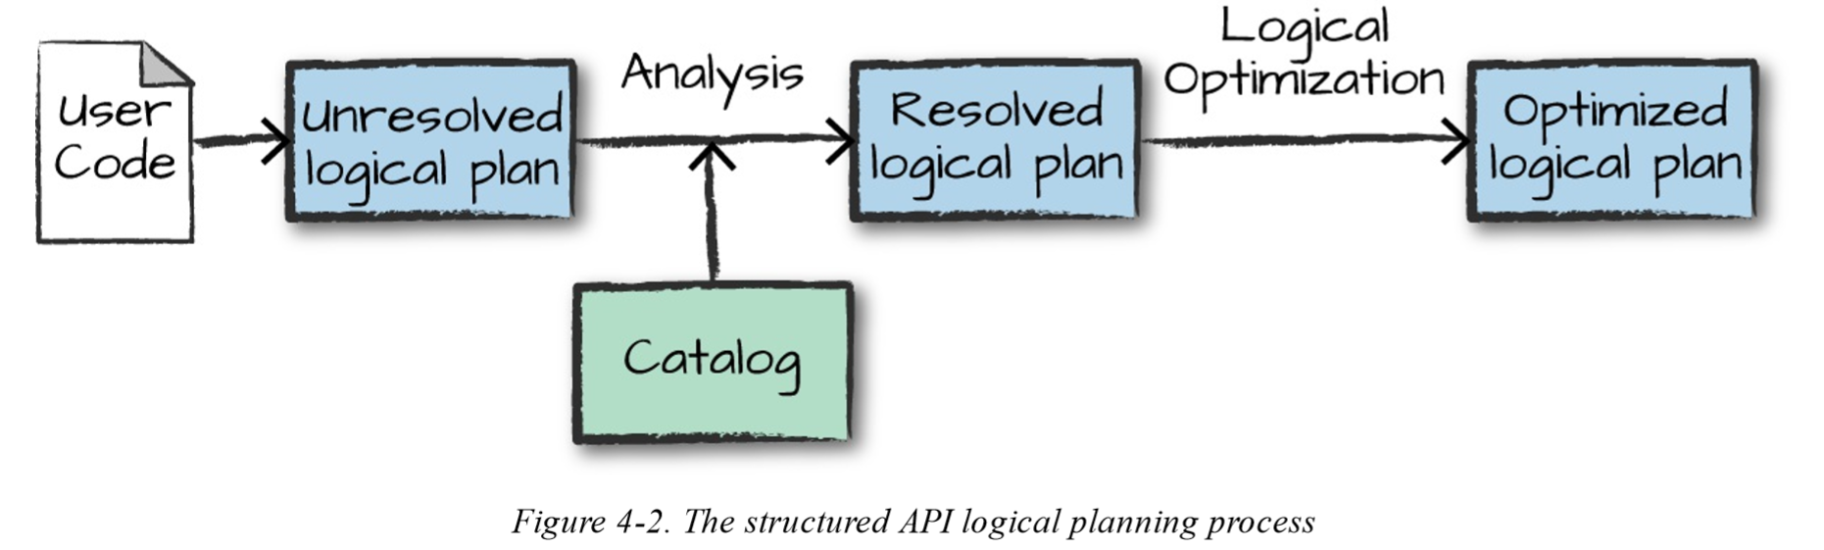

This logical plan only represents a set of abstract transformations that do not refer to executors or drivers, it’s purely to convert the user’s set of expressions into the most optimized version. It does this by converting user code into an unresolved logical plan. This plan is unresolved because although your code might be valid, the tables or columns that it refers to might or might not exist. Spark uses the catalog, a repository of all table and DataFrame information, to resolve columns and tables in the analyzer. The analyzer might reject the unresolved logical plan if the required table or column name does not exist in the catalog. If the analyzer can resolve it, the result is passed through the Catalyst Optimizer, a collection of rules that attempt to optimize the logical plan by pushing down predicates or selections. Packages can extend the Catalyst to include their own rules for domain specific optimizations.

After successfully creating an optimized logical plan, Spark then begins the physical planning process. The physical plan, often called a Spark plan, specifies how the logical plan will execute on the cluster by generating different physical execution strategies and comparing them through a cost model, as depicted in Figure 4-3. An example of the cost comparison might be choosing how to perform a given join by looking at the physical attributes of a given table (how big the table is or how big its partitions are).

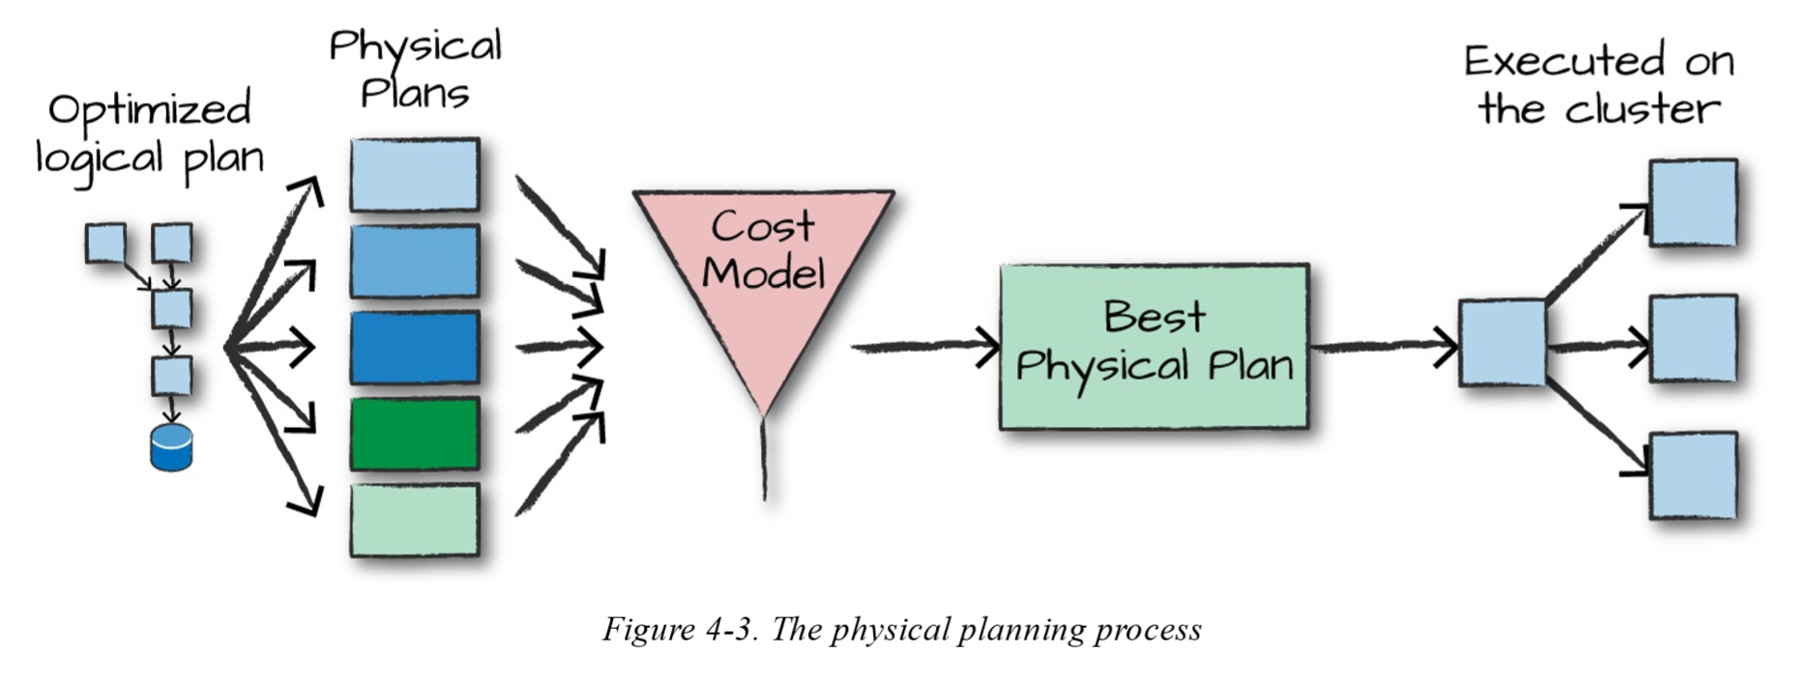

Physical planning results in a series of RDDs and transformations. This result is why you might have heard Spark referred to as a compiler—it takes queries in DataFrames, Datasets, and SQL and compiles them into RDD transformations for you.

Upon selecting a physical plan, Spark runs all of this code over RDDs, the lower-level programming interface of Spark

**Basic Structured Operations**

Definitionally, a DataFrame consists of a series of records (like rows in a table), that are of type Row, and a number of columns (like columns in a spreadsheet) that represent a computation expression that can be performed on each individual record in the Dataset. Schemas define the name as well as the type of data in each column. Partitioning of the DataFrame defines the layout of the DataFrame or Dataset’s physical distribution across the cluster. The partitioning scheme defines how that is allocated. You can set this to be based on values in a certain column or non-deterministically

# in Python

df = spark.read.format("json").load("/data/flight-data/json/2015-summary.json")

# in Python

spark.read.format ("json").load ("/data/flight-data/json/2015-summary.json").schema

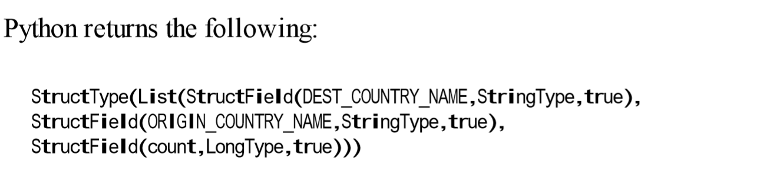

A schema is a StructType made up of a number of fields, StructFields, which have a name, type, a Boolean flag which specifies whether that column can contain missing or null values, and, finally, users can optionally specify associated metadata with that column. The metadata is a way of storing information about this column

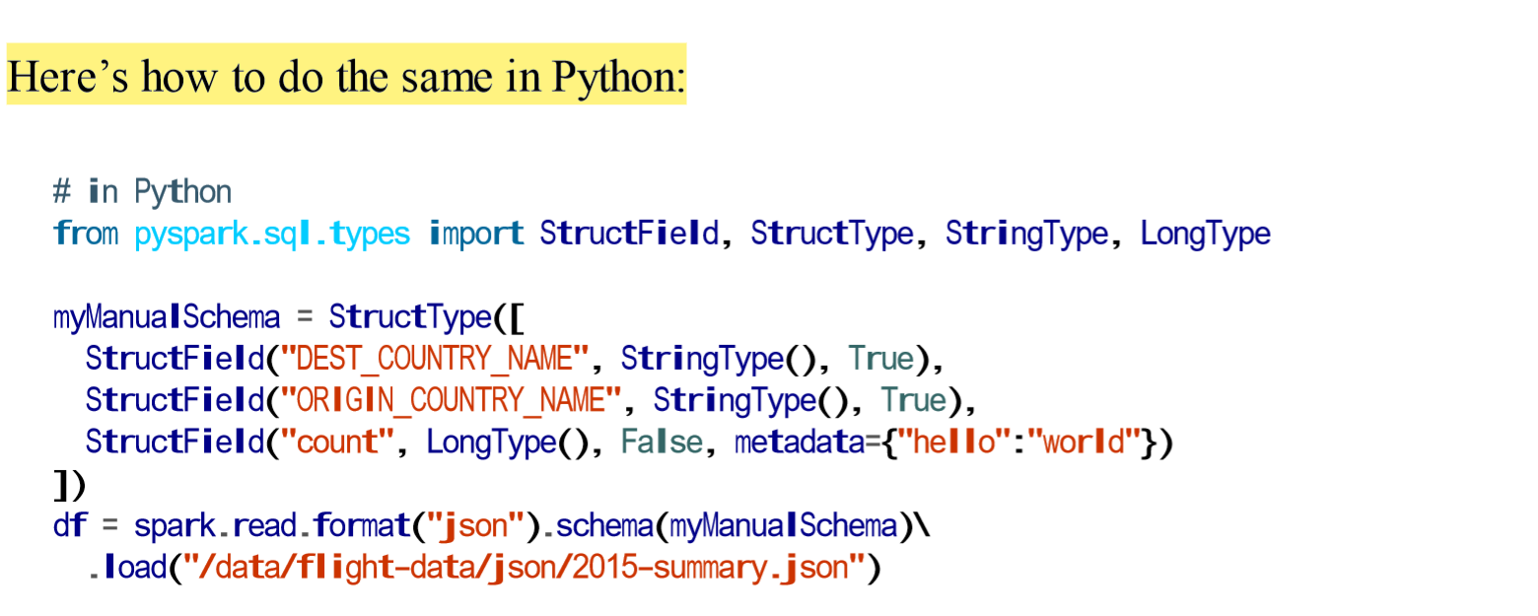

An **expression** is a set of transformations on one or more values in a record in a DataFrame. Think of it like a function that takes as input one or more column names, resolves them, and then potentially applies more expressions to create a single value for each record in the dataset. Importantly, this “single value” can actually be a complex type like a Map or Array. We’ll see more of the complex types in Chapter 6. In the simplest case, an expression, created via the expr function, is just a DataFrame column reference. In the simplest case, expr("someCol") is equivalent to col("someCol").

expr("someCol - 5") is the same transformation as performing col("someCol") - 5, or even expr("someCol") - 5.

* Columns are just expressions.
* Columns and transformations of those columns compile to the same logical plan as parsed expressions.

# in Python

from pyspark.sql.functions import expr

expr("(((someCol + 5) * 200) - 6) < otherCol")

In Spark, each **row** in a DataFrame is a single record. Spark represents this record as an object of type Row. Spark manipulates Row objects using column expressions in order to produce usable values. Row objects internally represent arrays of bytes

**Creating Rows**

You can create rows by manually instantiating a Row object with the values that belong in each column. It’s important to note that only DataFrames have schemas. Rows themselves do not have schemas. This means that if you create a Row manually, you must specify the values in the same order as the schema of the DataFrame to which they might be appended.

# in Python

from pyspark.sql import Row

myRow = Row("Hello", None, 1, False)

# in Python

df = spark.read.format ("json").load("/data/flight-data/json/2015-summary.json") df.createOrReplaceTempView("dfTable")

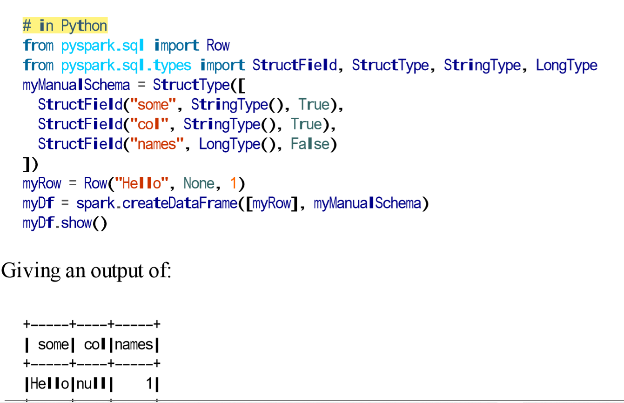

# in Python

df.select("DEST_COUNTRY_NAME").show(2)

df.select("DEST_COUNTRY_NAME", "ORIGIN_COUNTRY_NAME").show(2)

You can refer to columns in a number of different ways; all you need to keep in mind is that you can use them interchangeably:

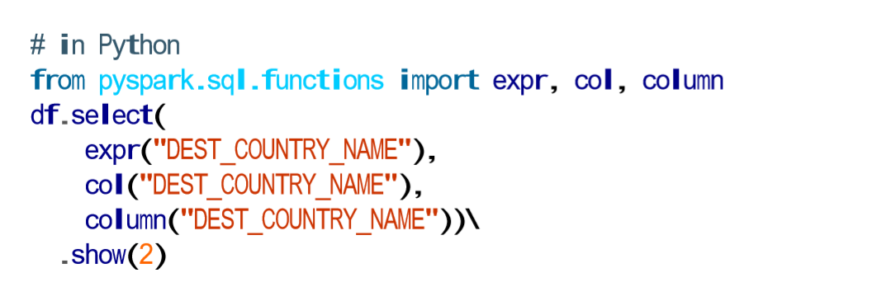

One common error is attempting to mix Column objects and strings. For example, the following code will result in a compiler error:

df.select(col("DEST_COUNTRY_NAME"), "DEST_COUNTRY_NAME")

**expr** is the most flexible reference that we can use. It can refer to a plain column or a string manipulation of a column.

df.select(expr("DEST_COUNTRY_NAME AS destination")).show(2)

df.selectExpr("DEST_COUNTRY_NAME as newColumnName", "DEST_COUNTRY_NAME").show(2) **🡪** we can add any valid non-aggregating SQL statement, and as long as the columns resolve, it will be valid!

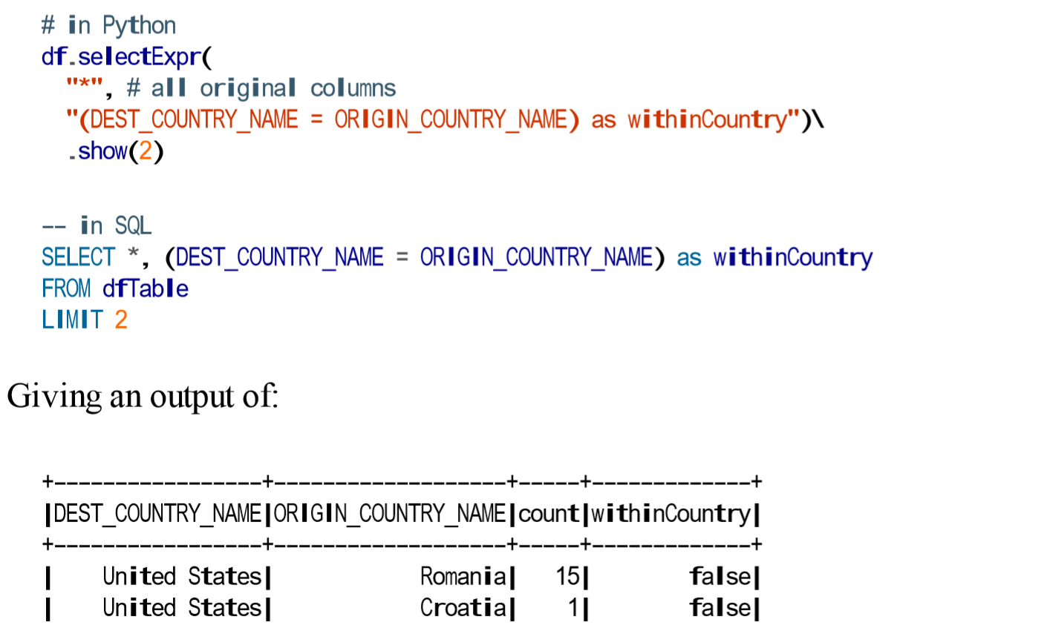

With select expression, we can also specify aggregations over the entire DataFrame by taking advantage of the functions that we have.

df.selectExpr("avg(count)", "count(distinct(DEST_COUNTRY_NAME))").show(2)

Sometimes, we need to pass explicit values into Spark that are just a value (rather than a new column). This might be a constant value or something we’ll need to compare to later on. The way we do this is through literals. This is basically a translation from a given programming language’s literal value to one that Spark understands. Literals are expressions and you can use them in the same way:

# in Python

from pyspark.sql.functions import lit

df.select(expr("*"), lit(1).alias("One")).show(2)

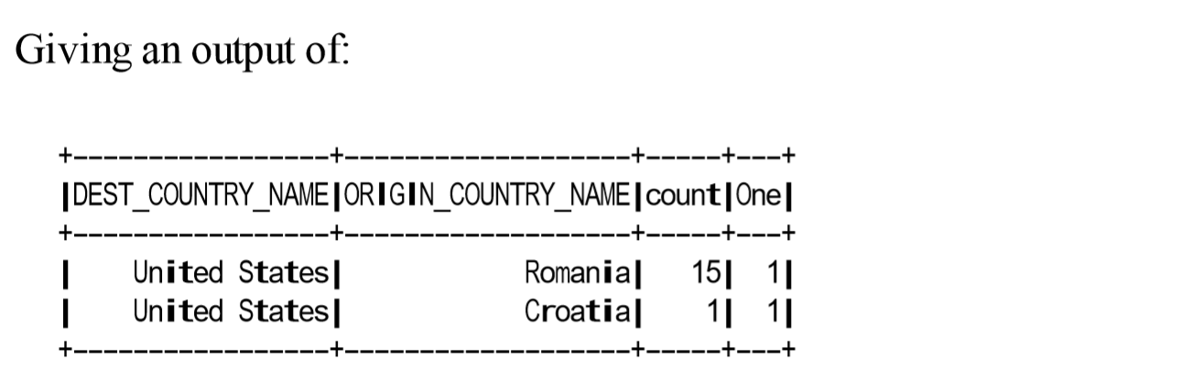

There’s also a more formal way of **adding a new column** to a DataFrame, and that’s by using the withColumn method on our DataFrame. For example, let’s add a column that just adds the number one as a column:

df.withColumn("numberOne", lit(1)).show(2)

df.withColumn("withinCountry", expr("ORIGIN_COUNTRY_NAME == DEST_COUNTRY_NAME"))\ .show(2)

df.withColumnRenamed("DEST_COUNTRY_NAME", "dest").columns

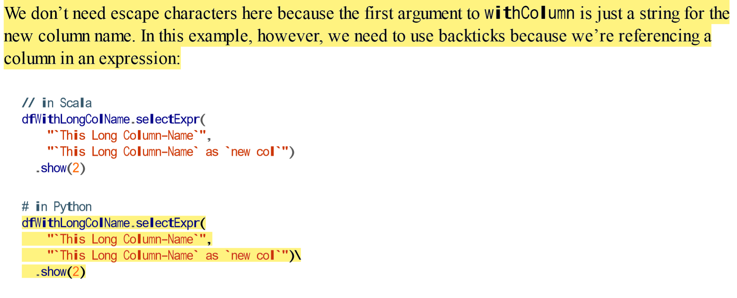

**Drop Columns**

dfWithLongColName.drop("ORIGIN_COUNTRY_NAME", "DEST_COUNTRY_NAME")

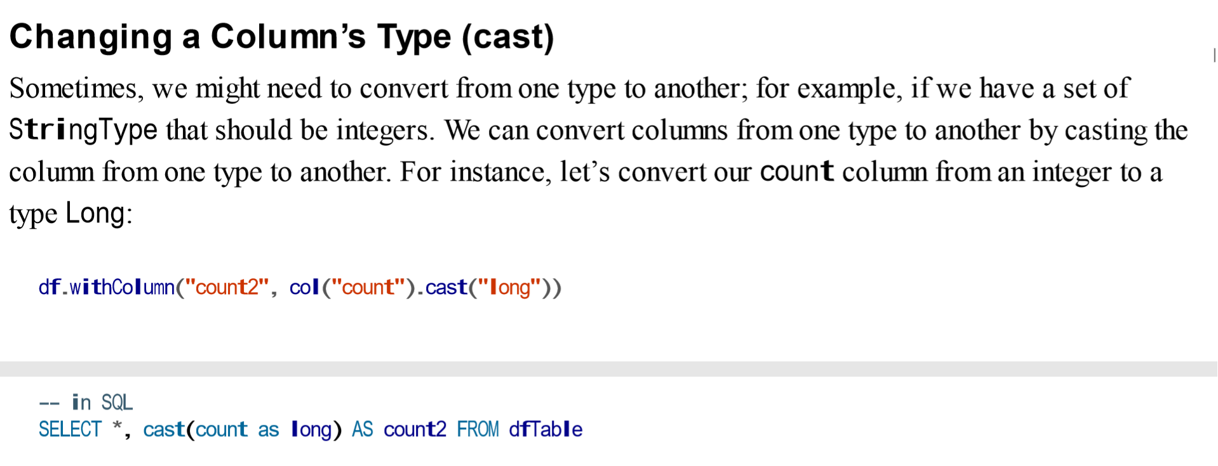

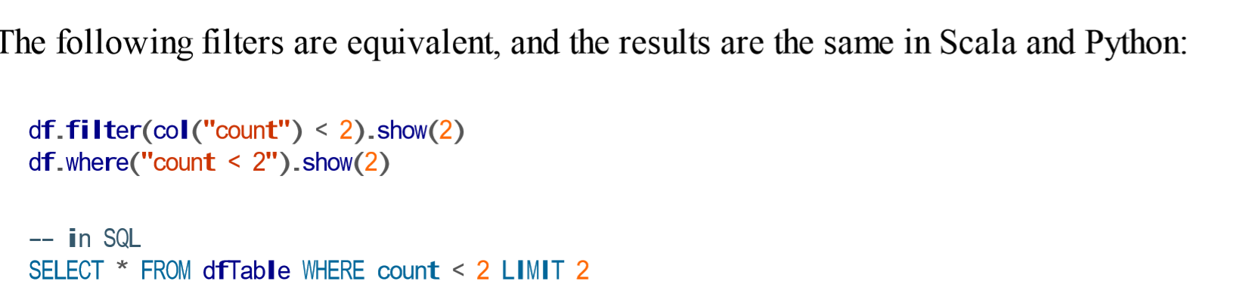

Instinctually, you might want to put multiple filters into the same expression. Although this is possible, it is not always useful, because Spark automatically performs all filtering operations at the same time regardless of the filter ordering. This means that if you want to specify multiple AND filters, just chain them sequentially and let Spark handle the rest:

df.where(col("count") < 2).where(col("ORIGIN_COUNTRY_NAME") != "Croatia").show(2)

A very common use case is to extract the unique or distinct values in a DataFrame. These values can be in one or more columns. The way we do this is by using the distinct method on a DataFrame, which allows us to deduplicate any rows that are in that DataFrame.

df.select("ORIGIN_COUNTRY_NAME", "DEST_COUNTRY_NAME").distinct().count()

Sometimes, you might just want to sample some random records from your DataFrame. You can do this by using the sample method on a DataFrame, which makes it possible for you to specify a fraction of rows to extract from a DataFrame and whether you’d like to sample with or without replacement:

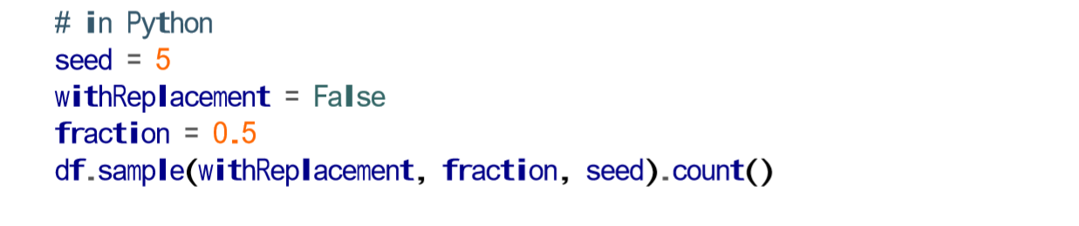

**Random Splits**

Random splits can be helpful when you need to break up your DataFrame into a random “splits” of the original DataFrame. This is often used with machine learning algorithms to create training, validation, and test sets. In this next example, we’ll split our DataFrame into two different DataFrames by setting the weights by which we will split the DataFrame (these are the arguments to the function). Because this method is designed to be randomized, we will also specify a seed (just replace seed with a number of your choosing in the code block). It’s important to note that if you don’t specify a proportion for each DataFrame that adds up to one, they will be normalized so that they do:

dataFrames = df.randomSplit([0.25, 0.75], seed)

dataFrames[0].count() > dataFrames[1].count() # False

As you learned in the previous section, DataFrames are immutable. This means users cannot append to DataFrames because that would be changing it. To append to a DataFrame, you must union the original DataFrame along with the new DataFrame. This just concatenates the two DataFramess. To union two DataFrames, you must be sure that they have the same schema and number of columns; otherwise, the union will fail.

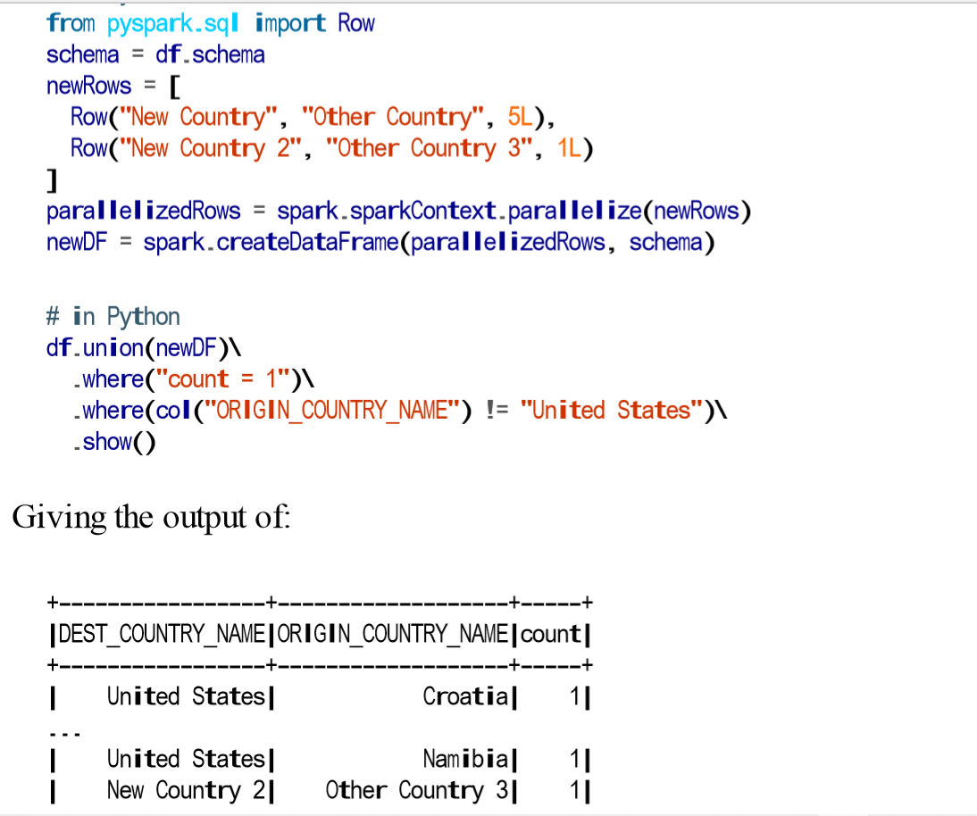

**Sorting Rows**

When we sort the values in a DataFrame, we always want to sort with either the largest or smallest values at the top of a DataFrame. There are two equivalent operations to do this sort and orderBy that work the exact same way. They accept both column expressions and strings as well as multiple columns. The default is to sort in ascending order:

# in Python

df.sort("count").show(5)

df.orderBy("count", "DEST_COUNTRY_NAME").show(5)

df.orderBy(col("count"), col("DEST_COUNTRY_NAME")).show(5)

from pyspark.sql.functions import desc, asc

df.orderBy(expr("count desc")).show(2)

df.orderBy(col("count").desc(), col("DEST_COUNTRY_NAME").asc()).show(2)

An advanced tip is to use asc_nulls_first, desc_nulls_first, asc_nulls_last, or desc_nulls_last to specify where you would like your null values to appear in an ordered DataFrame. For optimization purposes, it’s sometimes advisable to sort within each partition before another set of transformations. You can use the sortWithinPartitions method to do this:

df.orderBy(expr("count desc")).limit(6).show()

**Repartition and Coalesce**

Another important optimization opportunity is to partition the data according to some frequently filtered columns, which control the physical layout of data across the cluster including the partitioning scheme and the number of partitions. Repartition will incur a full shuffle of the data, regardless of whether one is necessary. This means that you should typically only repartition when the future number of partitions is greater than your current number of partitions or when you are looking to partition by a set of columns:

df.repartition(5)

If you know that you’re going to be filtering by a certain column often, it can be worth repartitioning based on that column:

df.repartition(col("DEST_COUNTRY_NAME"))

df.repartition(5, col("DEST_COUNTRY_NAME"))

Coalesce, on the other hand, will not incur a full shuffle and will try to combine partitions. This operation will shuffle your data into five partitions based on the destination country name, and then coalesce them (without a full shuffle):

The method toLocalIterator collects partitions to the driver as an iterator. This method allows you to iterate over the entire dataset partition-by-partition in a serial manner:

collectDF.toLocalIterator()

**Working with Different Types of Data**

from pyspark.sql.functions import col

df.where(col("InvoiceNo") != 536365).select("InvoiceNo", "Description").show(5, False)

df.where("InvoiceNo = 536365") .show(5, false)

df.where("InvoiceNo <> 536365") .show(5, false)

df.where(col("Description").eqNullSafe("hello")).show()

from pyspark.sql.functions import expr, pow

fabricatedQuantity = pow(col("Quantity") * col("UnitPrice"), 2) + 5

df.select(expr("CustomerId"), fabricatedQuantity.alias("realQuantity")).show(2)

from pyspark.sql.functions import lit, round, bround

df.select(round(lit("2.5")), bround(lit("2.5"))).show(2)

from pyspark.sql.functions import initcap

df.select(initcap(col("Description"))).show()

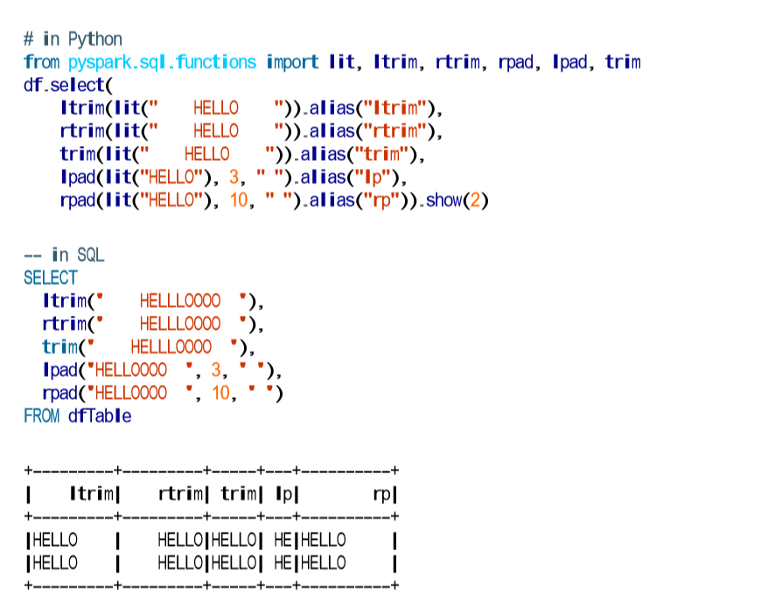

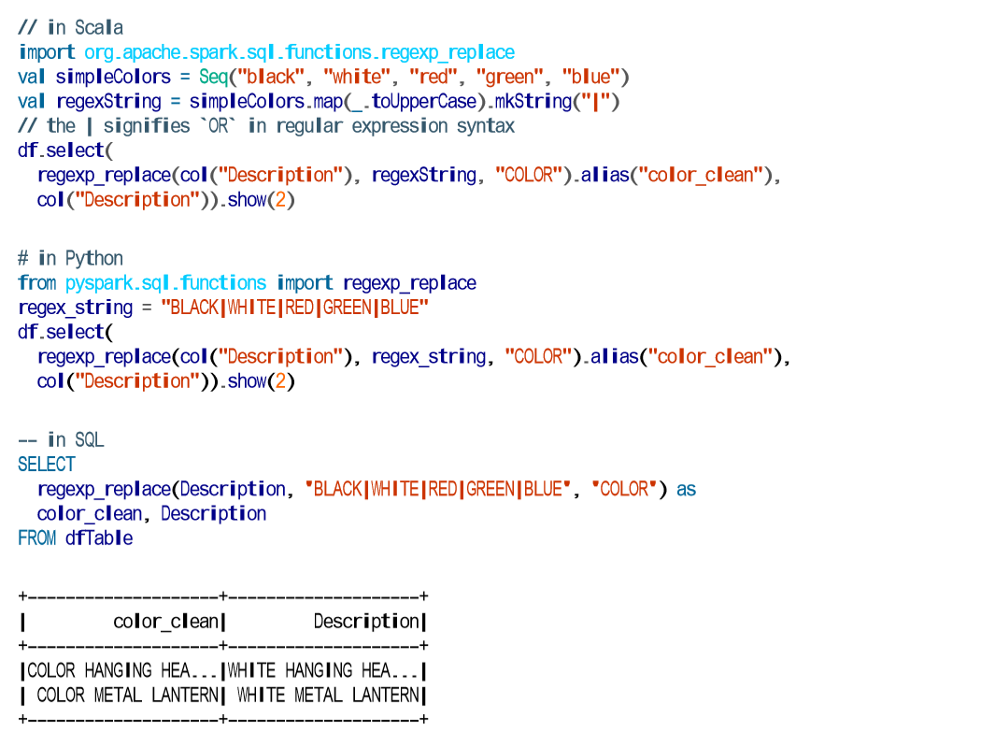

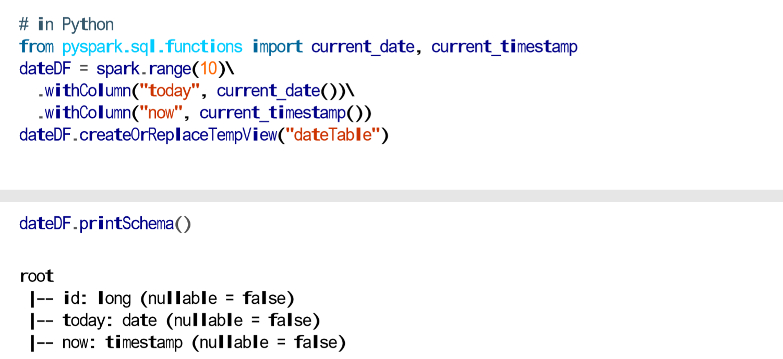

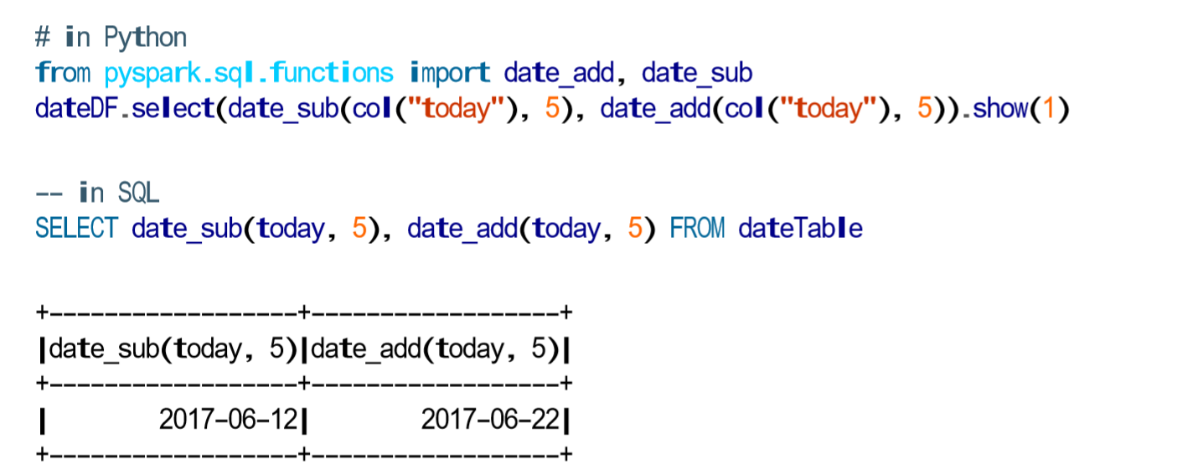

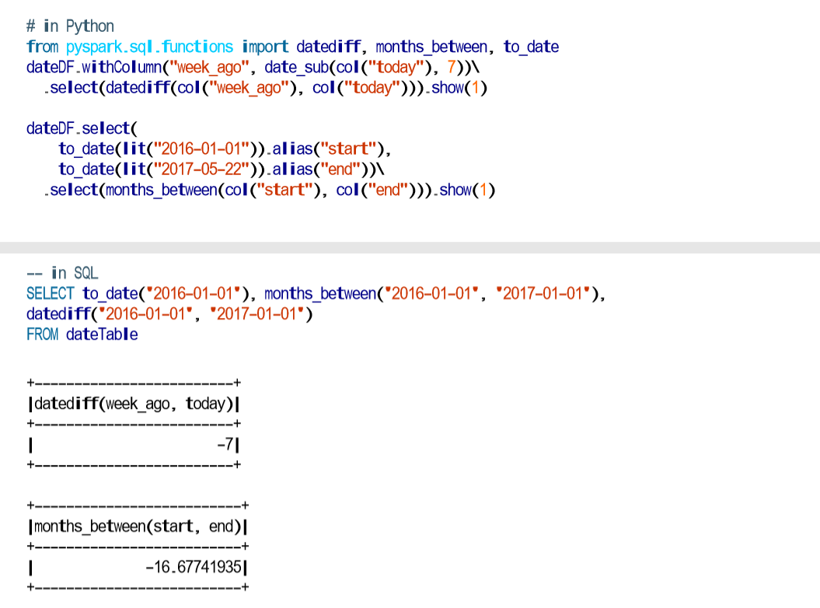

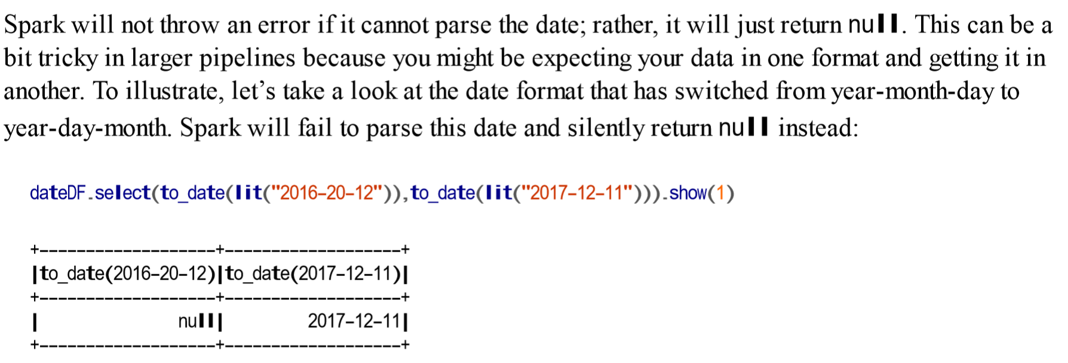

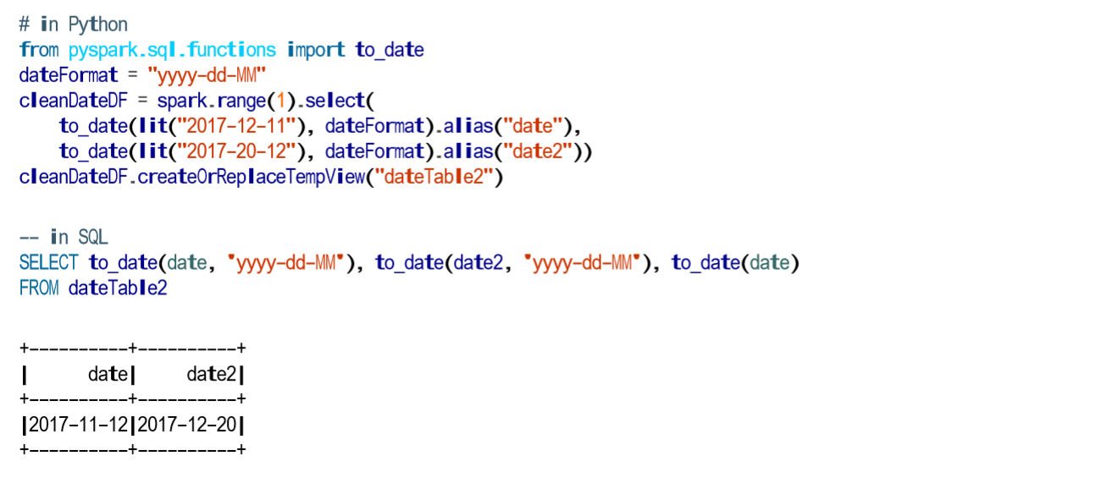

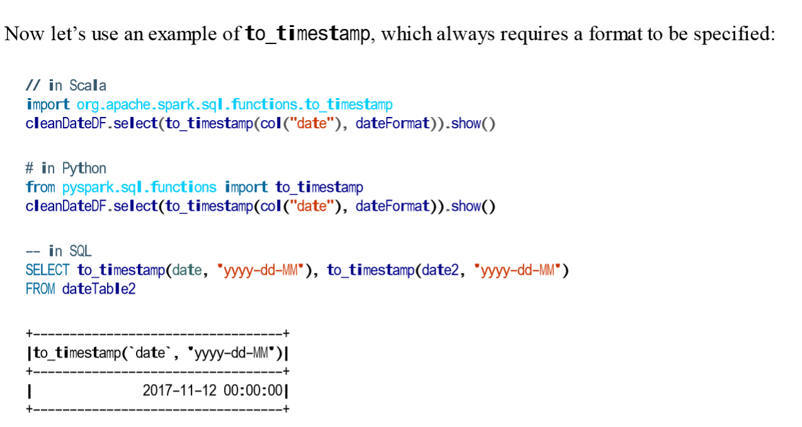

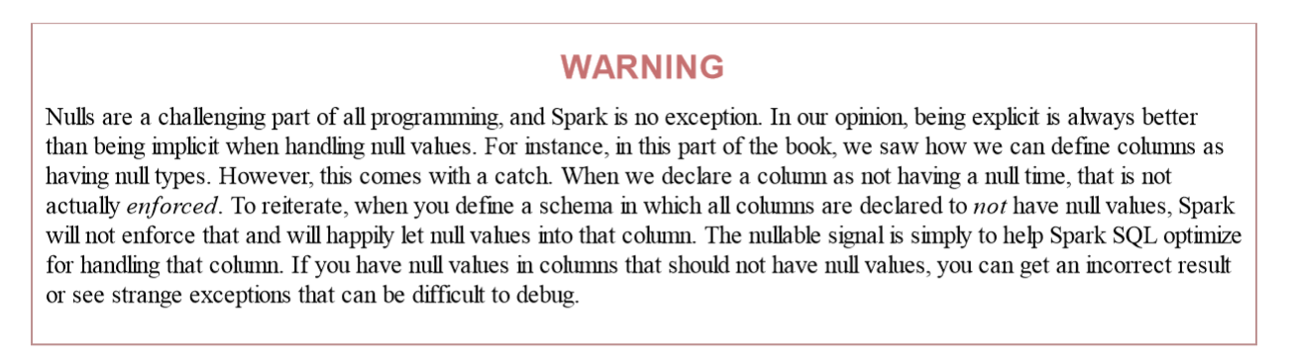

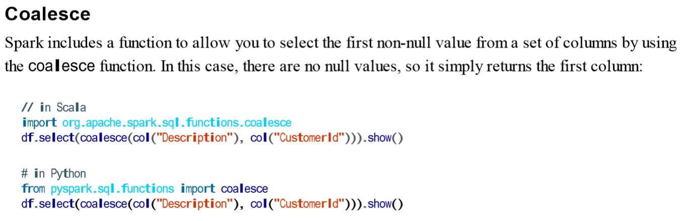

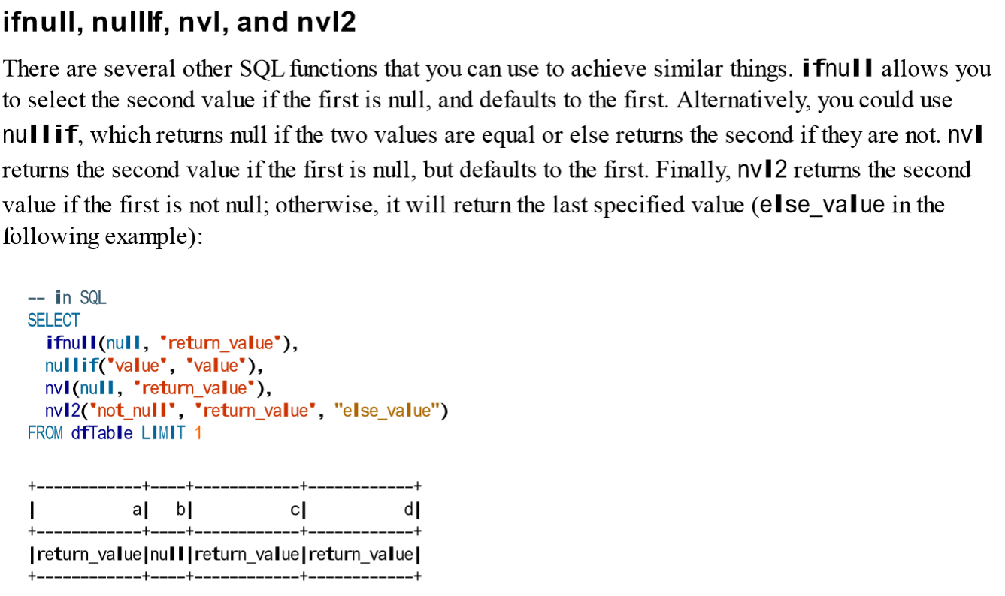

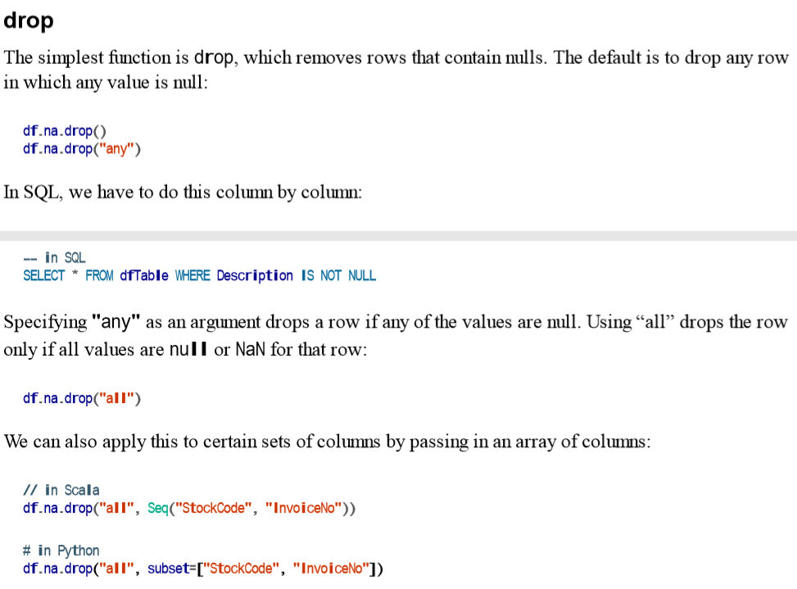

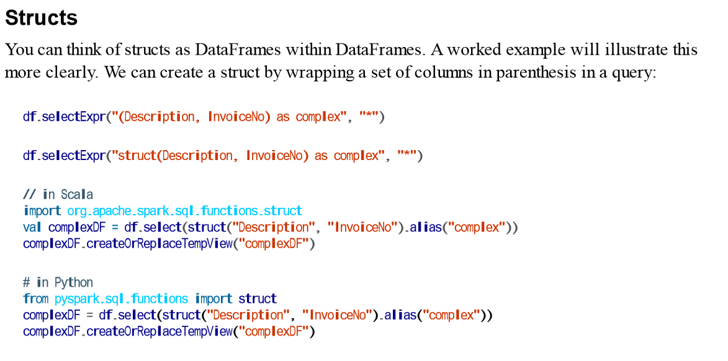

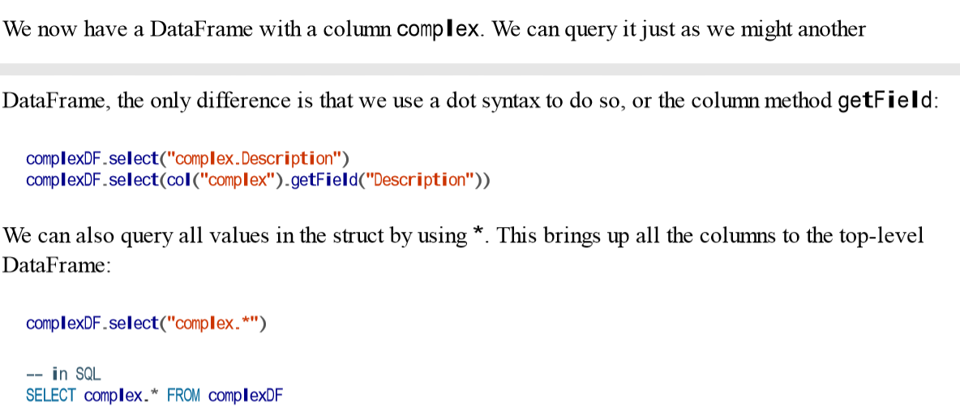

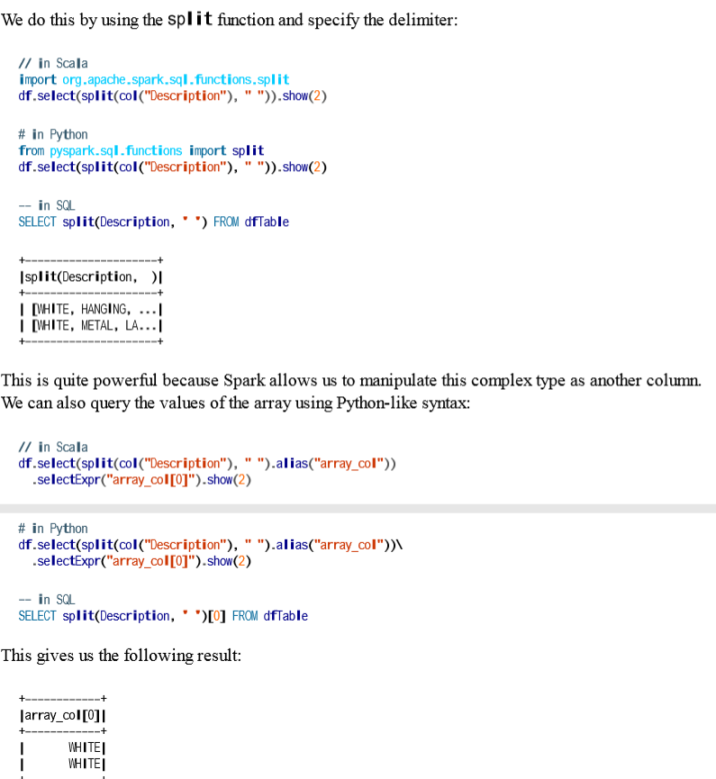

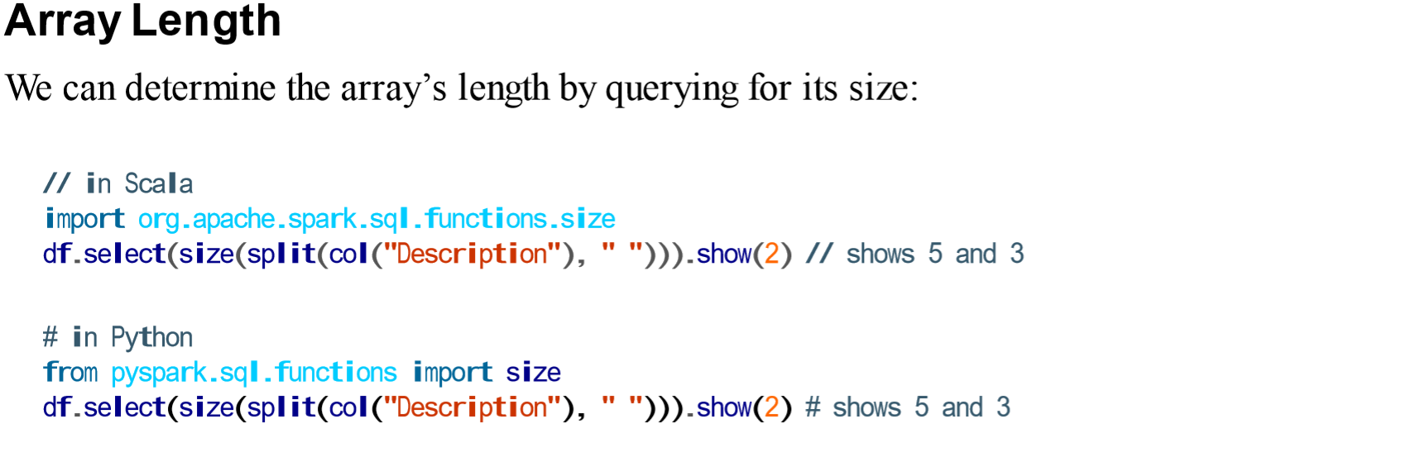

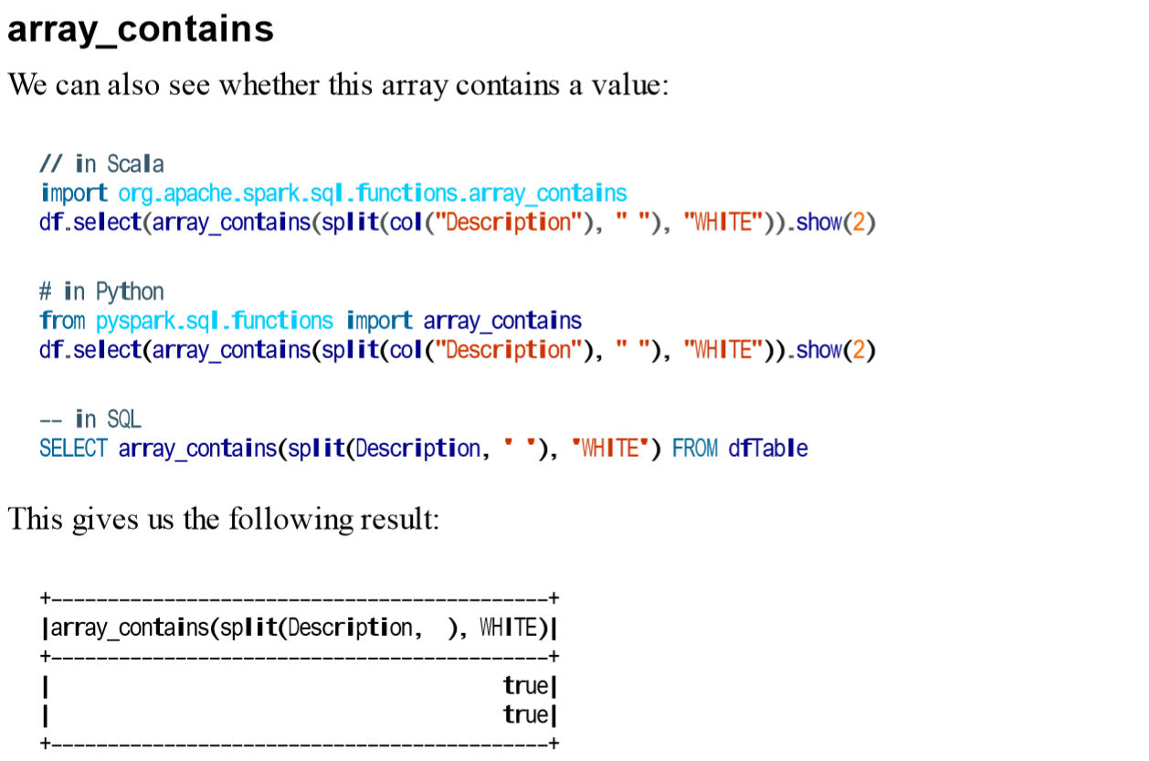

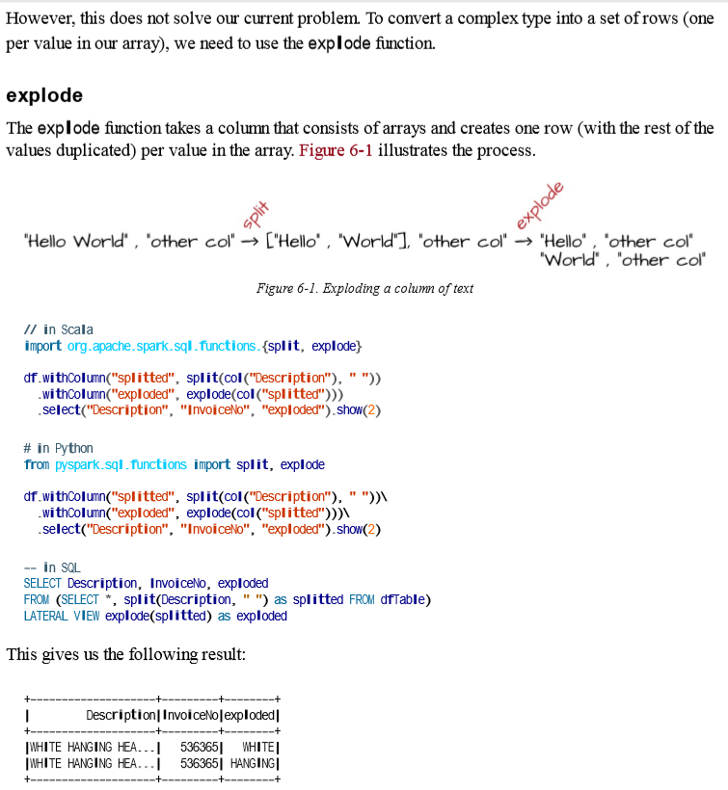

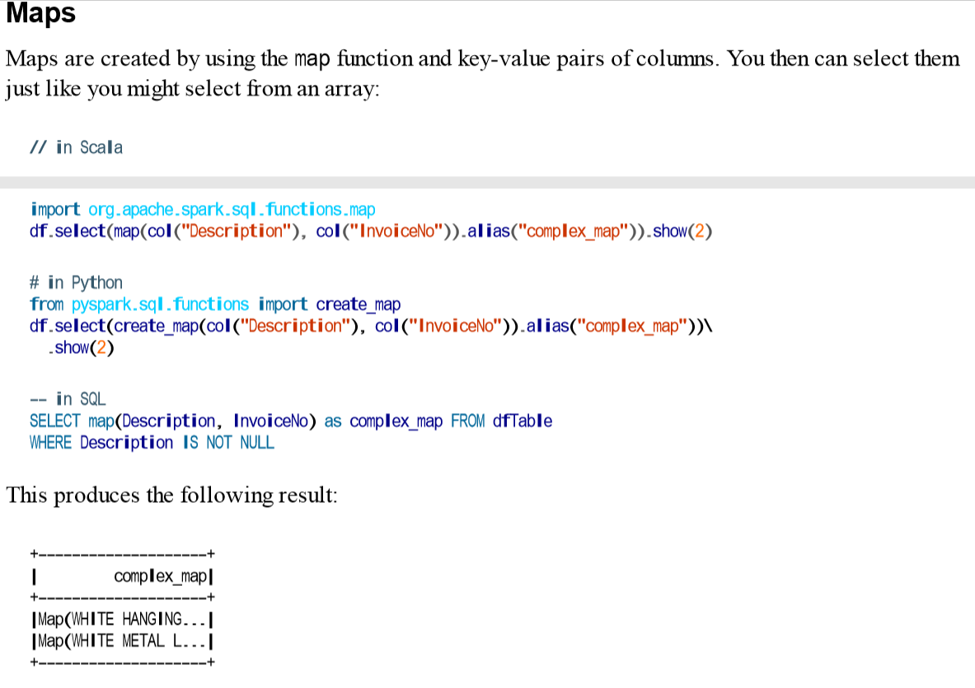

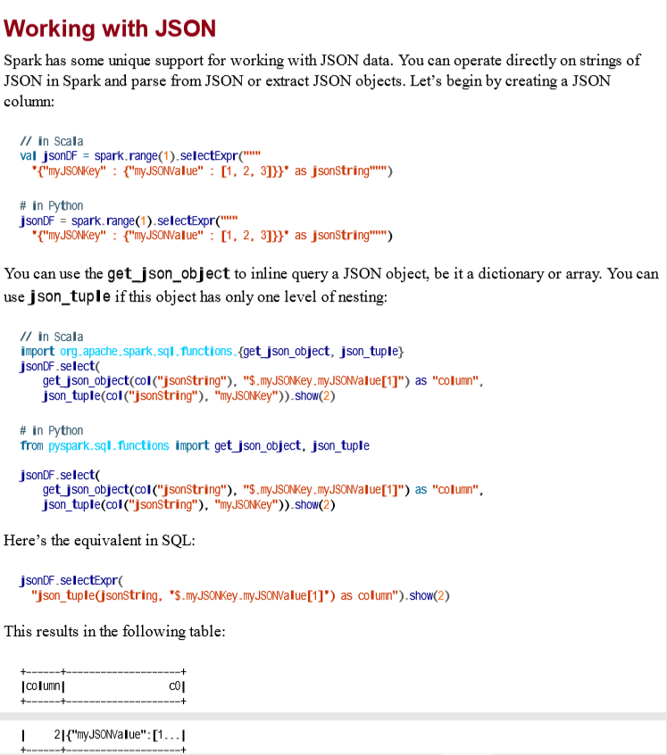

**User-Defined Functions 🡪 Chapter 6**

One of the most powerful things that you can do in Spark is define your own functions. These userdefined functions (UDFs) make it possible for you to write your own custom transformations using Python or Scala and even use external libraries. UDFs can take and return one or more columns as input. Spark UDFs are incredibly powerful because you can write them in several different programming languages; you do not need to create them in an esoteric format or domain-specific language. They’re just functions that operate on the data, record by record. By default, these functions are registered as temporary functions to be used in that specific SparkSession or Context. Although you can write UDFs in Scala, Python, or Java, there are performance considerations that you should be aware of. To illustrate this, we’re going to walk through exactly what happens when you create UDF, pass that into Spark, and then execute code using that UDF. The first step is the actual function. We’ll create a simple one for this example. Let’s write a power3 function that takes a number and raises it to a power of three:

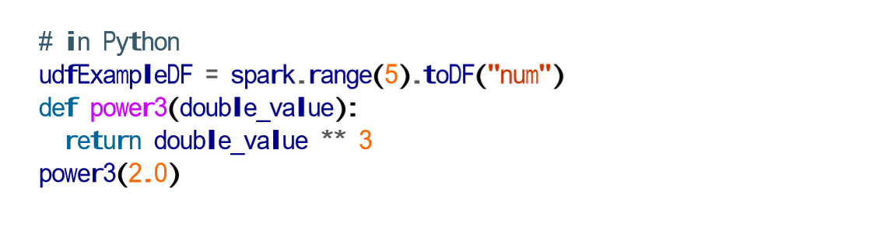

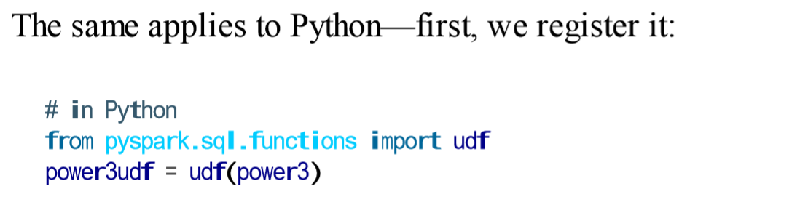

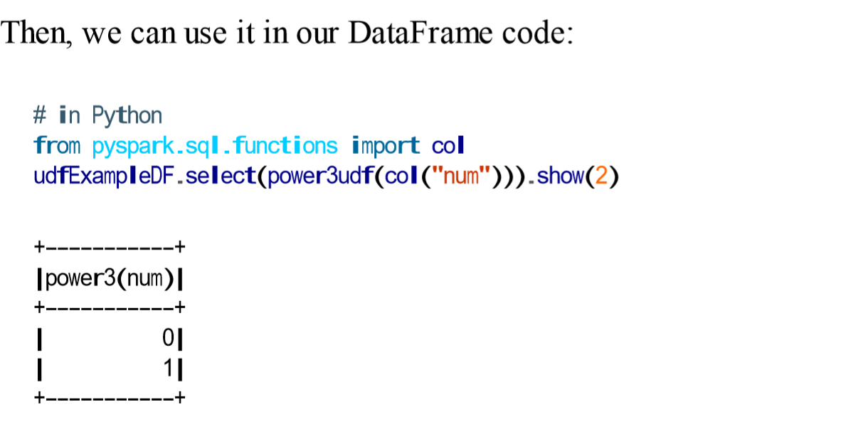

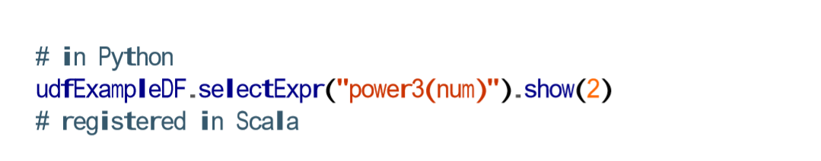

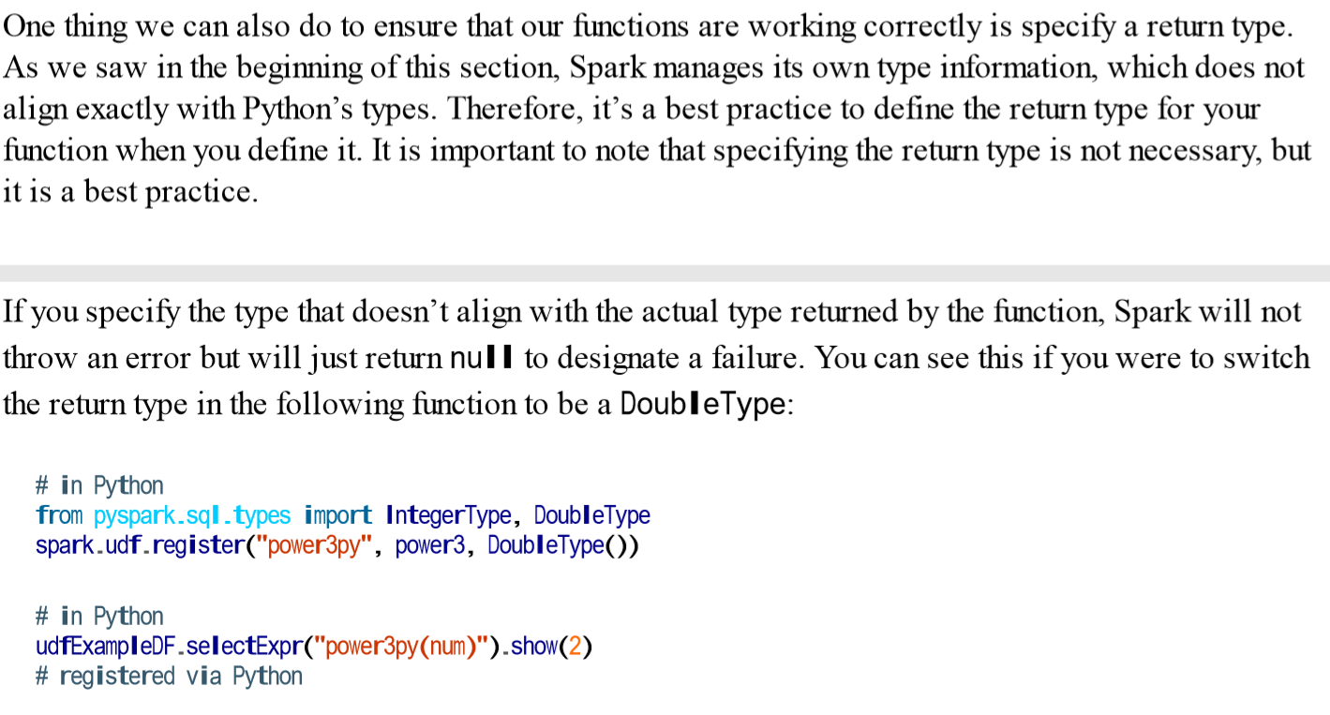

**Read spark UDF**

**Aggregations**

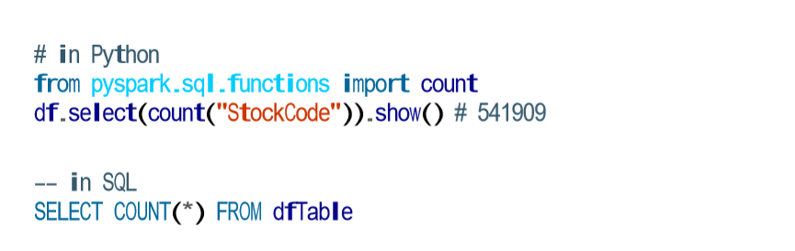

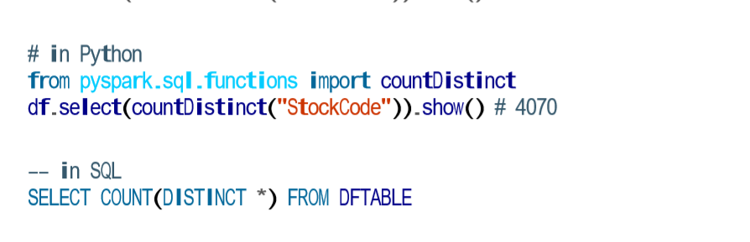

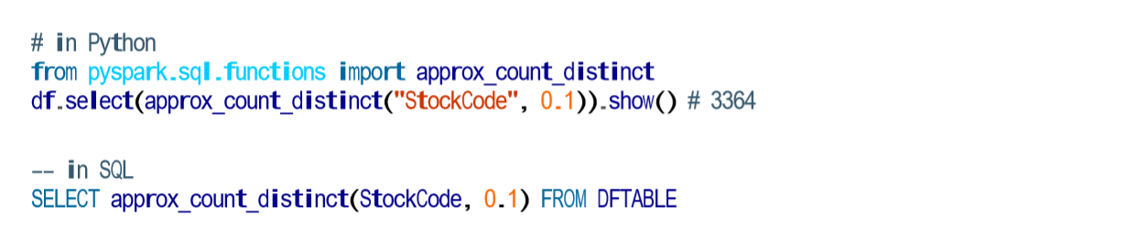

You will notice that approx_count_distinct took another parameter with which you can specify the maximum estimation error allowed. In this case, we specified a rather large error and thus receive an answer that is quite far off but does complete more quickly than countDistinct. You will see much greater performance gains with larger datasets.

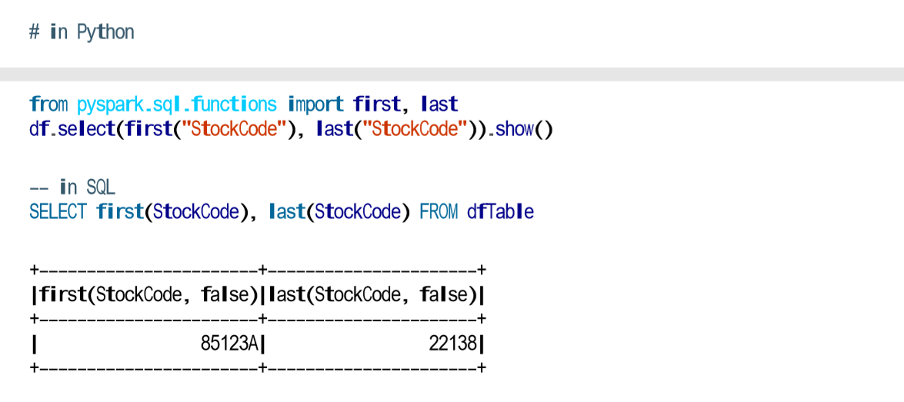

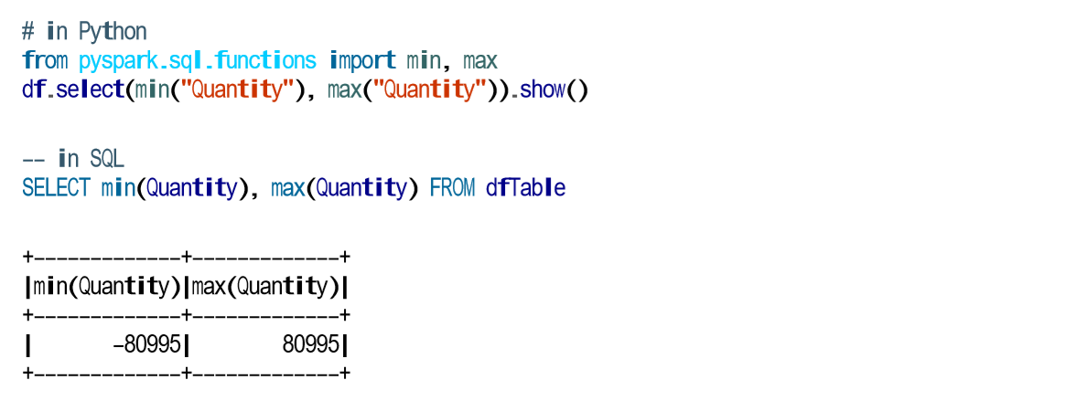

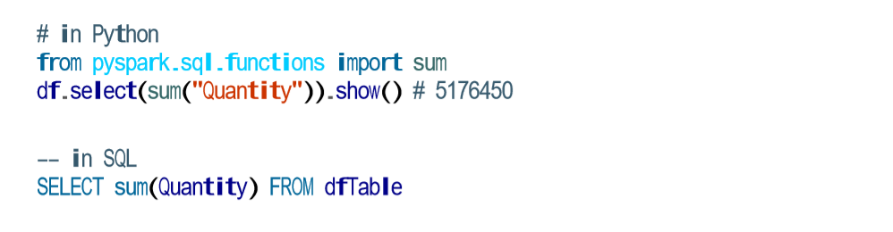

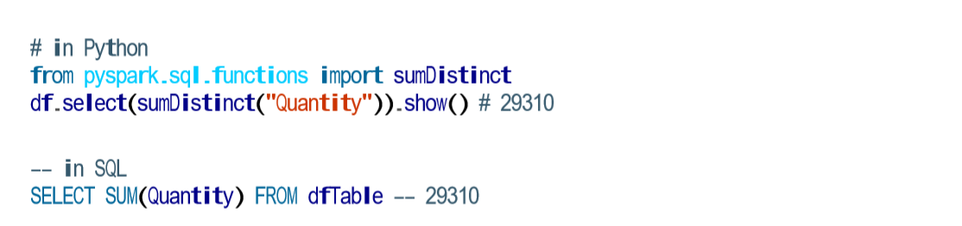

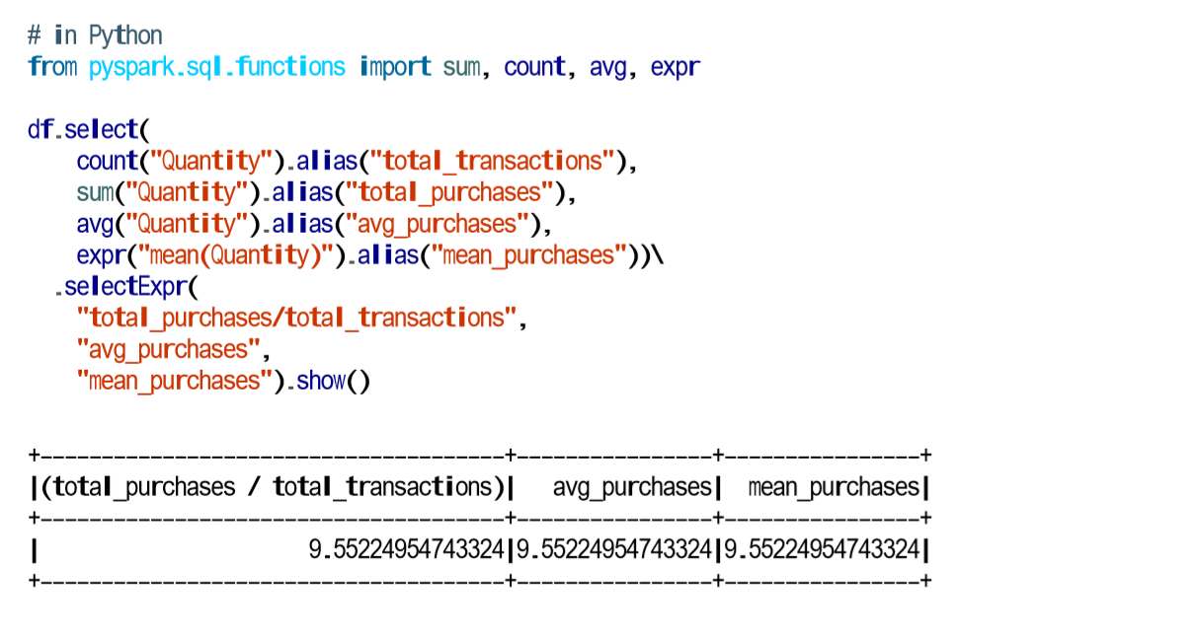

Calculating the mean naturally brings up questions about the variance and standard deviation. These are both measures of the spread of the data around the mean. The variance is the average of the squared differences from the mean, and the standard deviation is the square root of the variance. You can calculate these in Spark by using their respective functions. However, something to note is that Spark has both the formula for the sample standard deviation as well as the formula for the population standard deviation. These are fundamentally different statistical formulae, and we need to differentiate between them. By default, Spark performs the formula for the sample standard deviation or variance if you use the variance or stddev functions.

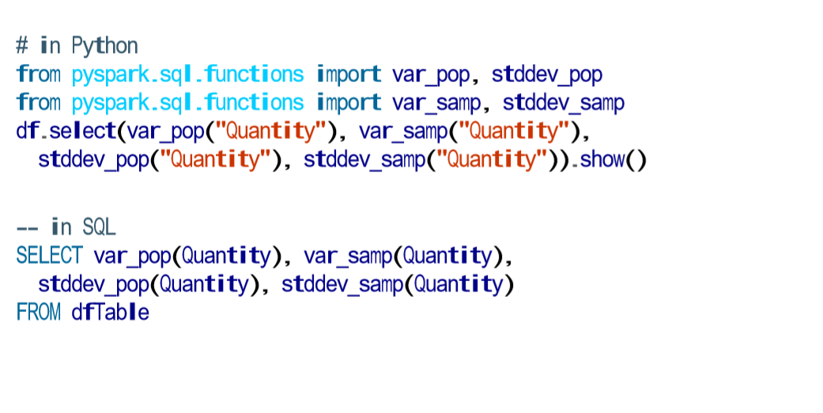

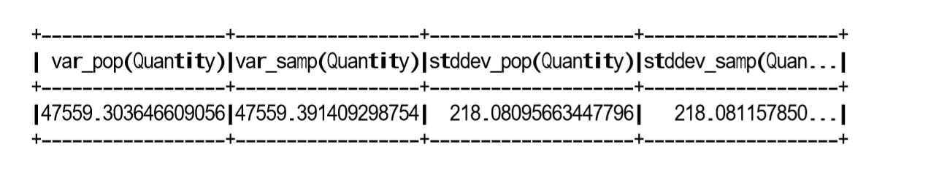

Skewness and kurtosis are both measurements of extreme points in your data. Skewness measures the asymmetry of the values in your data around the mean, whereas kurtosis is a measure of the tail of data. These are both relevant specifically when modelling your data as a probability distribution of a random variable

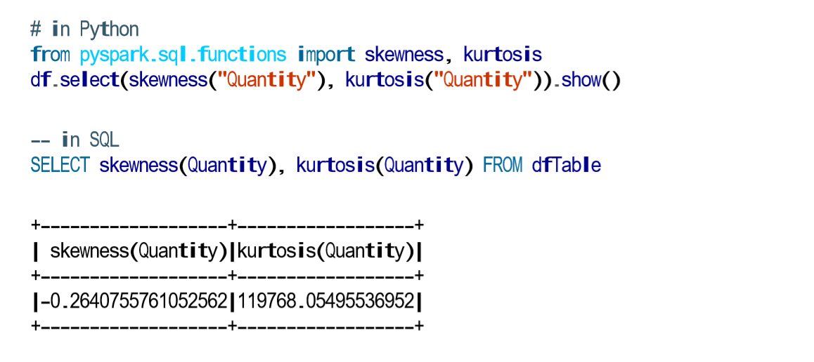

We discussed single column aggregations, but some functions compare the interactions of the values in two difference columns together. Two of these functions are cov and corr, for covariance and correlation, respectively. Correlation measures the Pearson correlation coefficient, which is scaled between –1 and +1. The covariance is scaled according to the inputs in the data. Like the var function, covariance can be calculated either as the sample covariance or the population covariance. Therefore it can be important to specify which formula you want to use. Correlation has no notion of this and therefore does not have calculations for population or sample. Here’s how they work

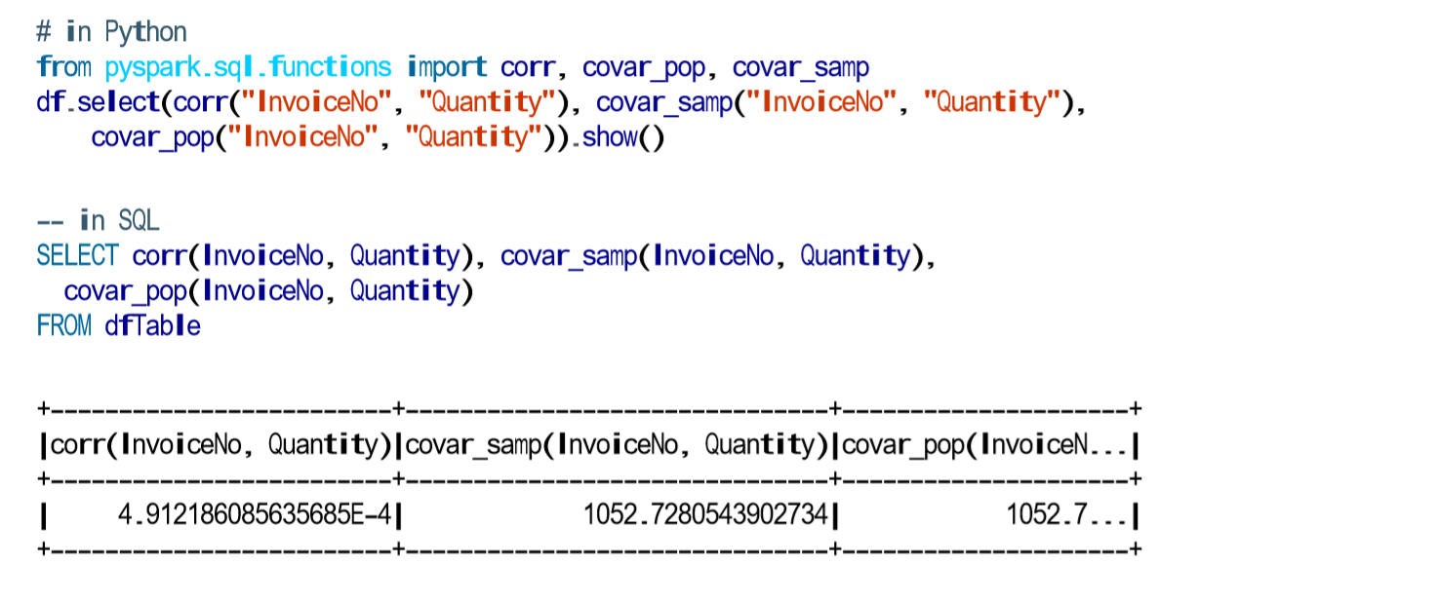

In Spark, you can perform aggregations not just of numerical values using formulas, you can also perform them on complex types. For example, we can collect a list of values present in a given column or only the unique values by collecting to a set

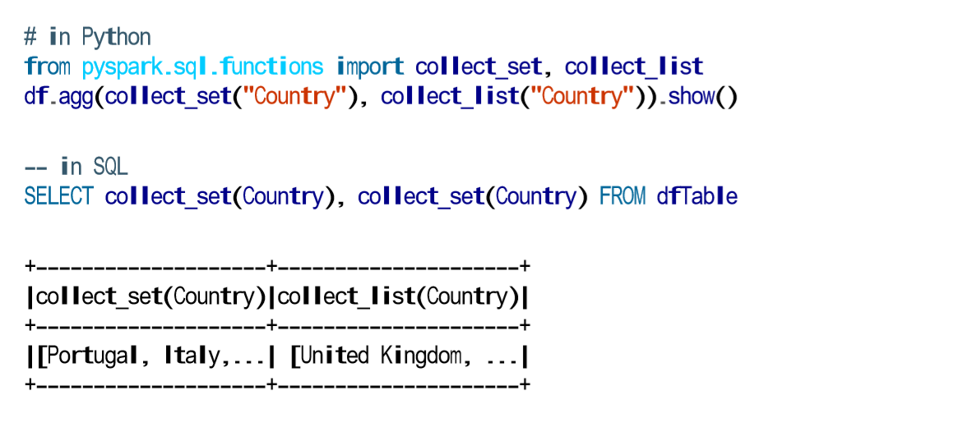

The first will be a count, just as we did before. We will group by each unique invoice number and get the count of items on that invoice. Note that this returns another DataFrame and is lazily performed. We do this grouping in two phases. **First we specify the column(s) on which we would like to group, and then we specify the aggregation(s).** The first step returns a RelationalGroupedDataset, and the second step returns a DataFrame. As mentioned, we can specify any number of columns on which we want to group:

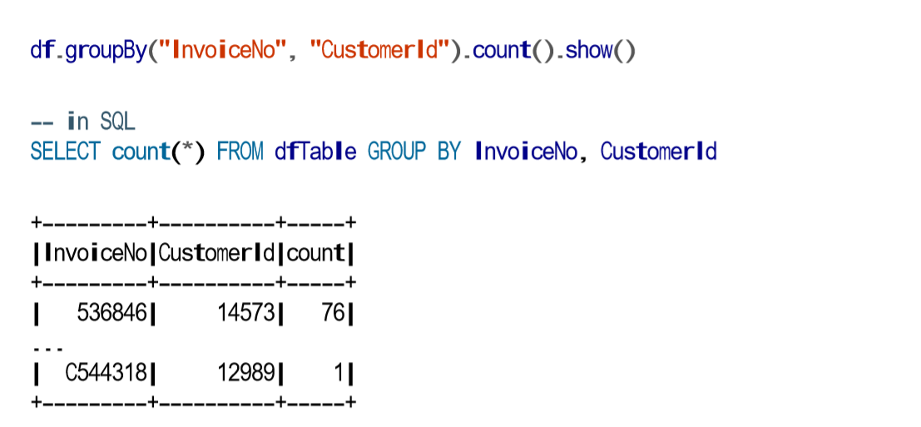

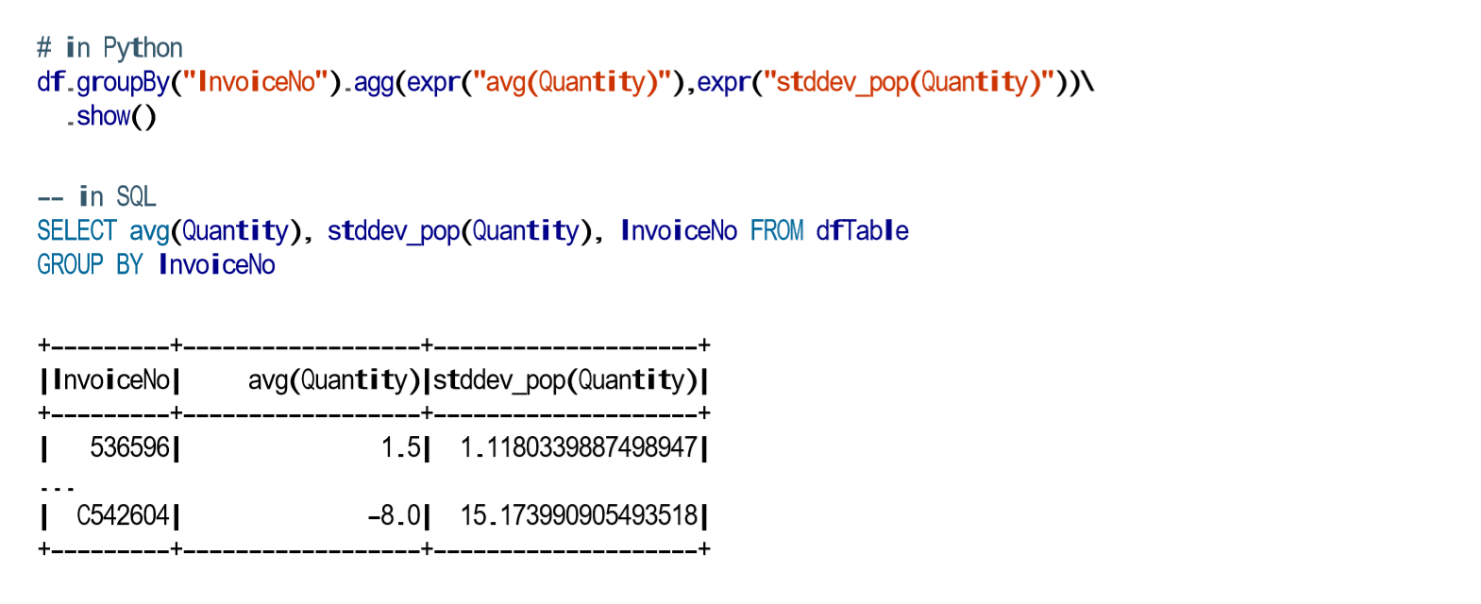

**Chapter 7 page no 134 to 144 pending**

**JOINS**

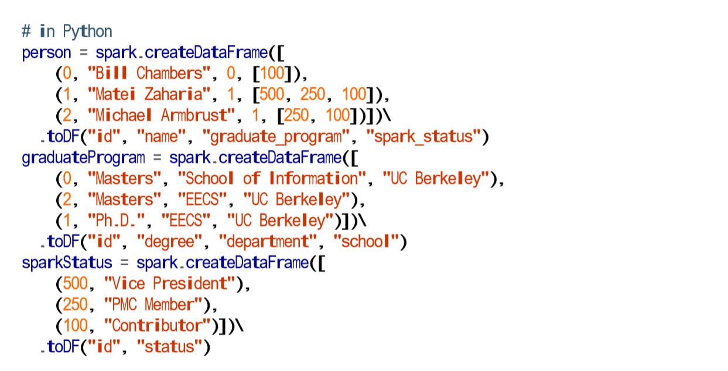

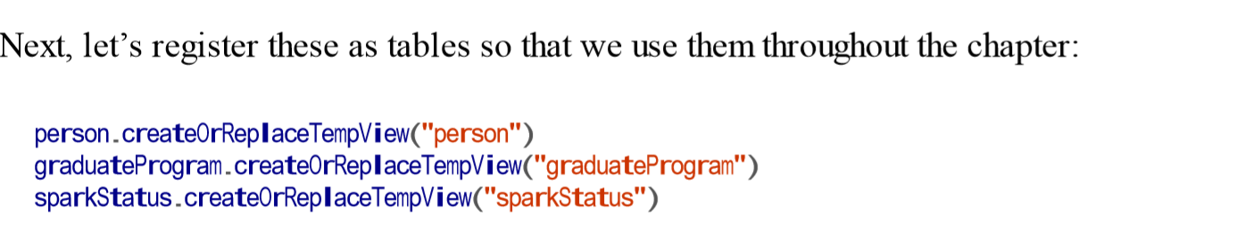

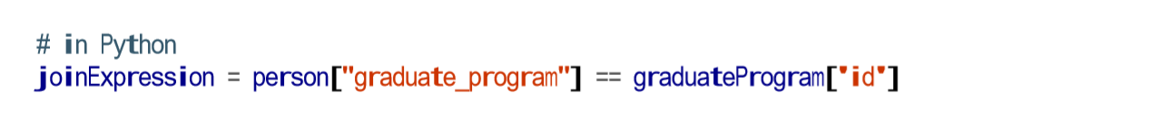

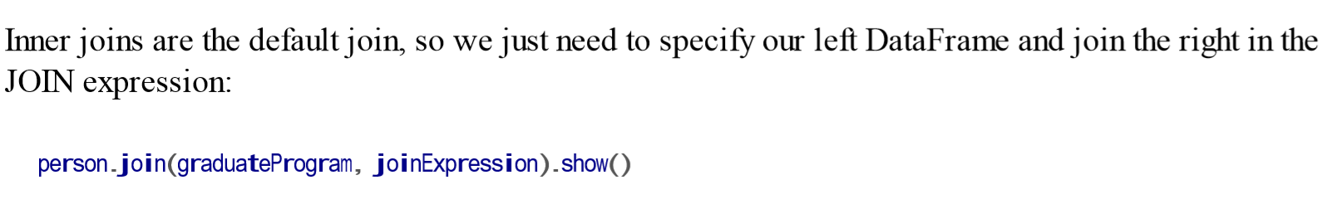

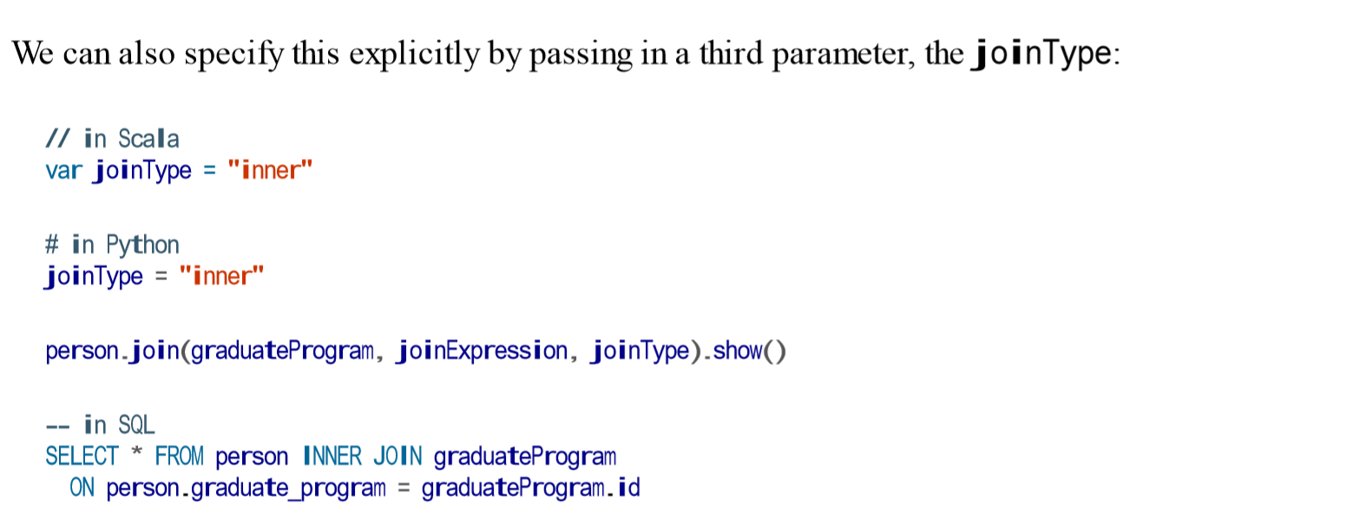

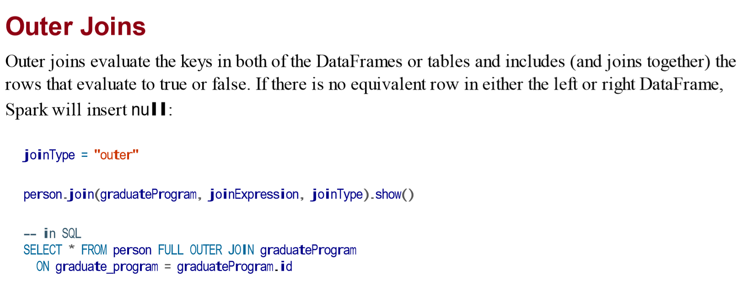

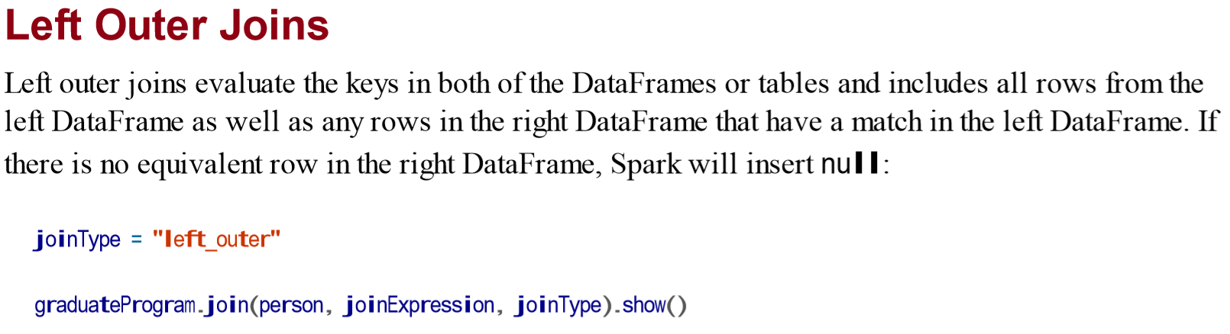

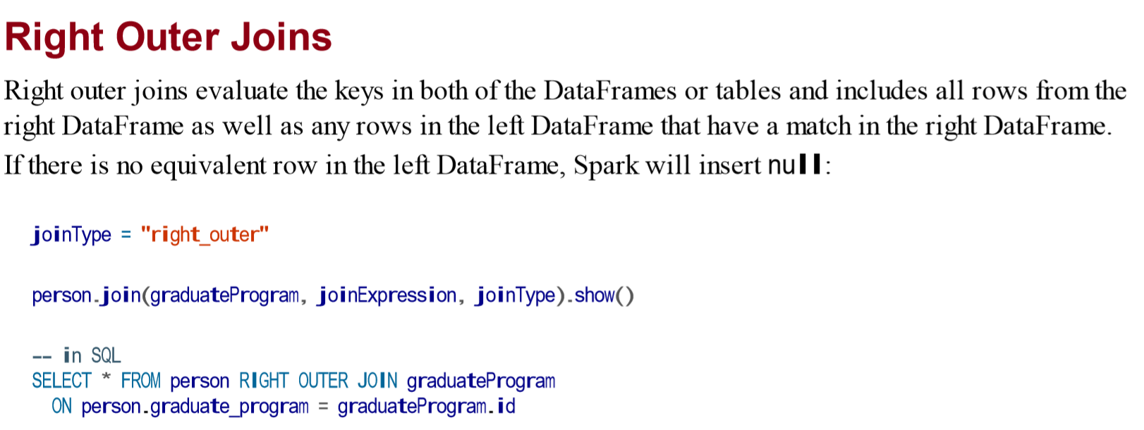

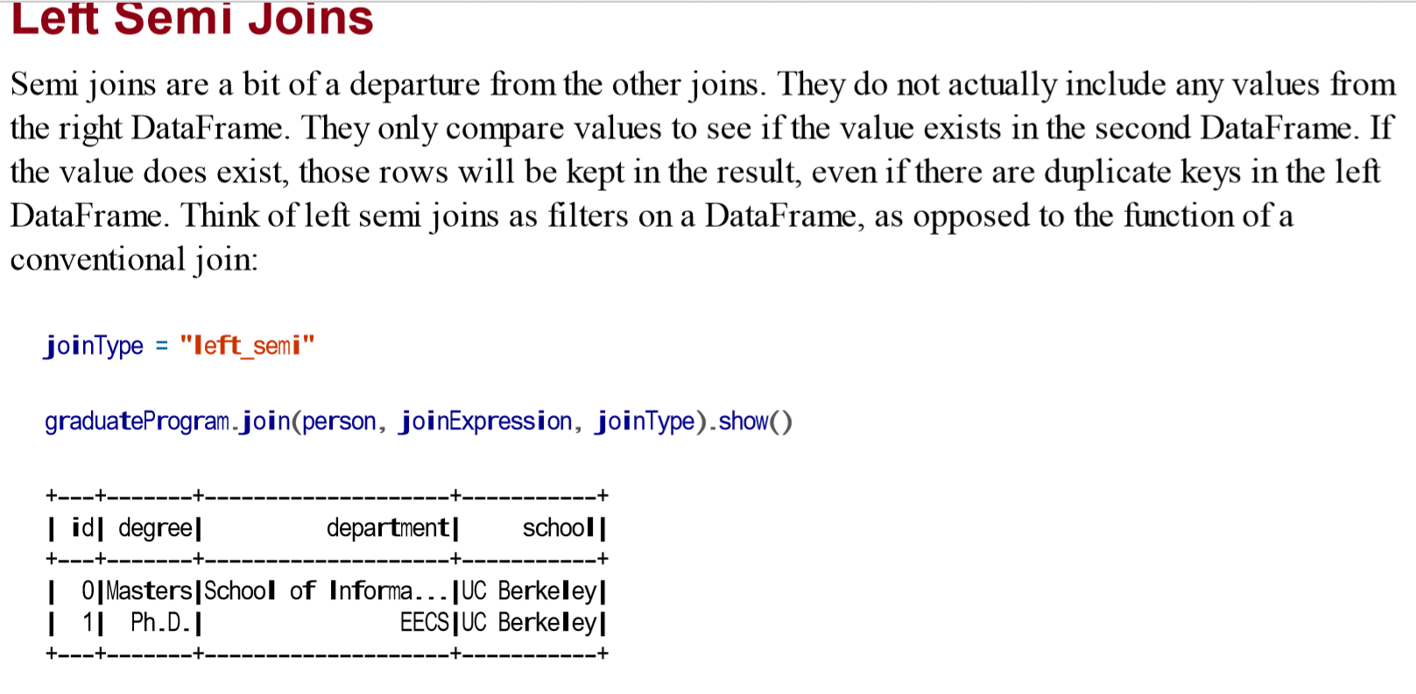

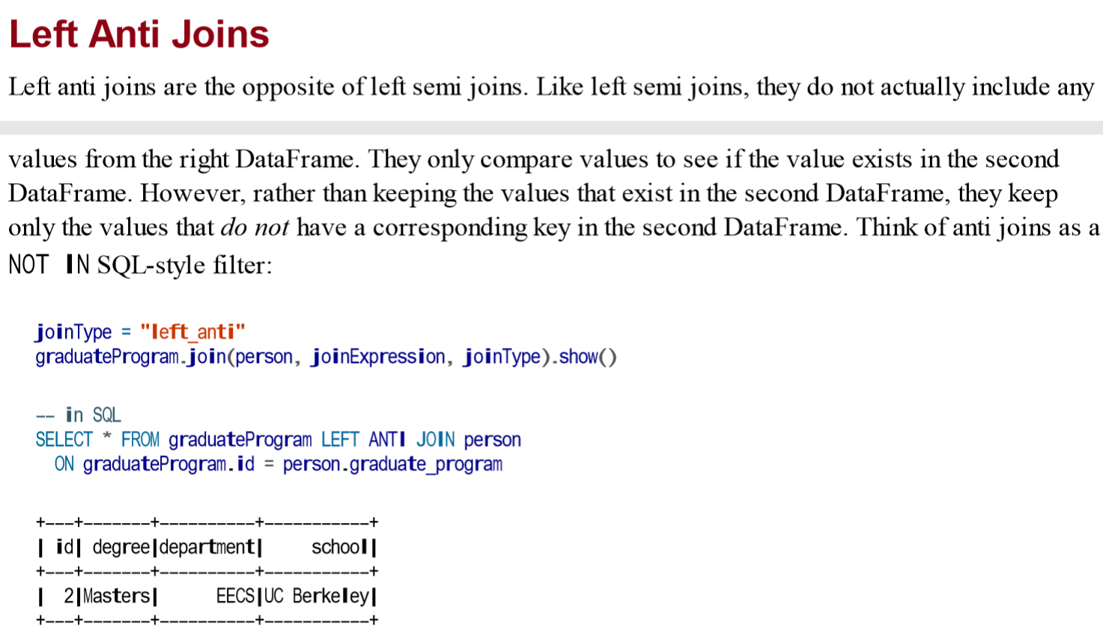

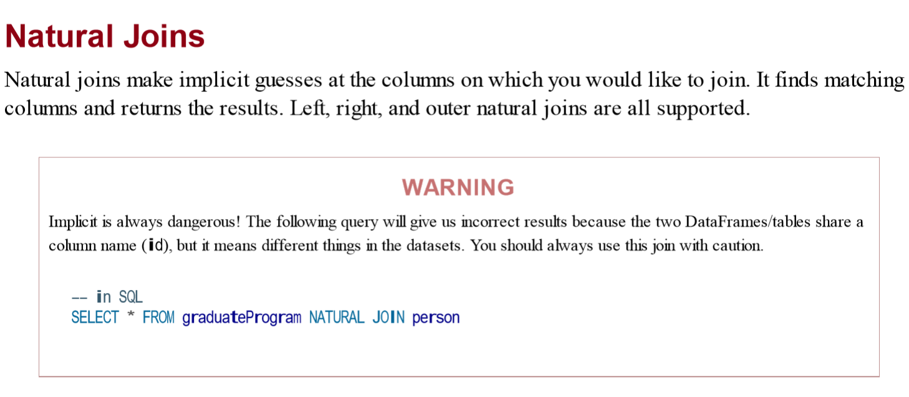

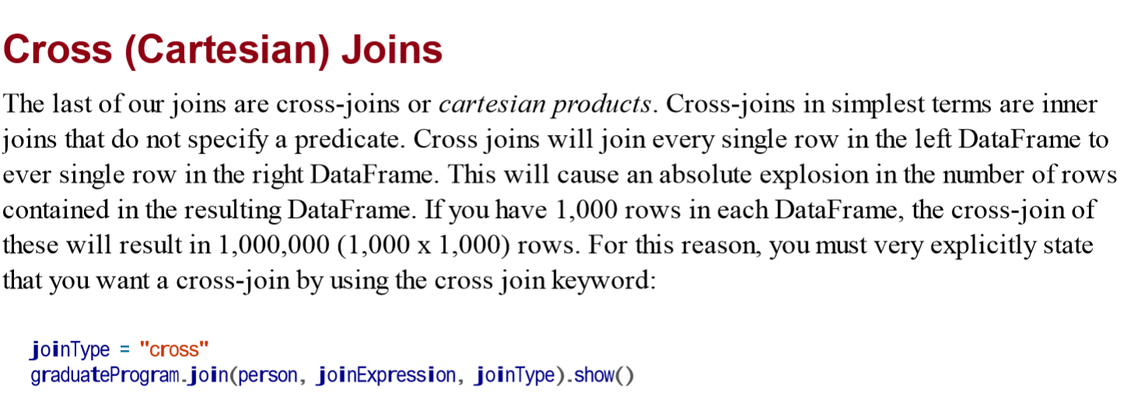

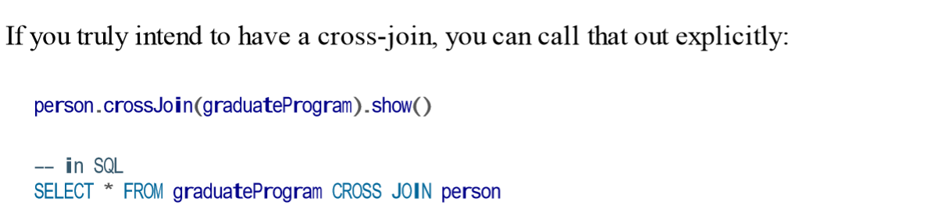

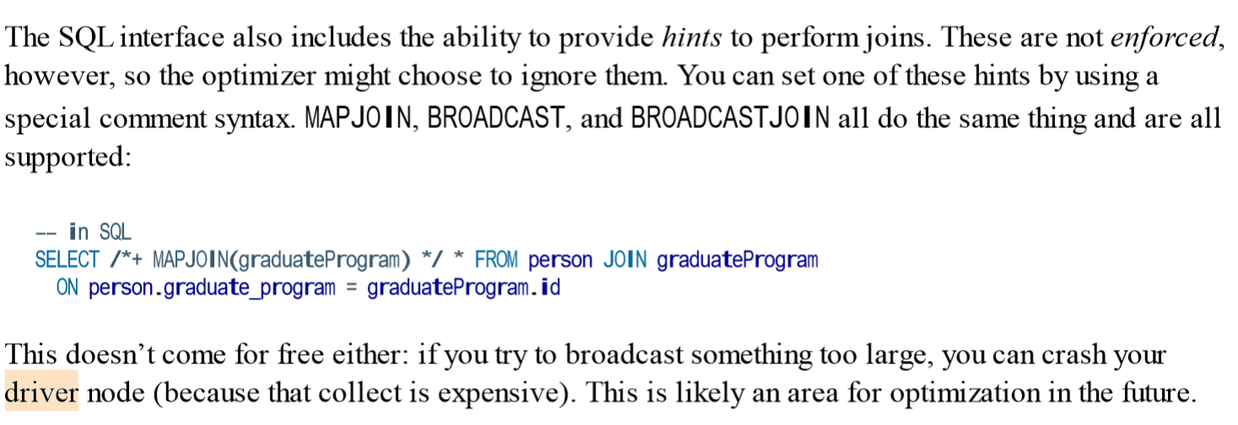

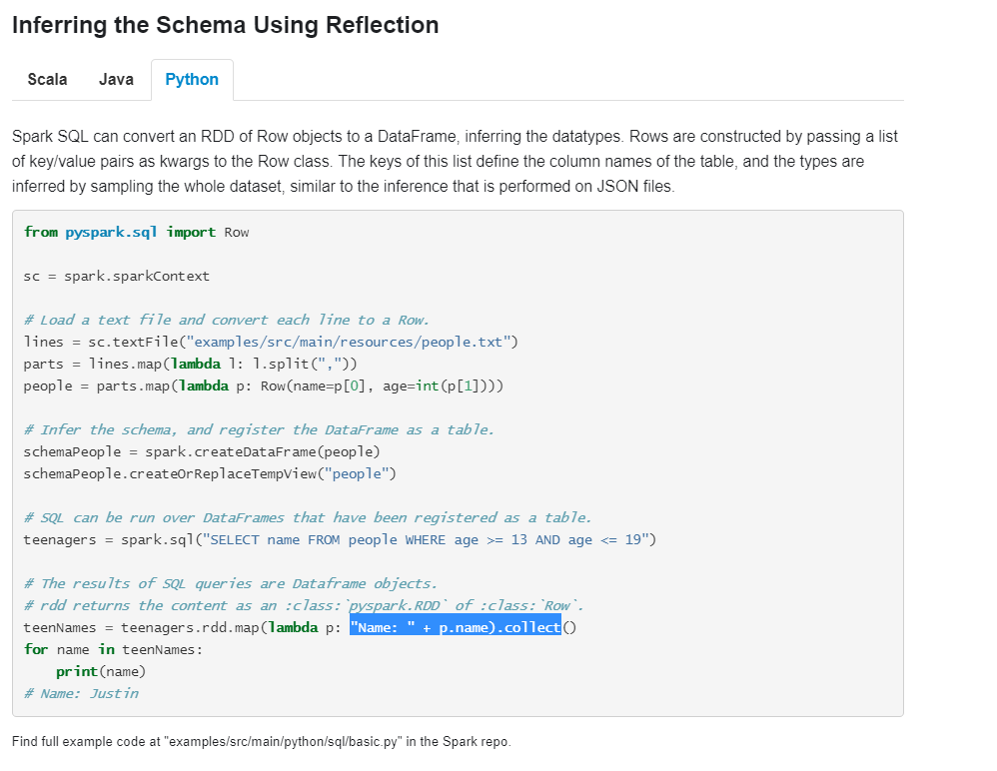

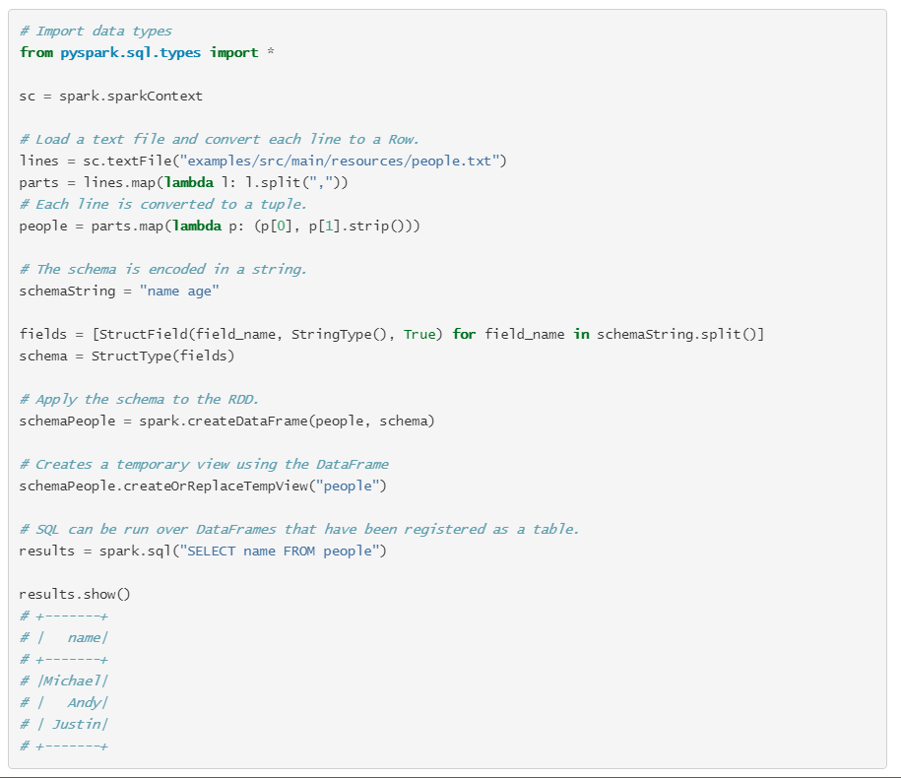

**Spark Data Sources**

DataFrameReader.format(...).option("key", "value").schema(...).load()

Format is optional because by default Spark will use the Parquet format. Option allows you to set key-value configurations to parameterize how you will read data. Lastly, schema is optional if the data source provides a schema or if you intend to use schema inference

After we have a DataFrame reader, we specify several values:

* The format
* The schema
* The read mode
* A series of options

spark.read.format("csv") .option("mode", "FAILFAST") .option("inferSchema", "true") .option("path", "path/to/file(s)") .schema(someSchema) .load()

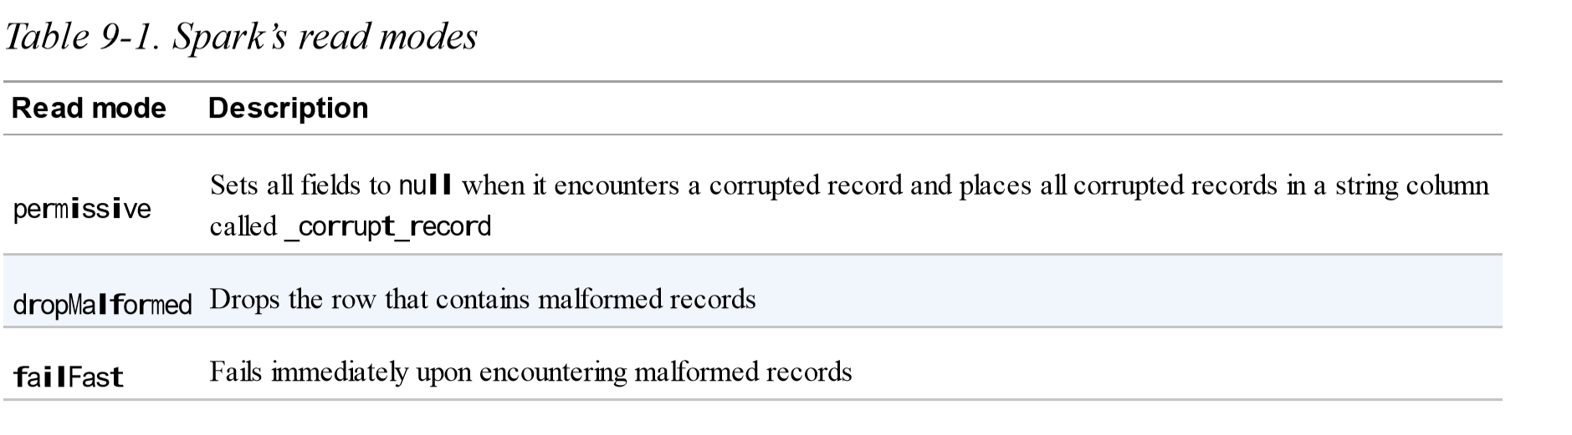

Permissive is default

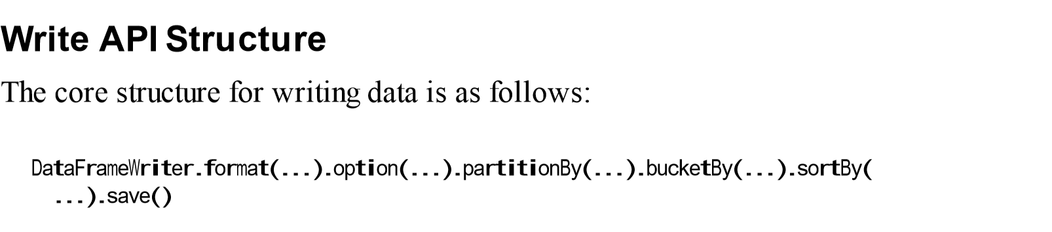

We will use this format to write to all of our data sources. format is optional because by default, Spark will use the arquet format. option, again, allows us to configure how to write out our given data. PartitionBy, bucketBy, and sortBy work only for file-based data sources; you can use them to control the specific layout of files at the destination

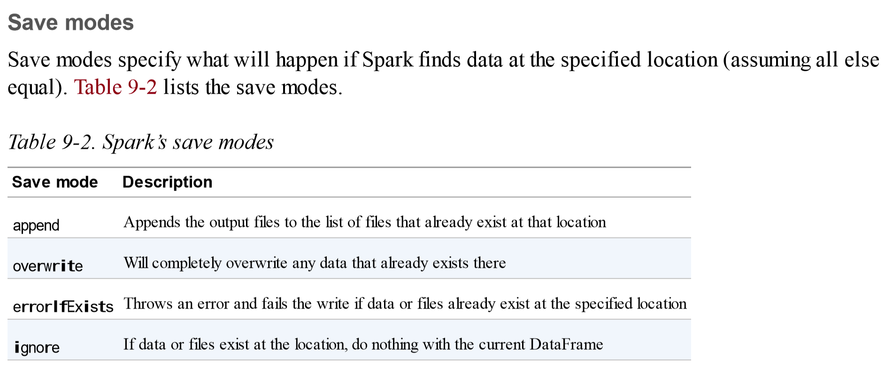

errorIfExists is default

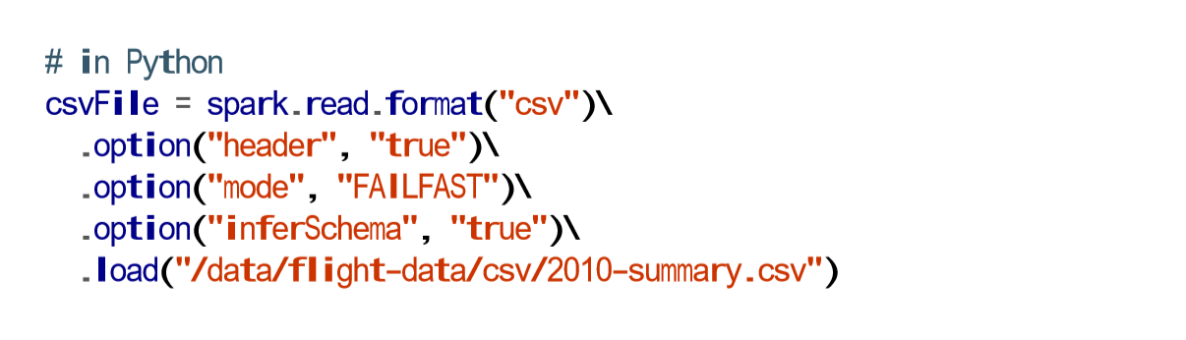

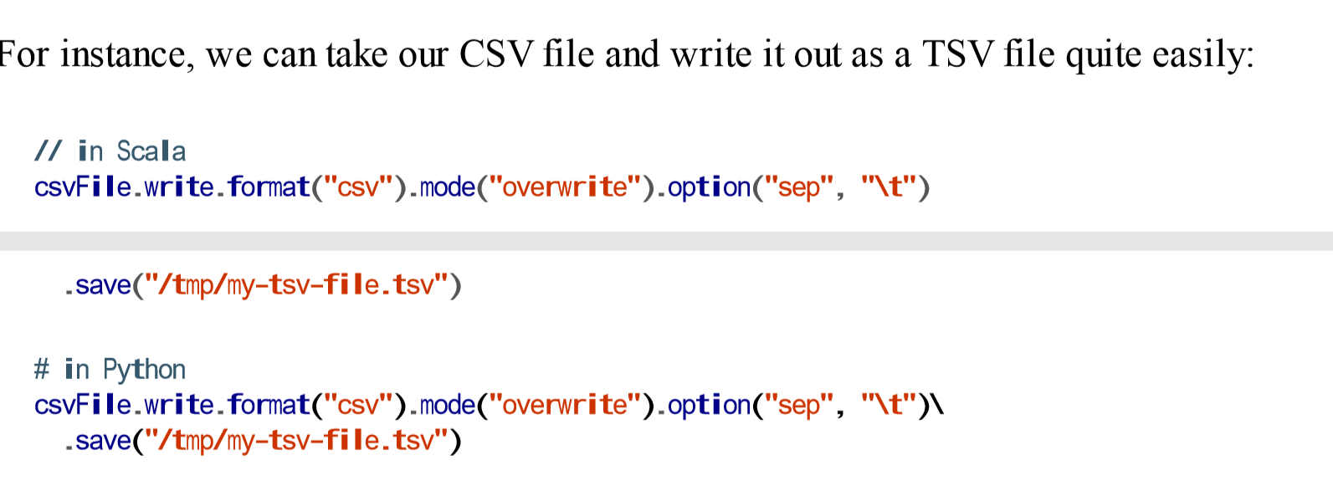

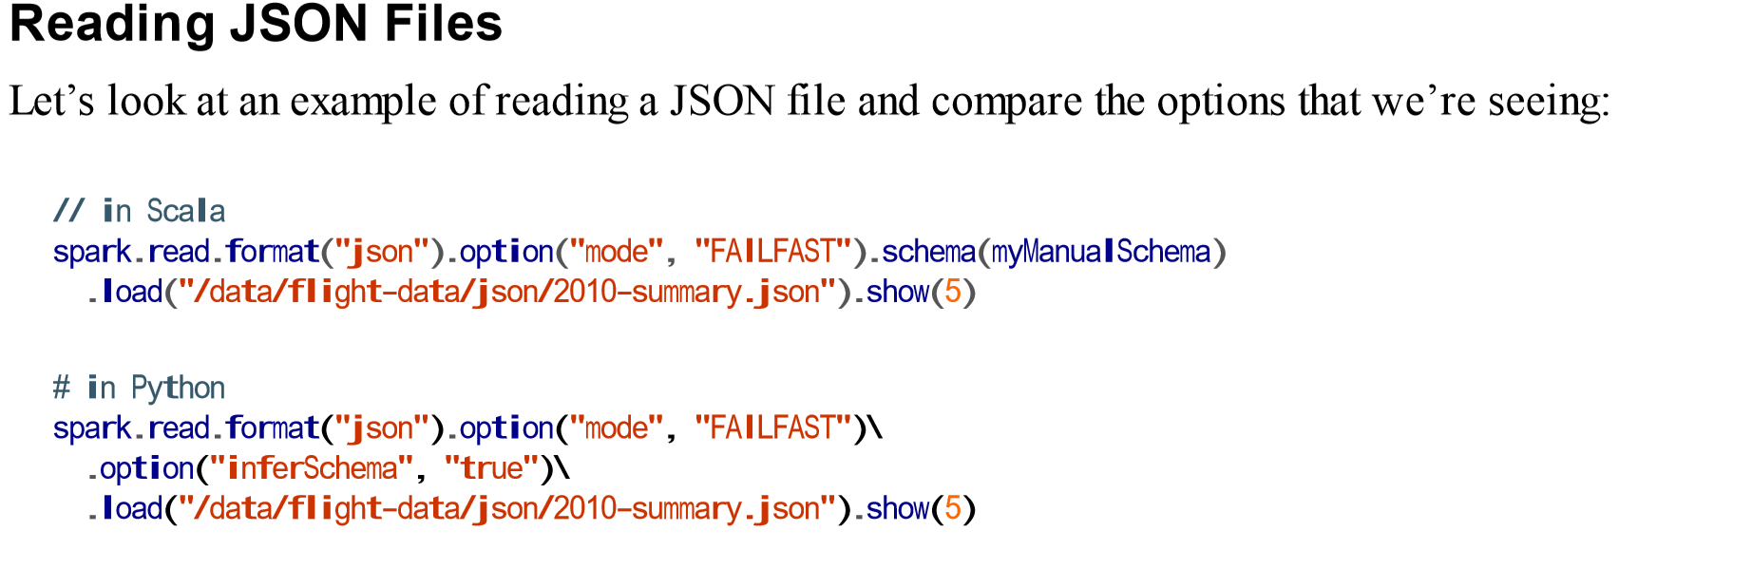

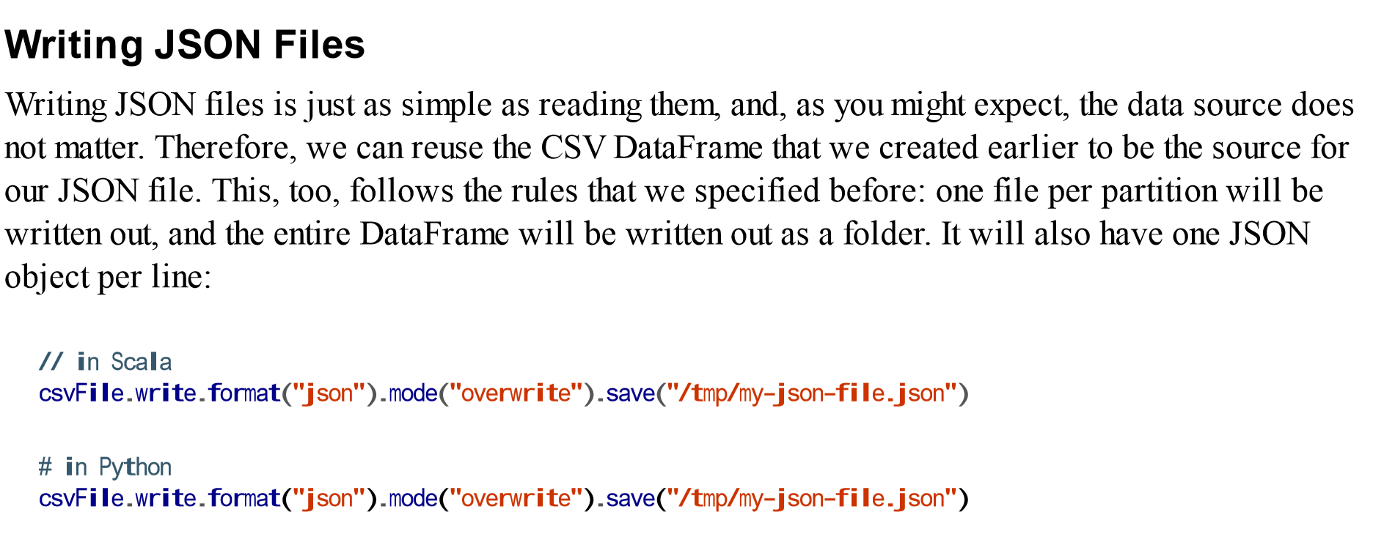

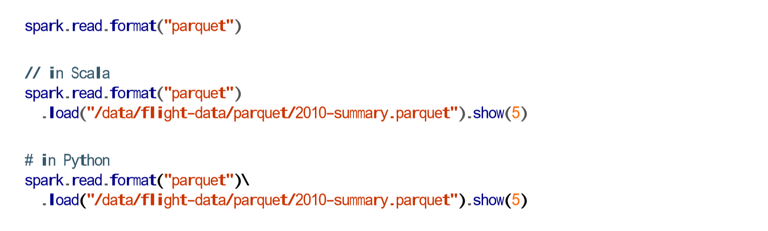

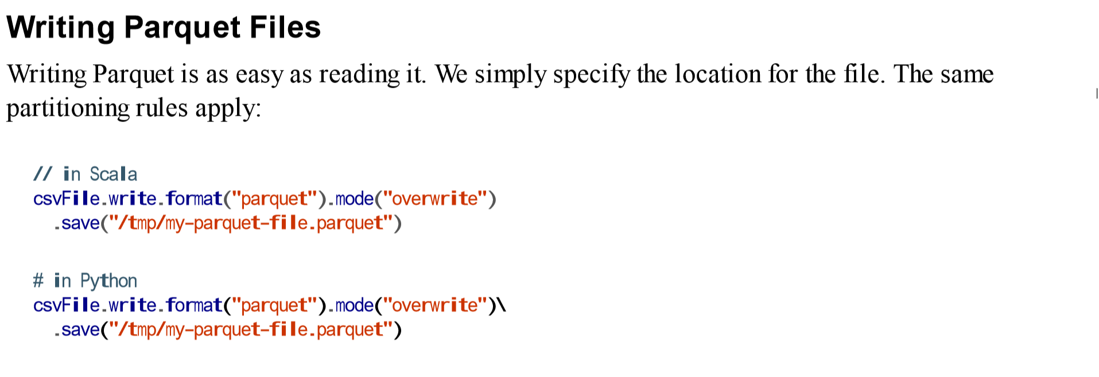

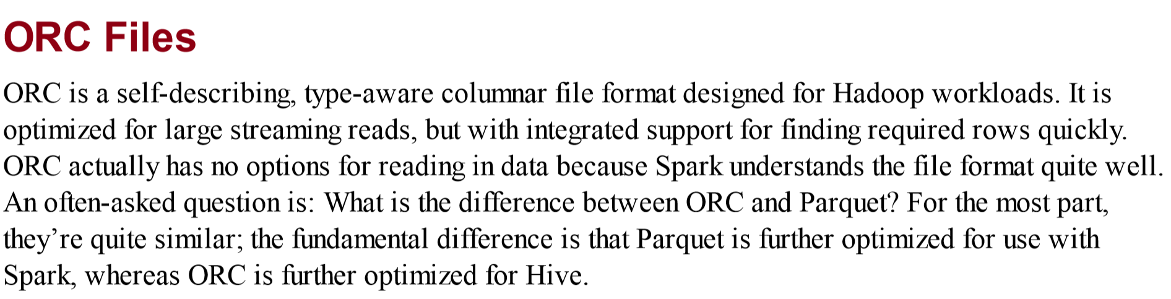

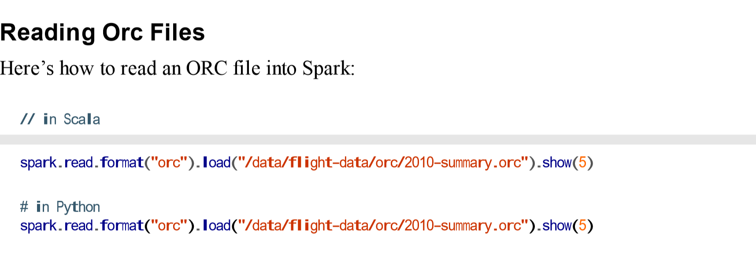

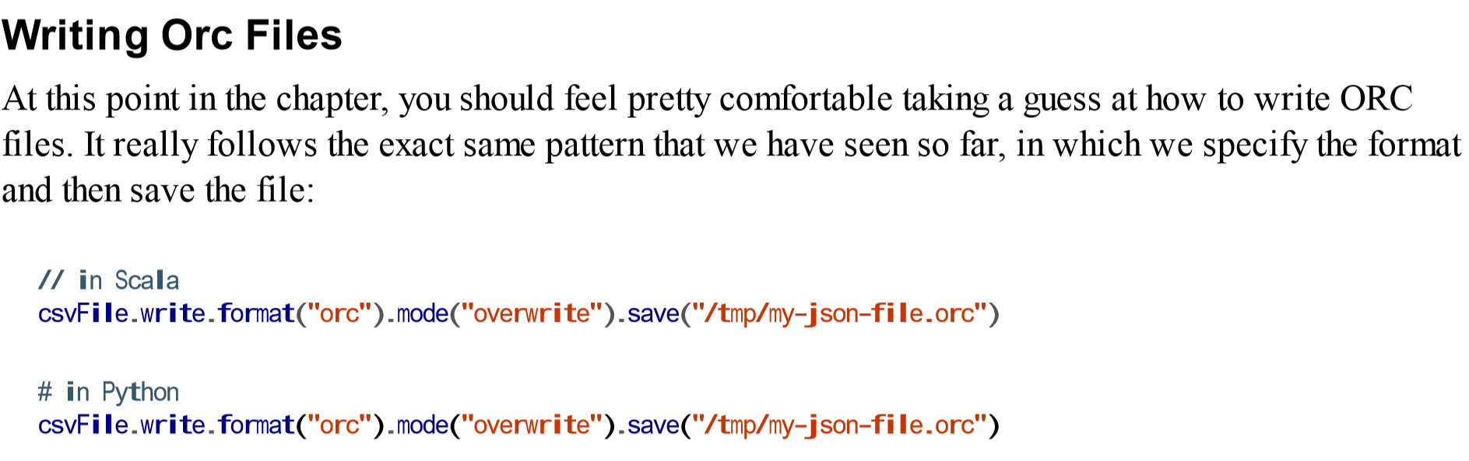

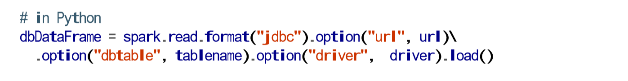

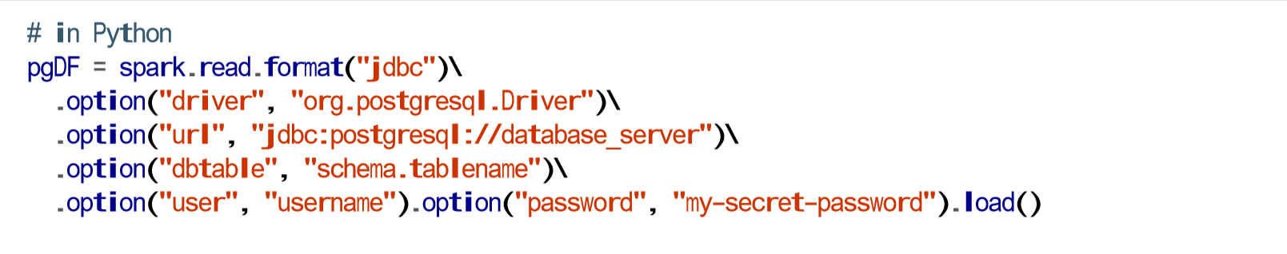

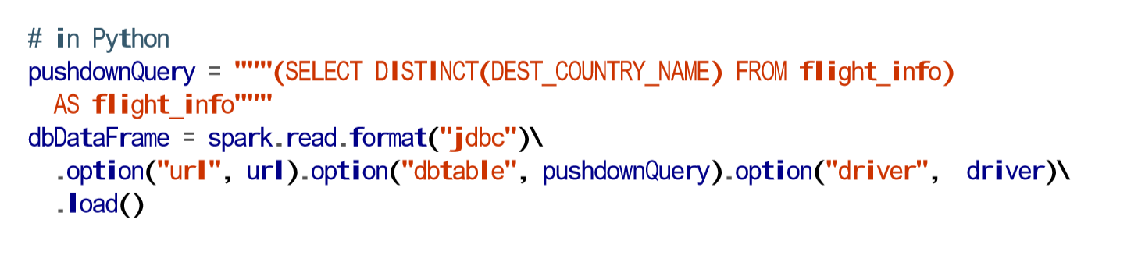

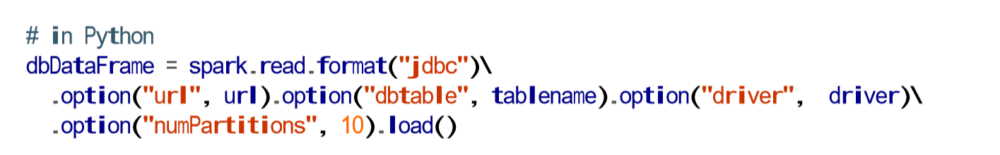

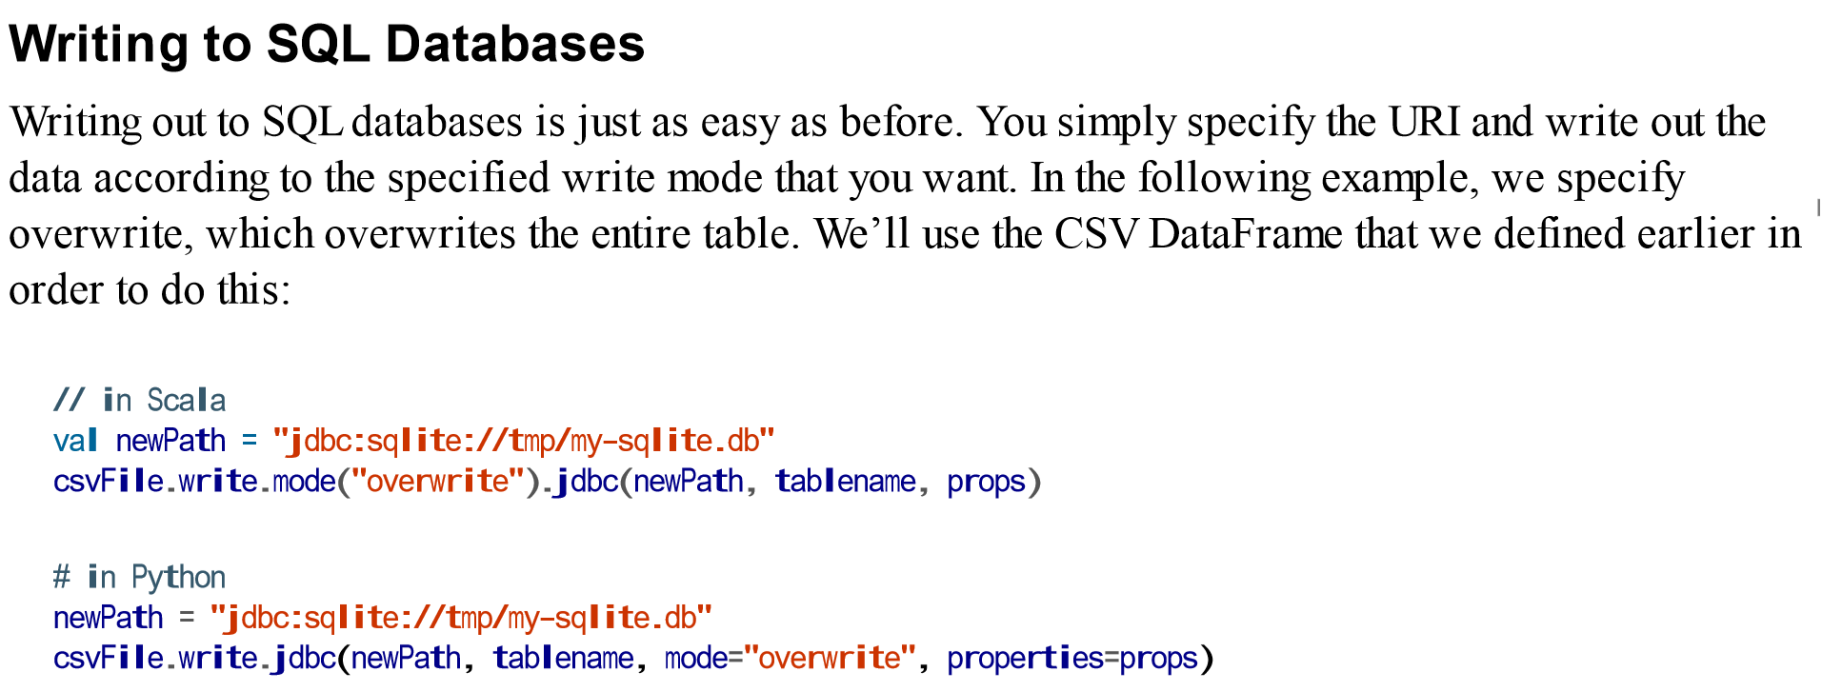

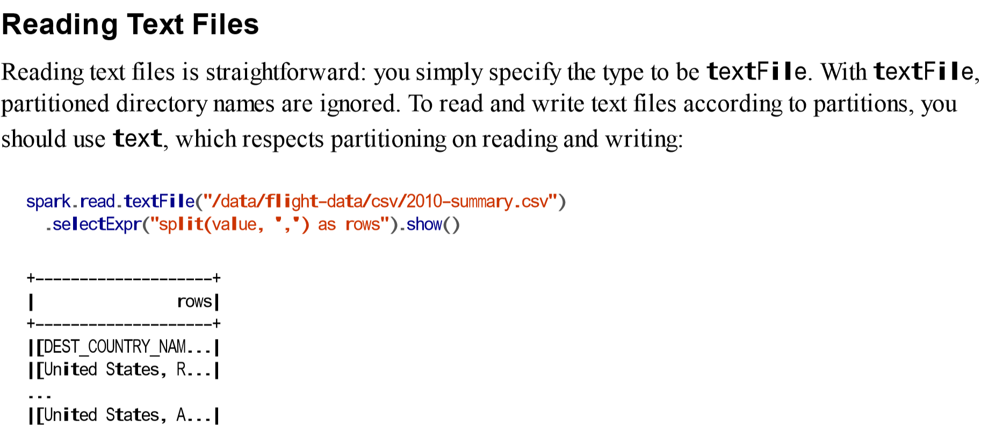

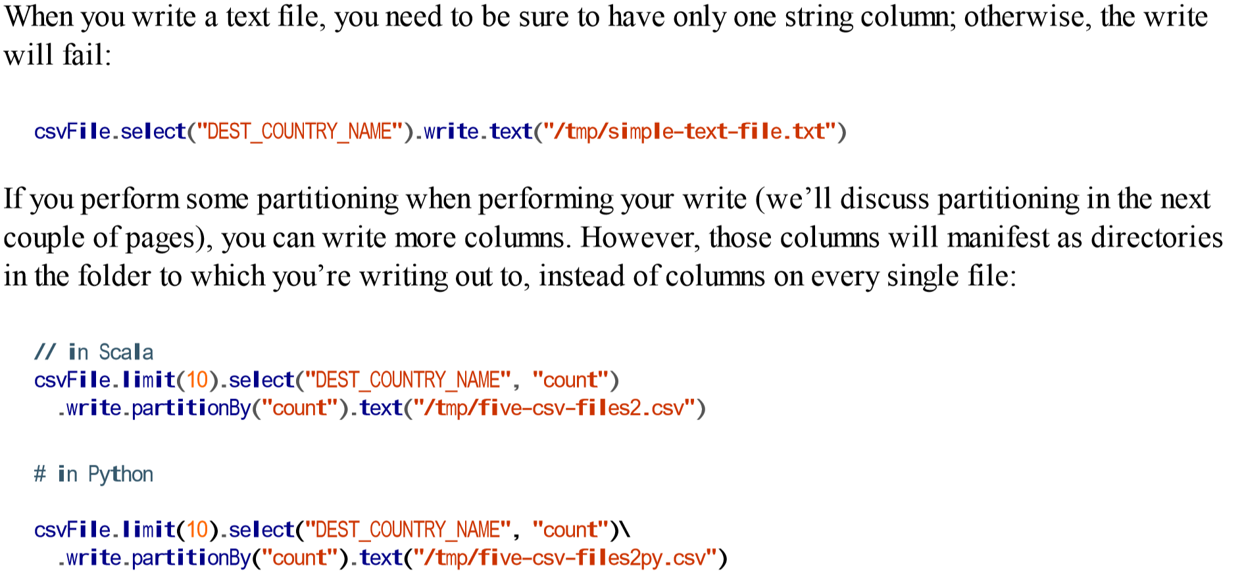

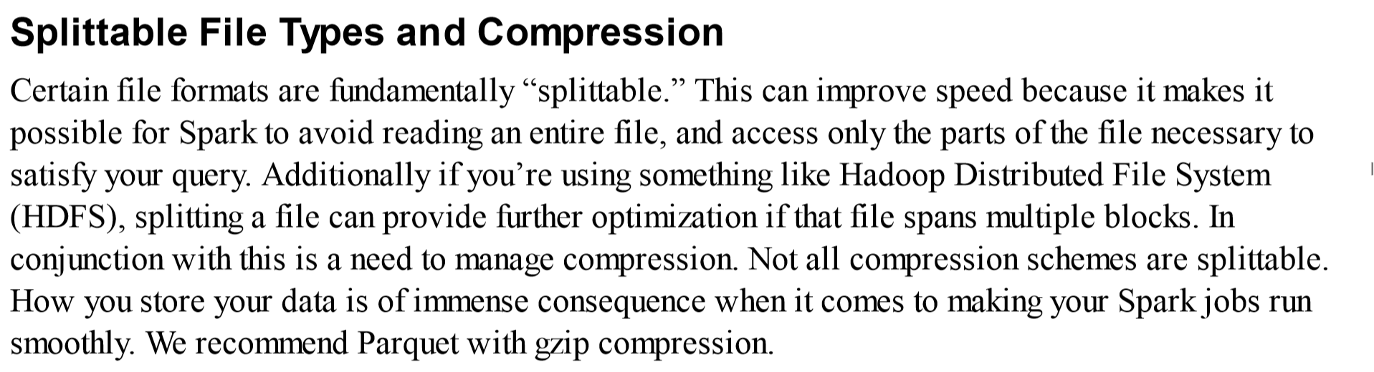

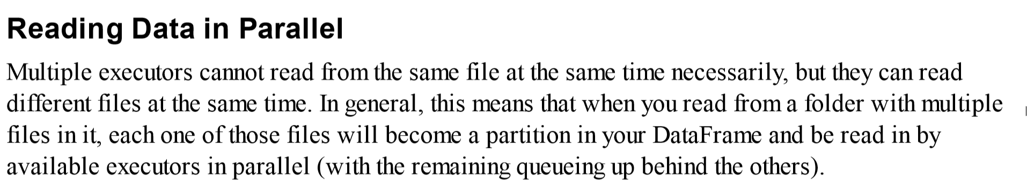

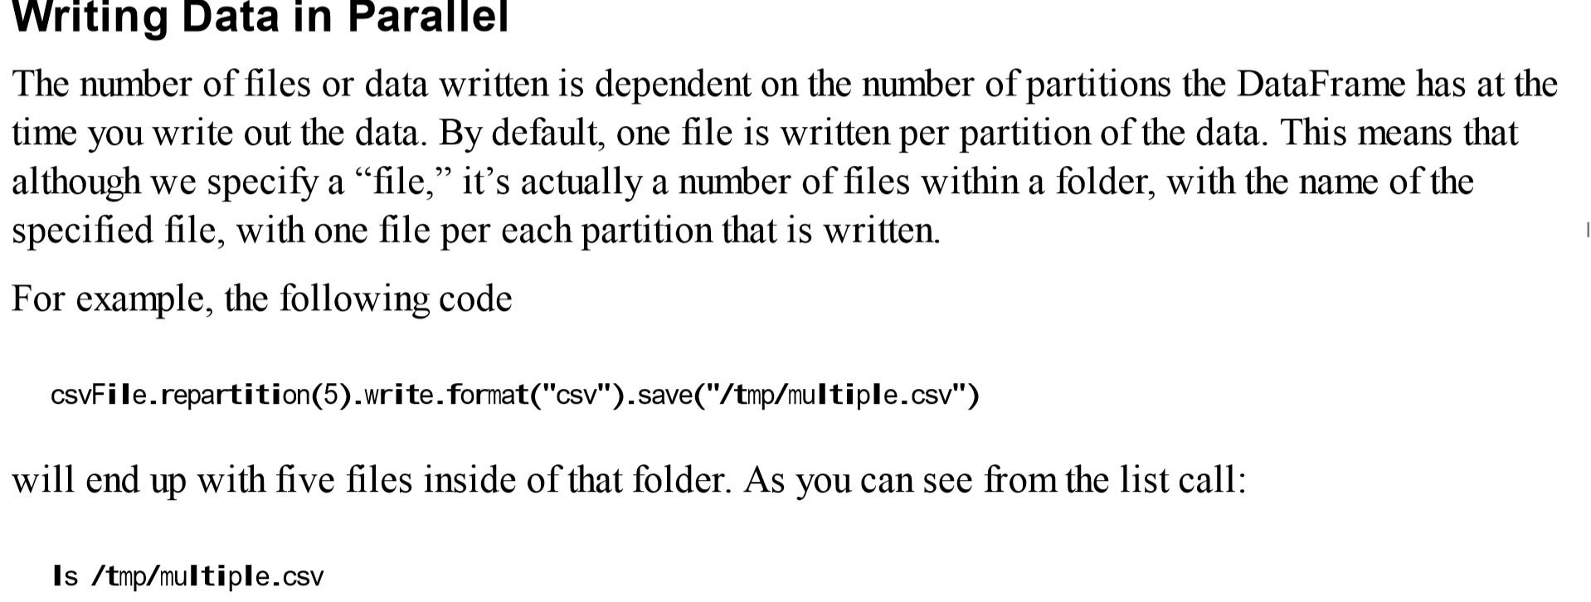

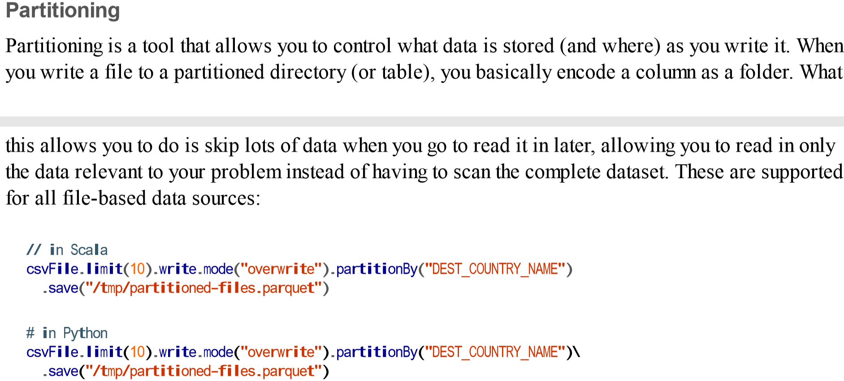

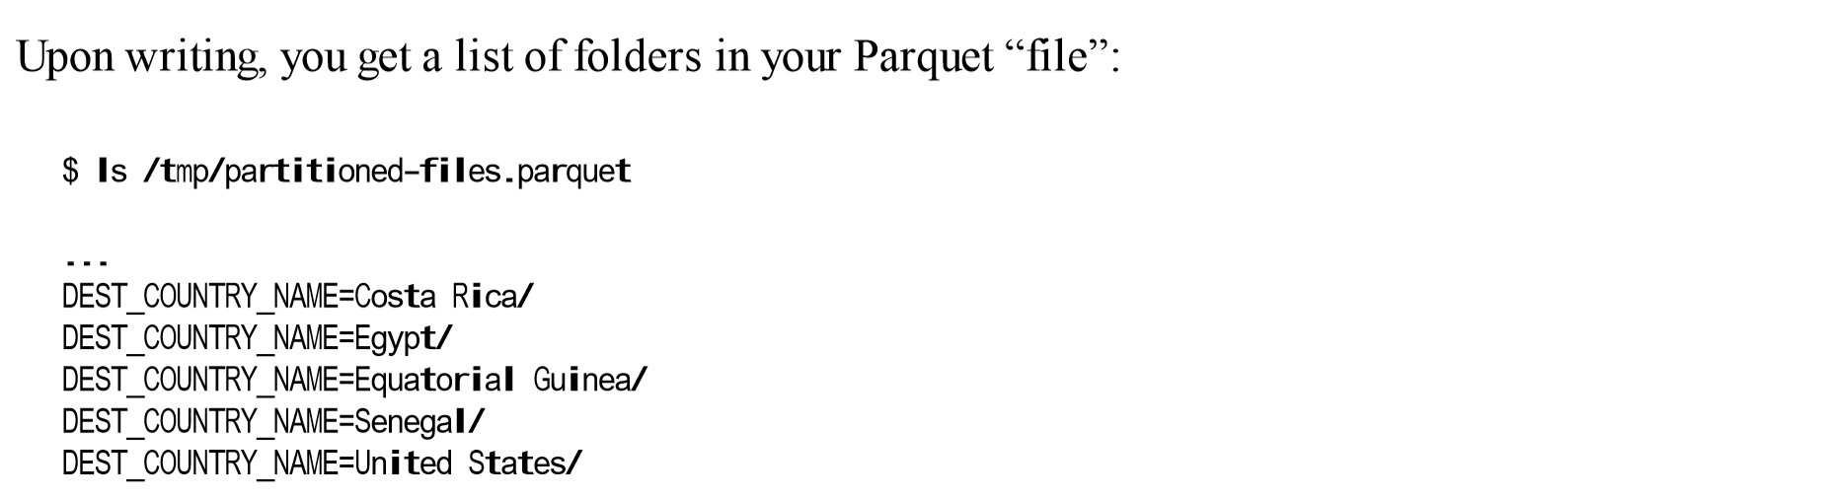

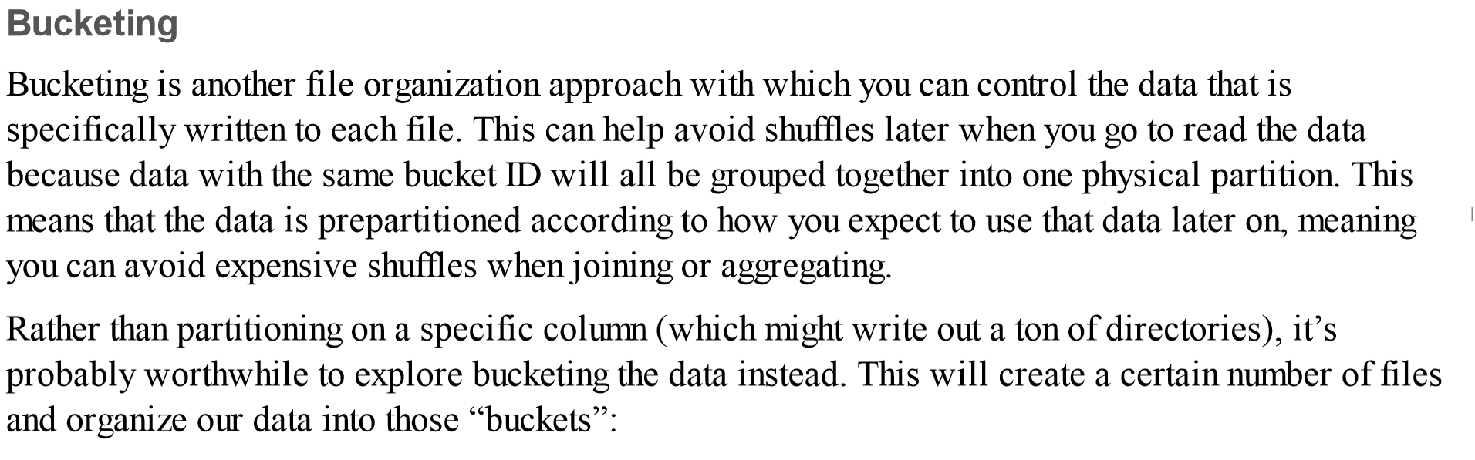

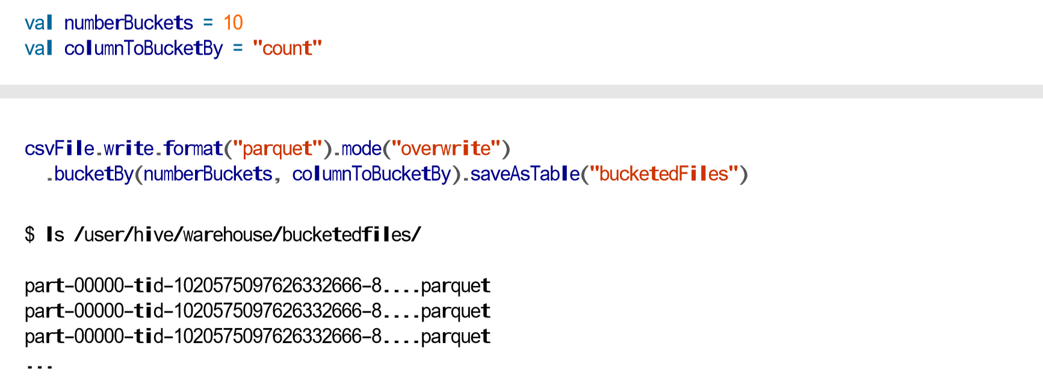

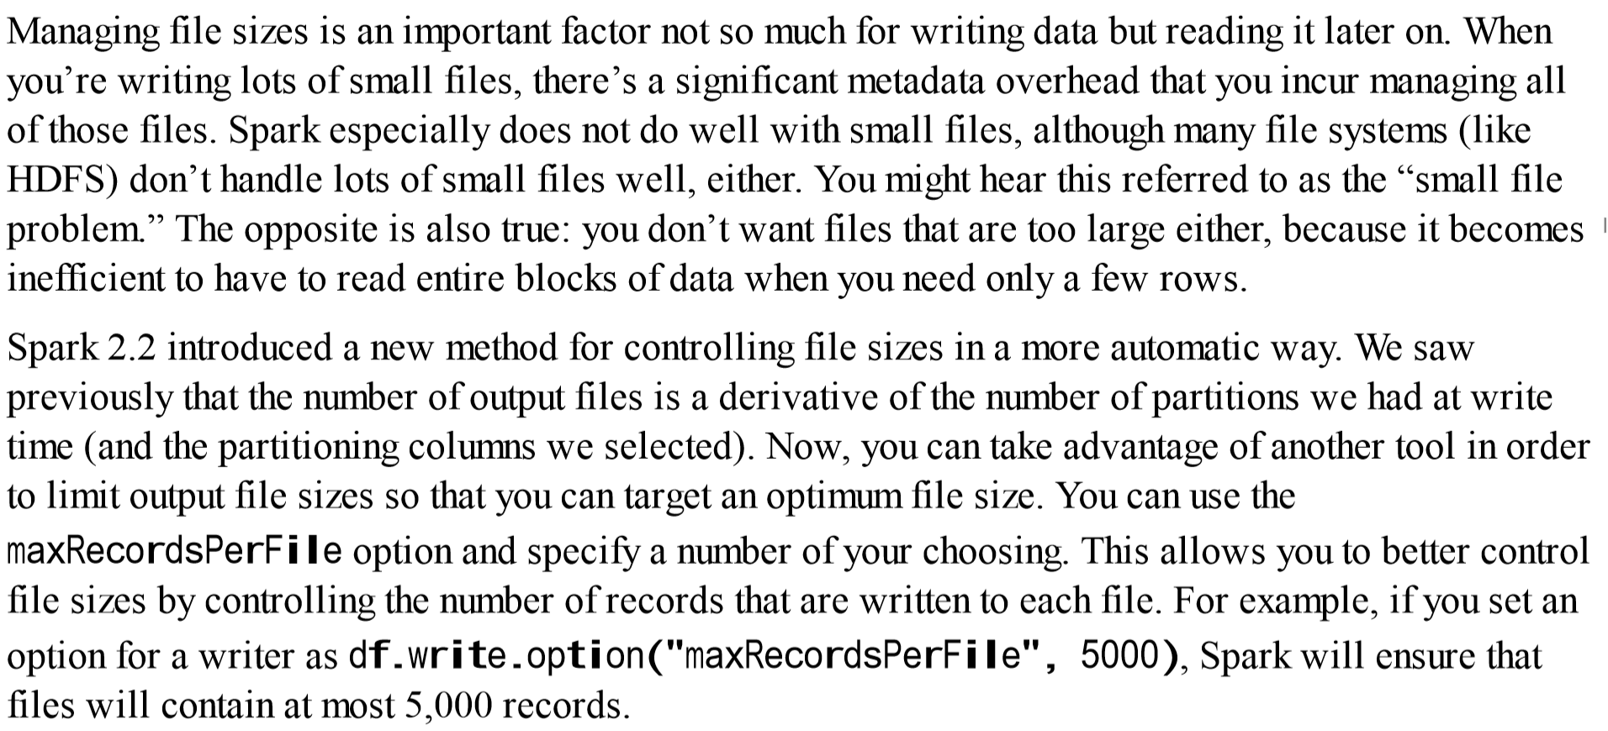

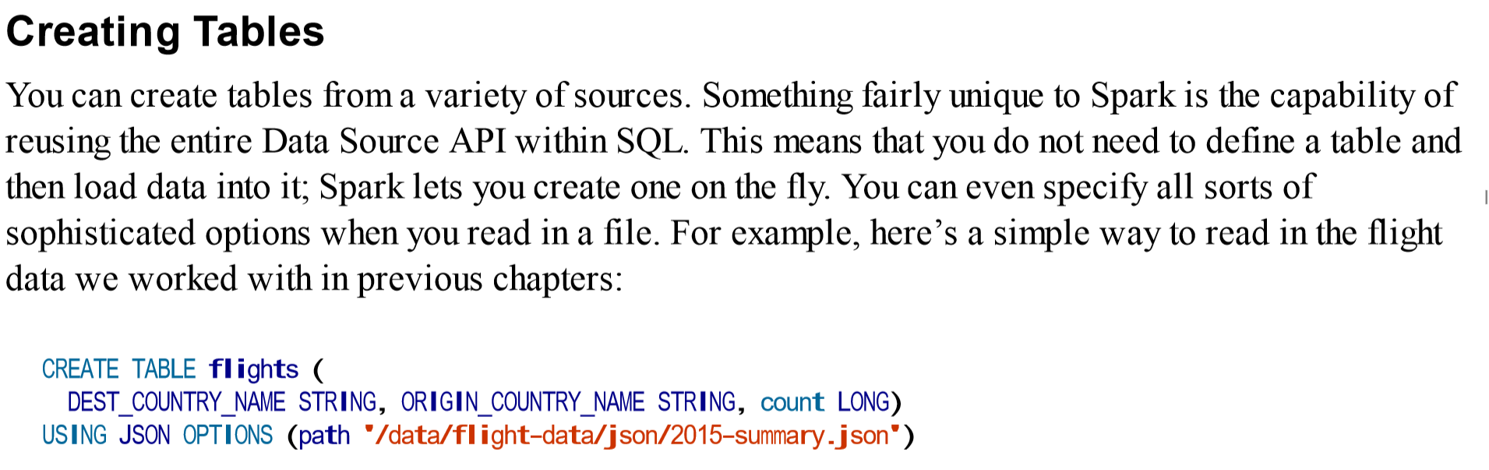

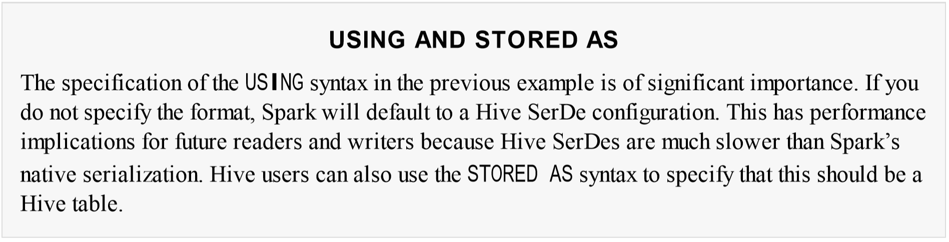

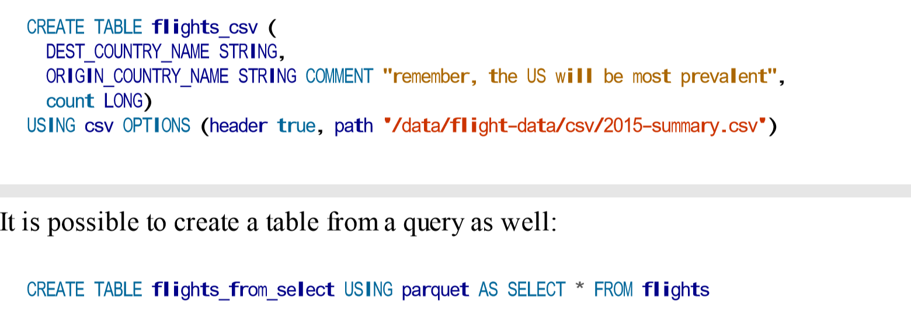

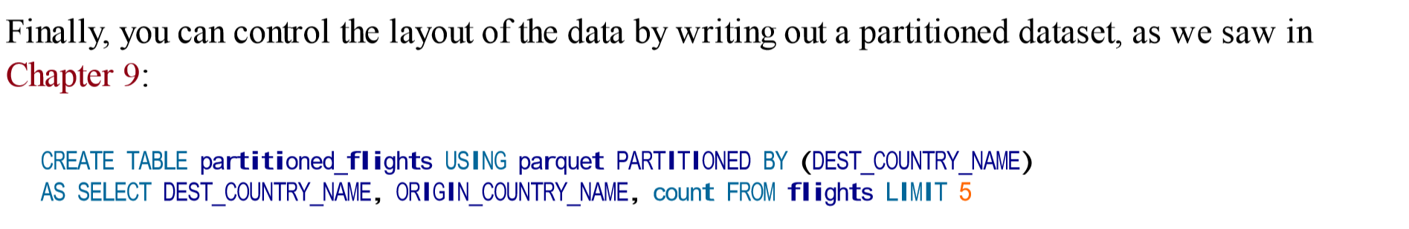

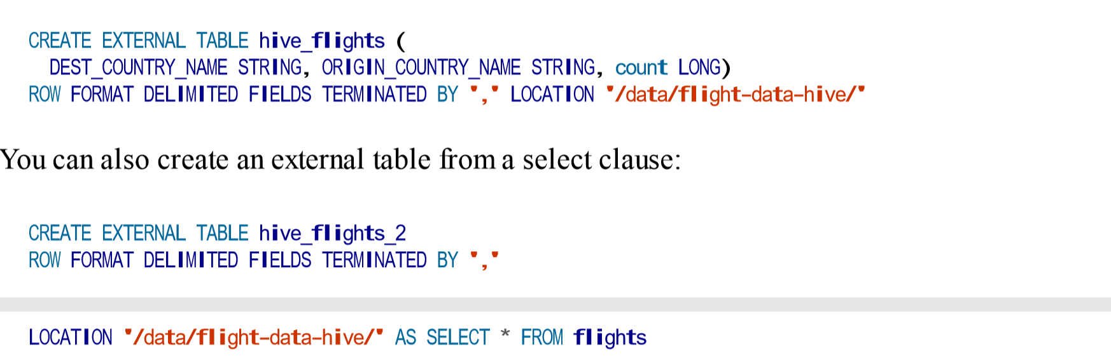

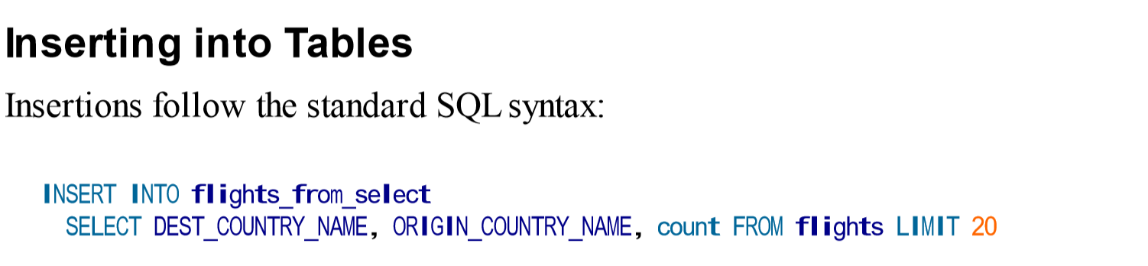

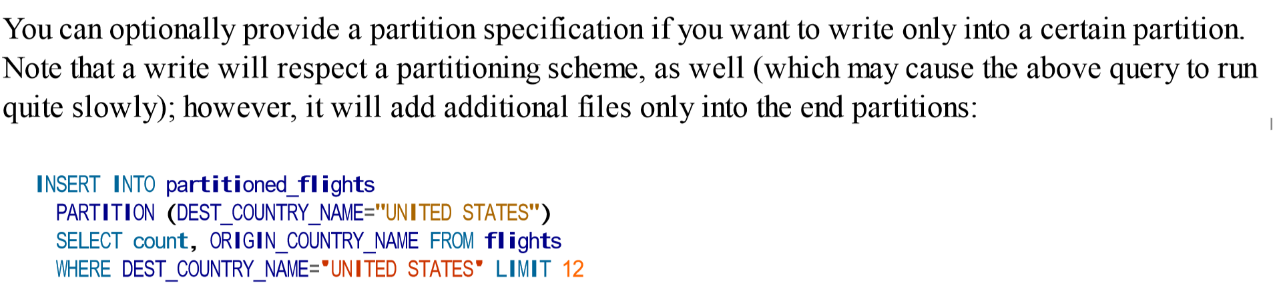

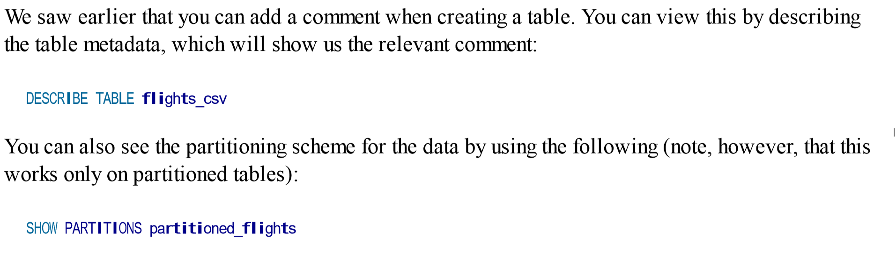

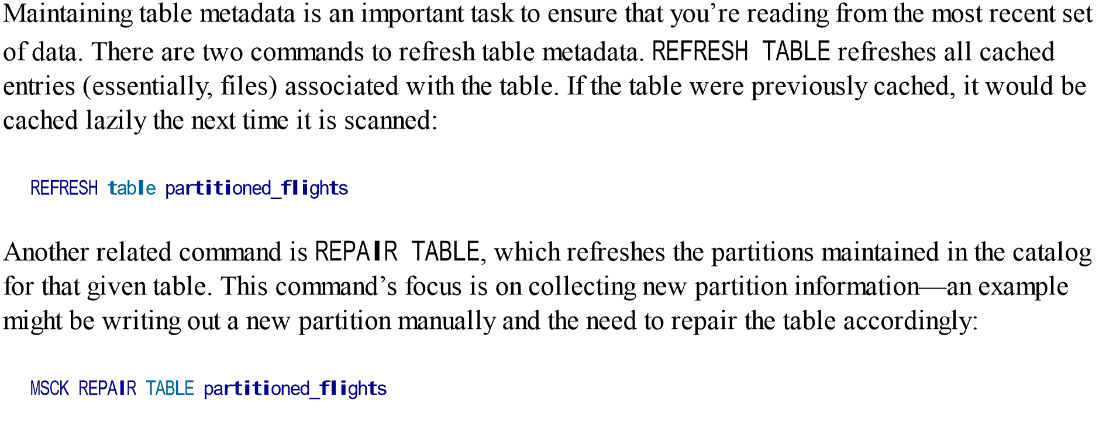

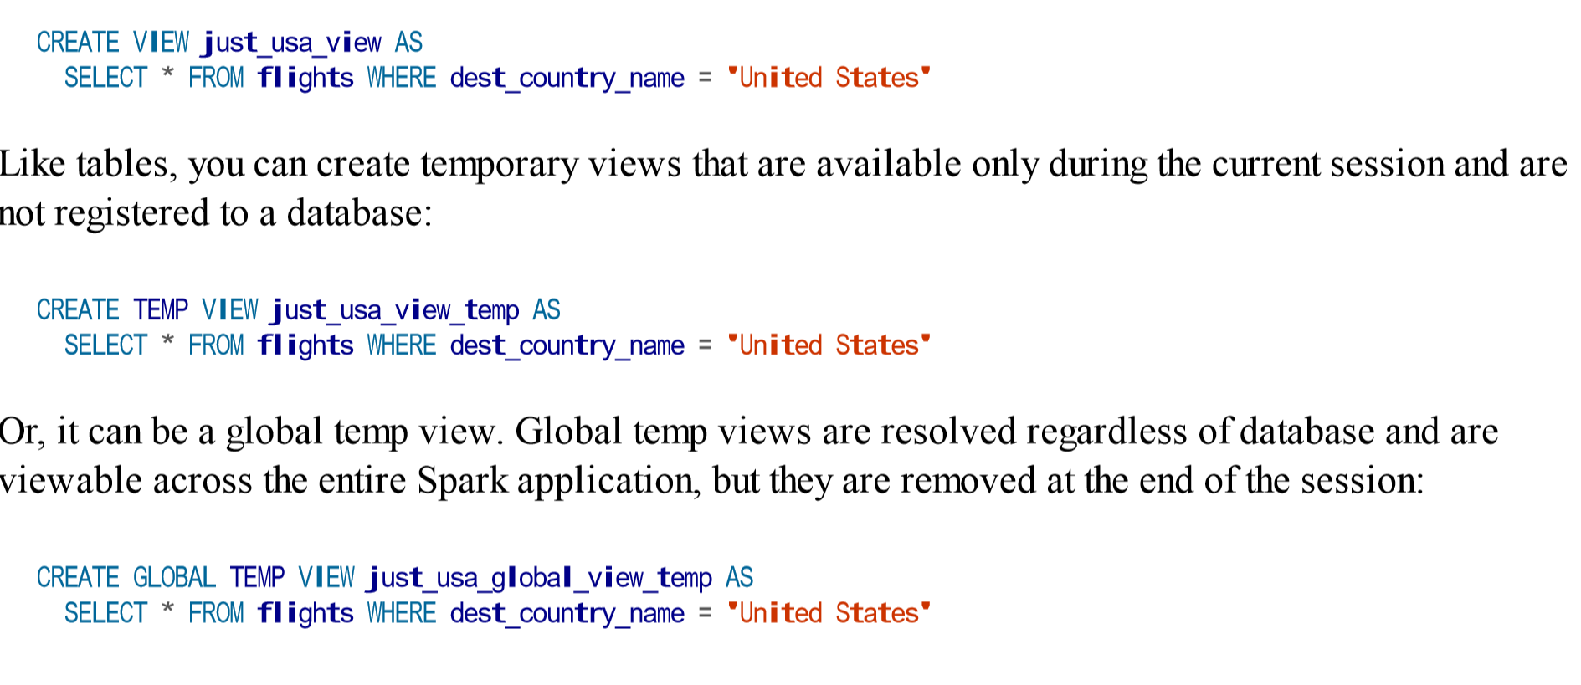

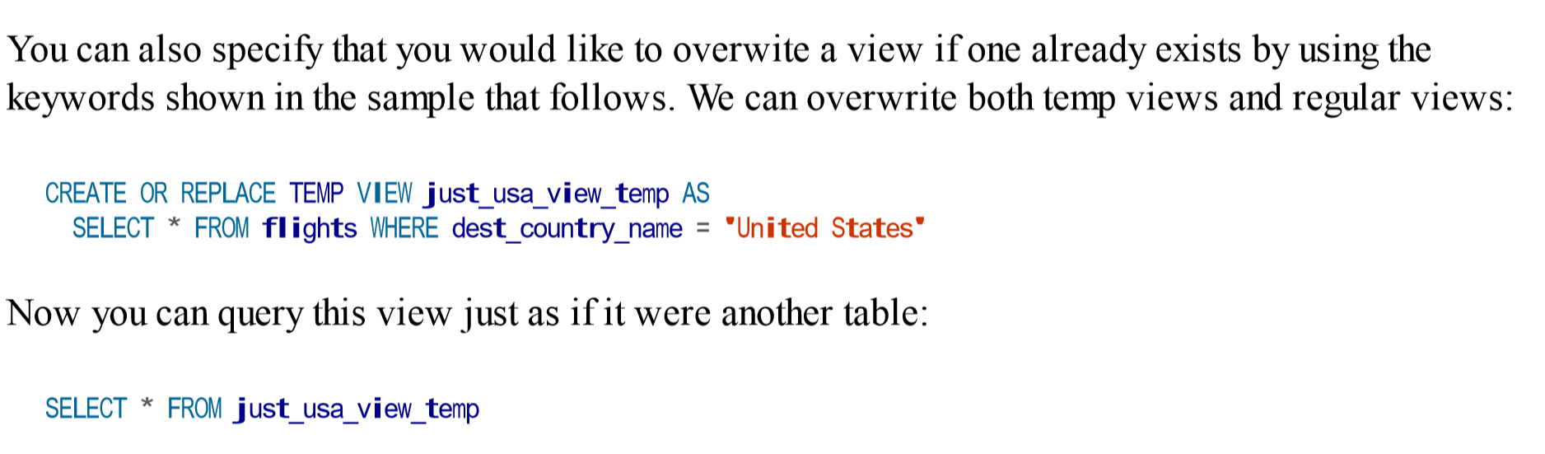



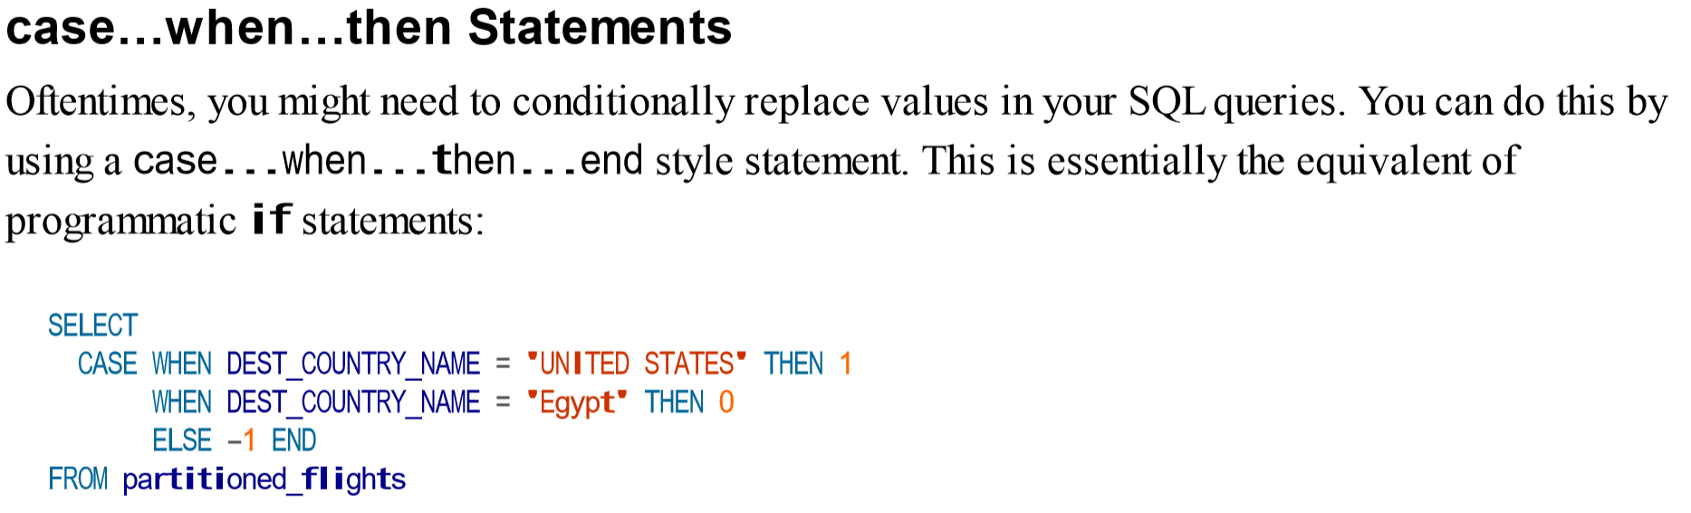

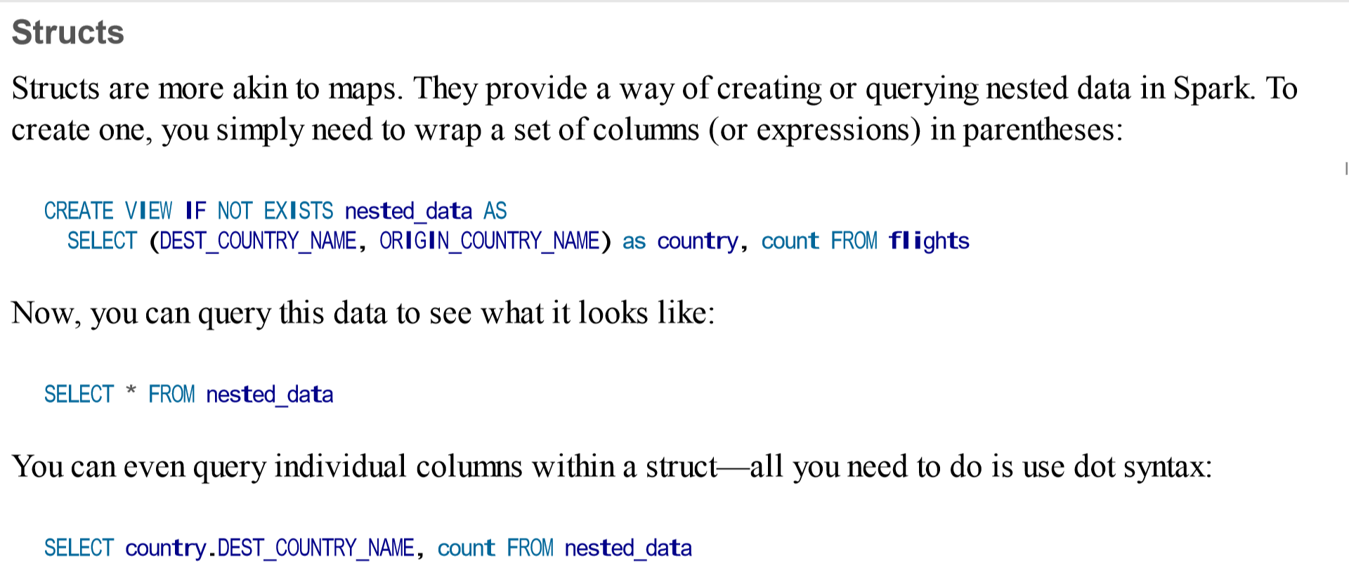

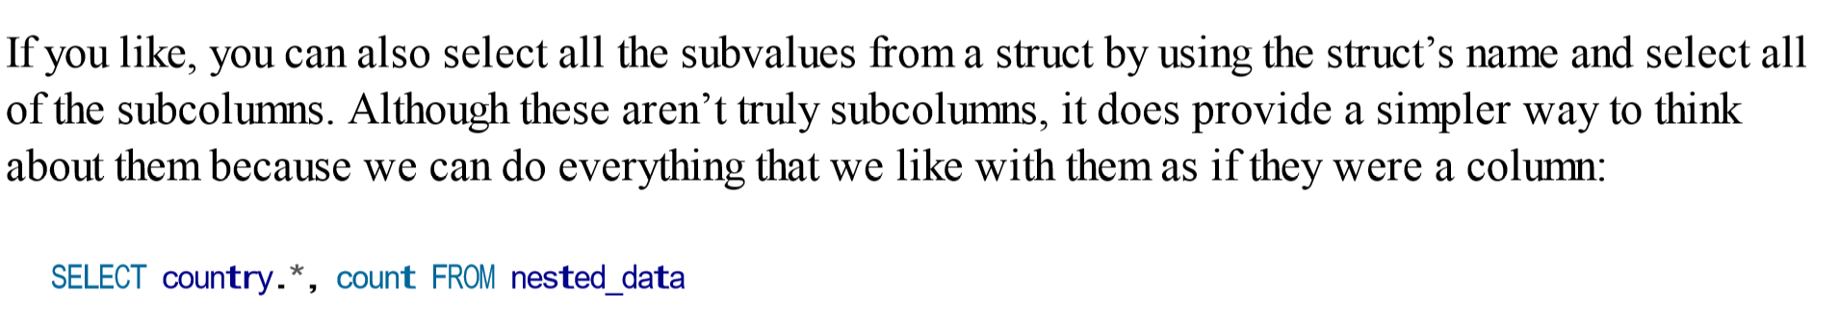

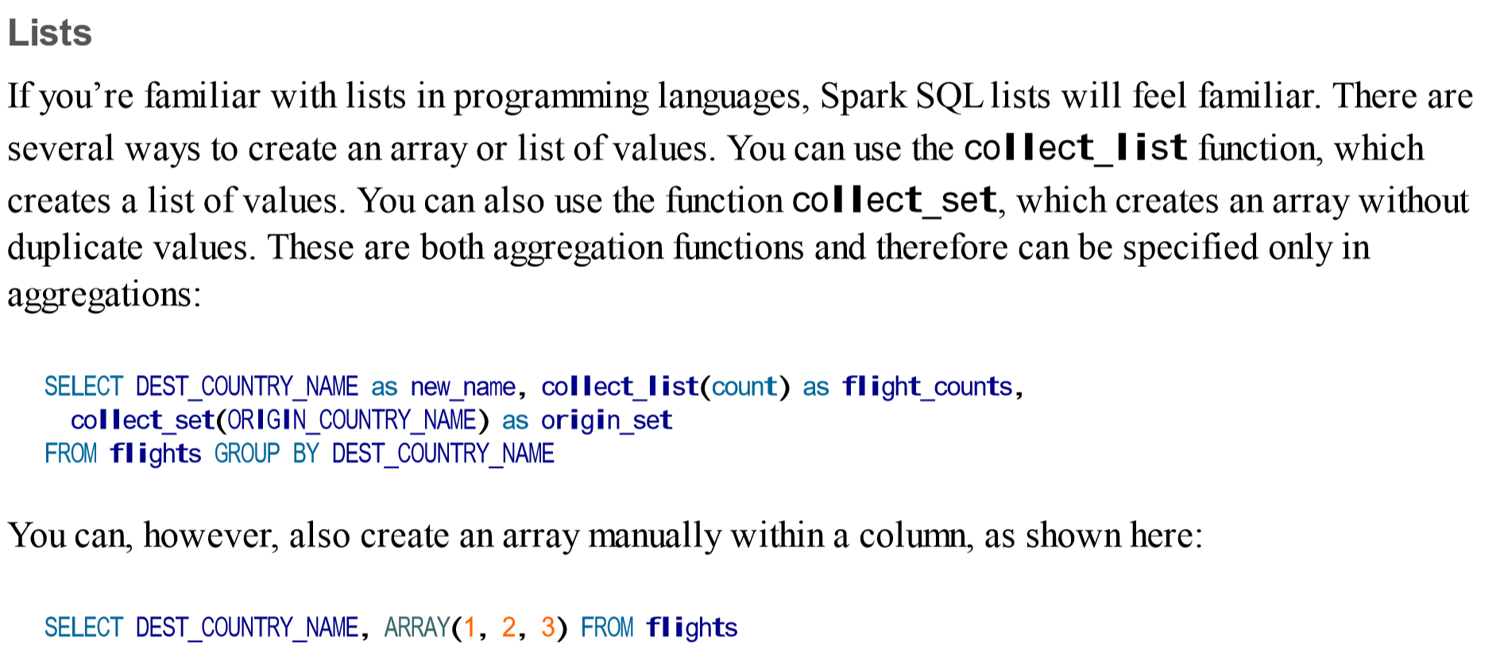

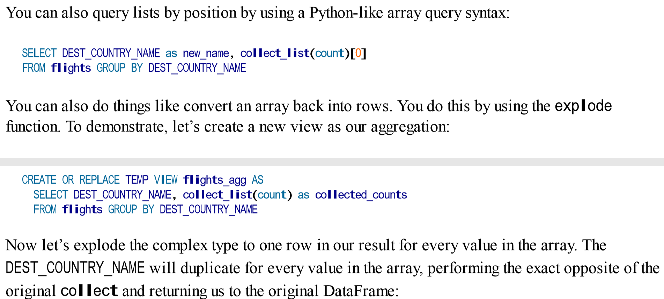



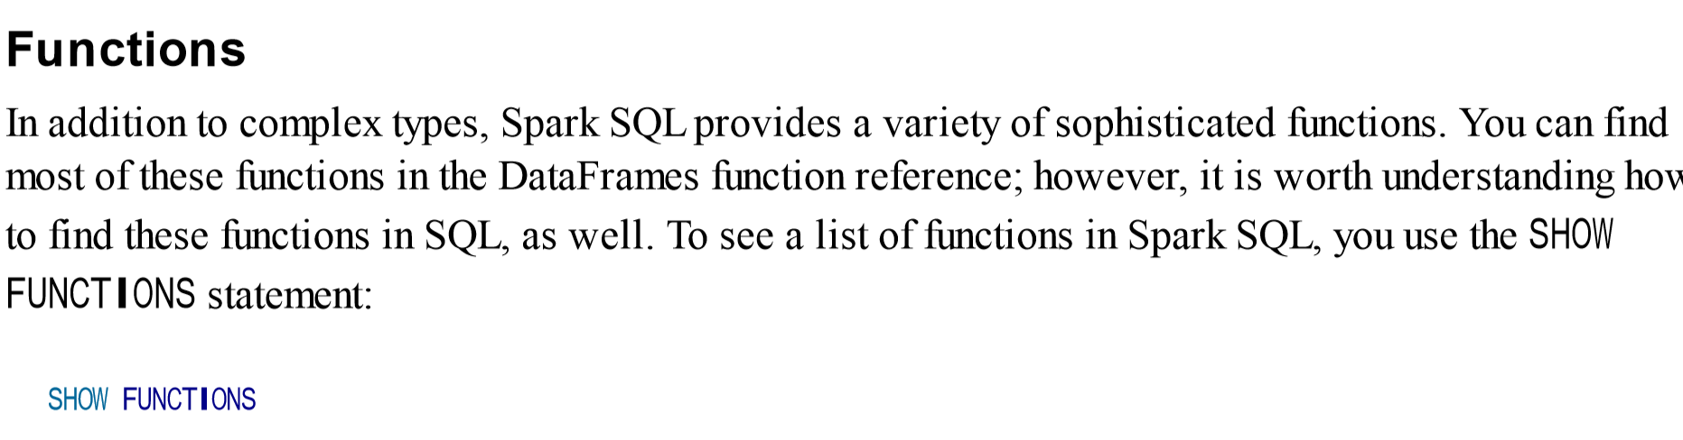

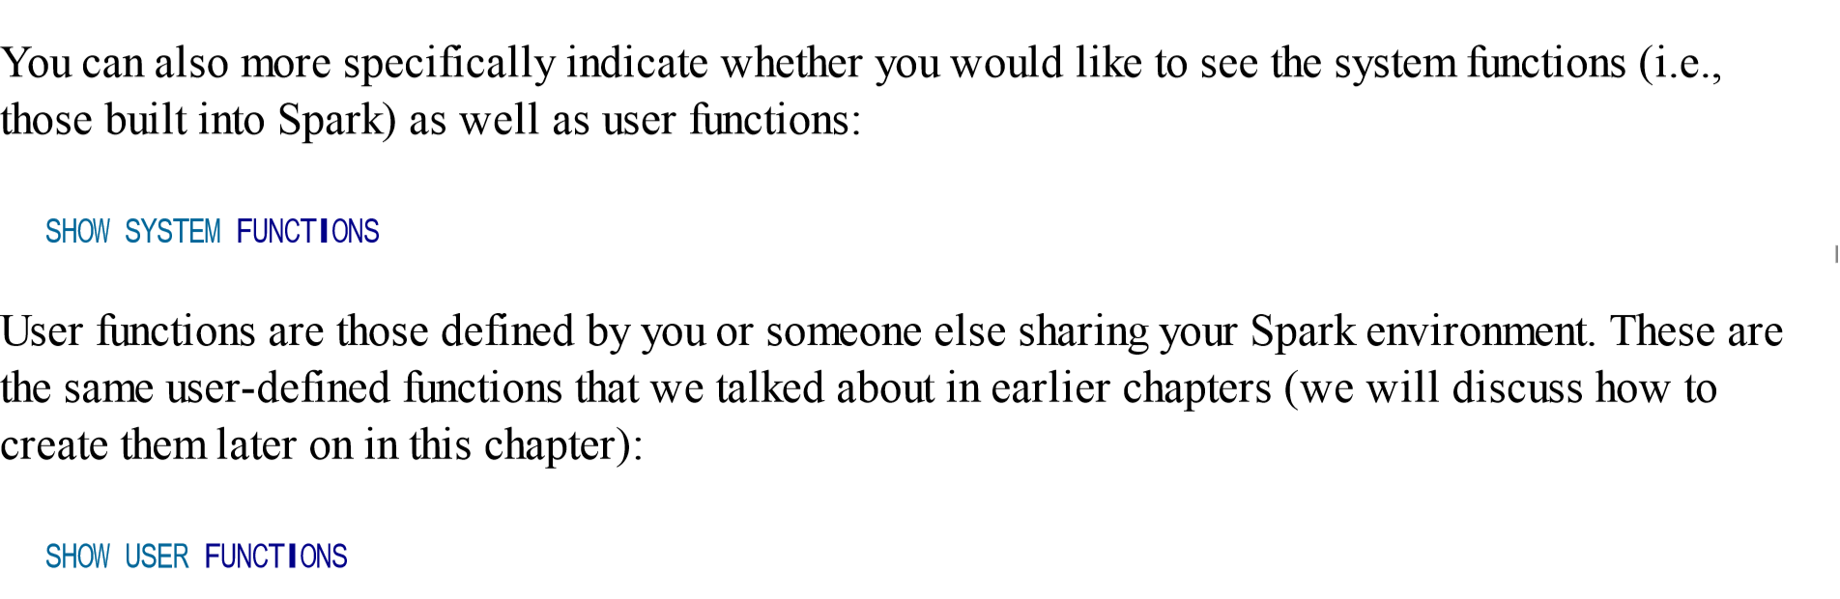

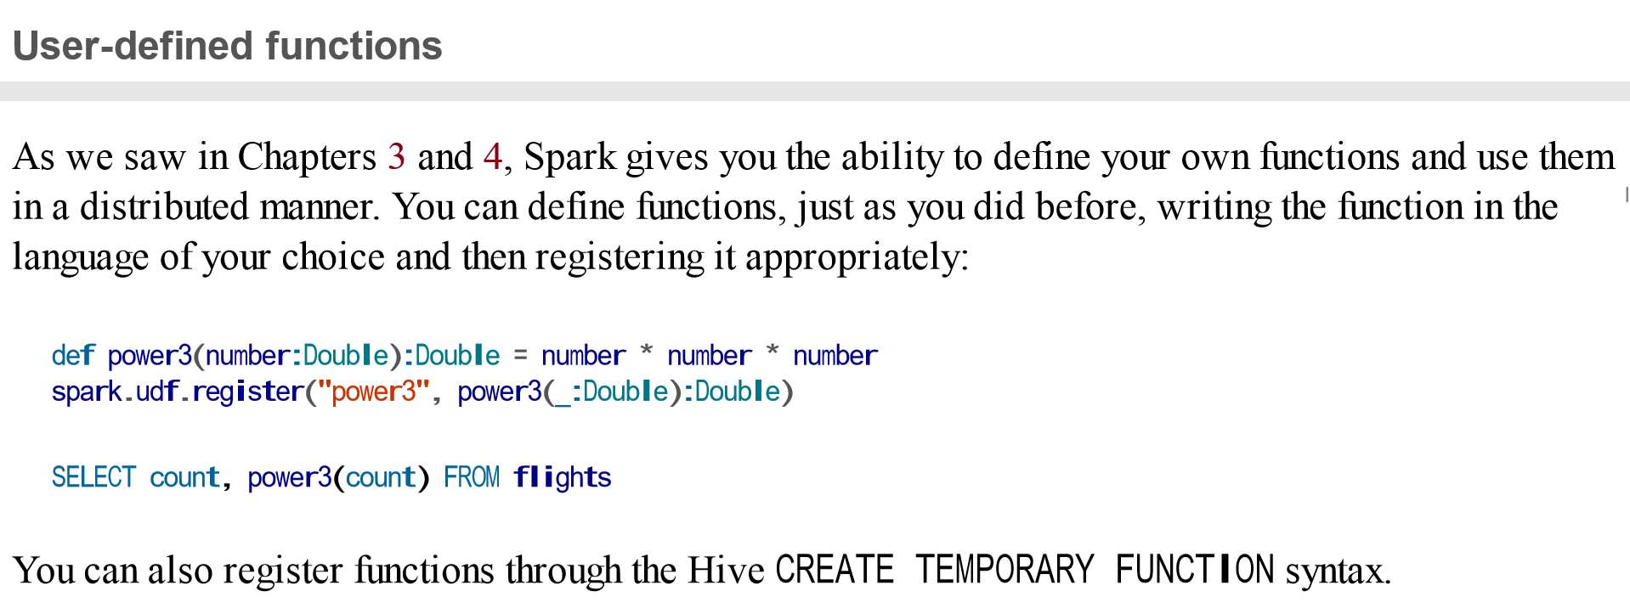

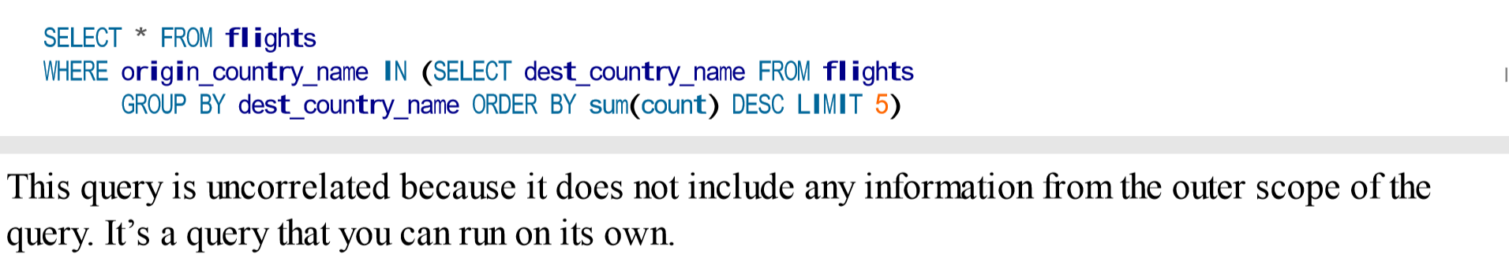

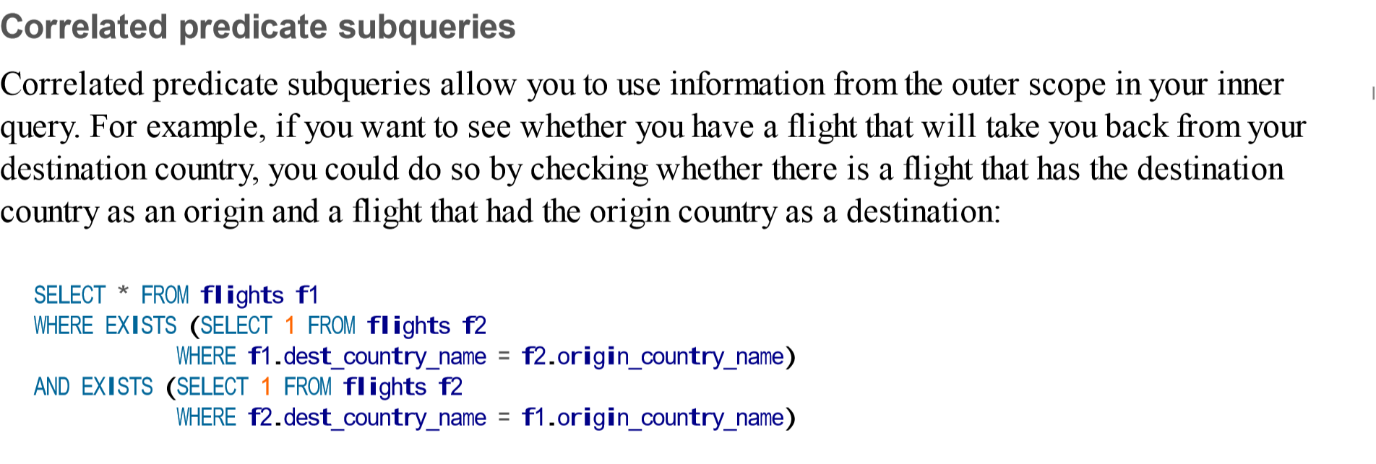

In short, an RDD represents an immutable, partitioned collection of records that can be operated on in parallel. Unlike DataFrames though, where each record is a structured row containing fields with a known schema, in RDDs the records are just Java, Scala, or Python objects of the programmer’s choosing.

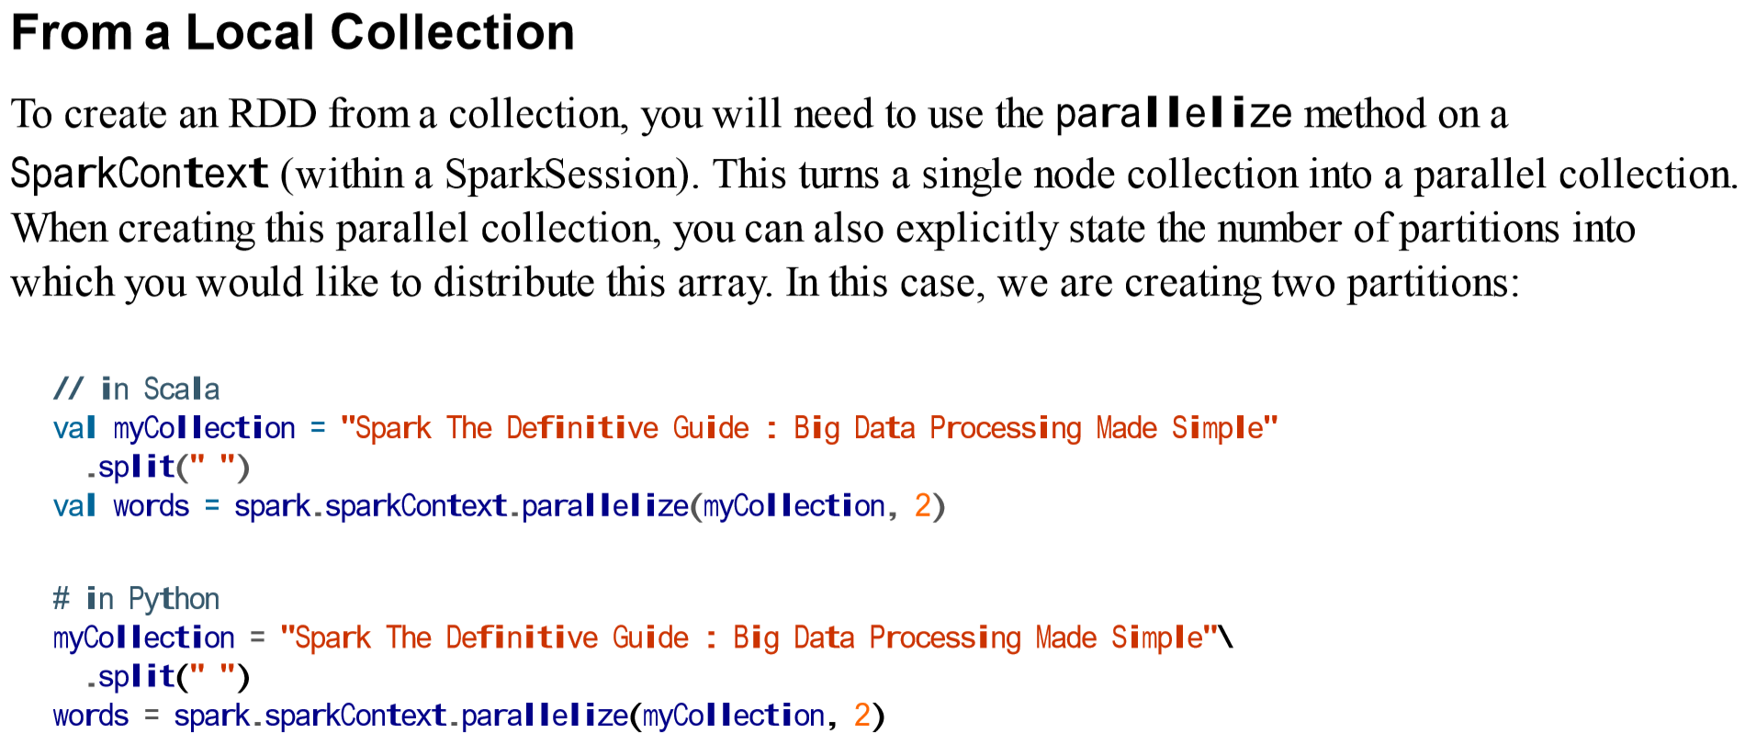

Course

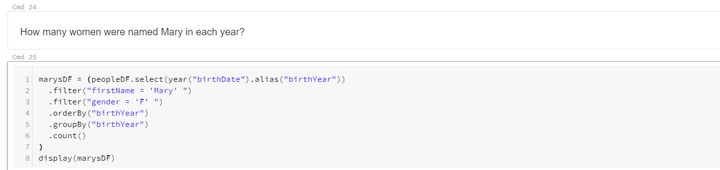

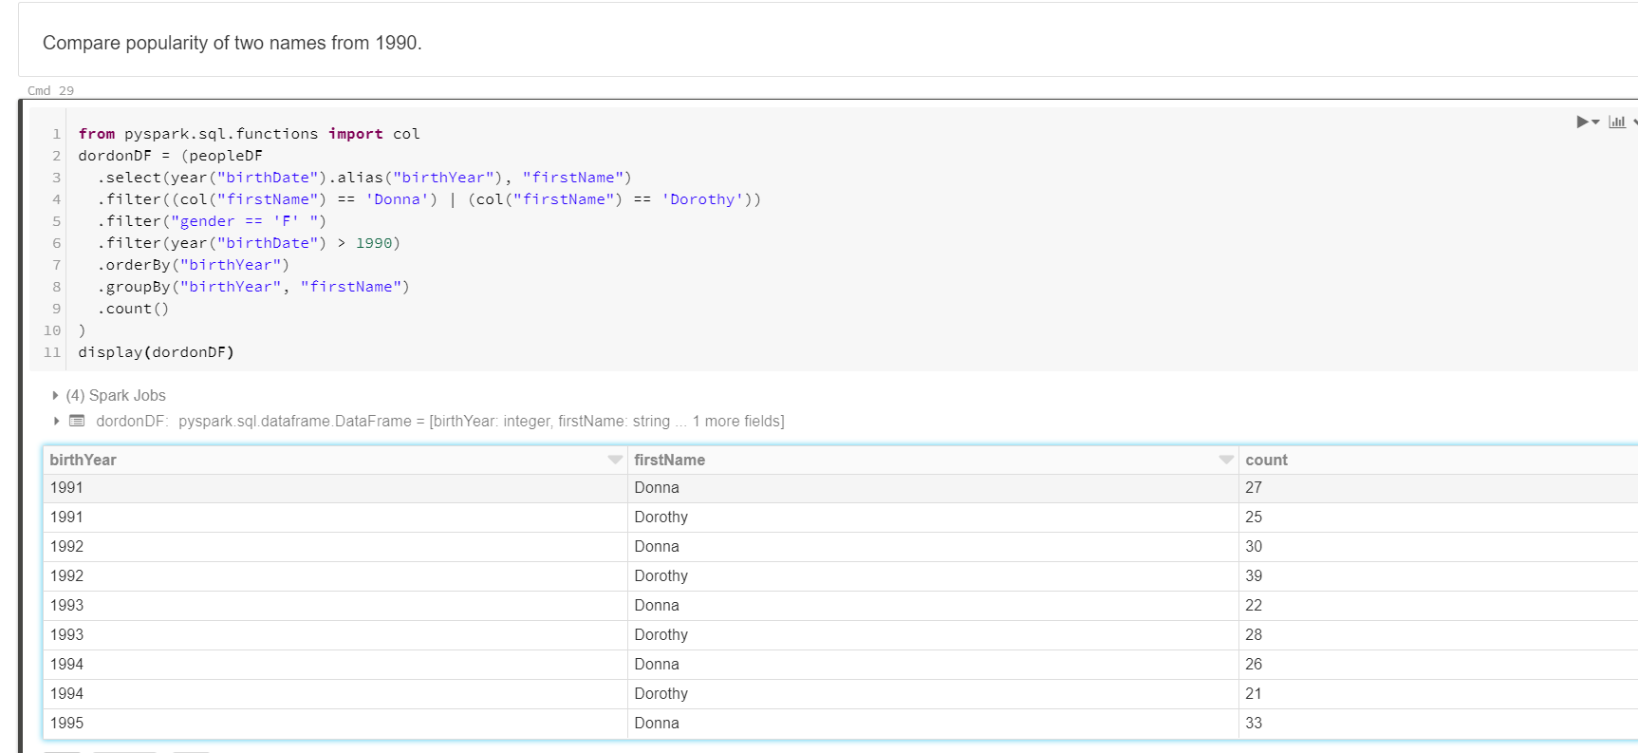

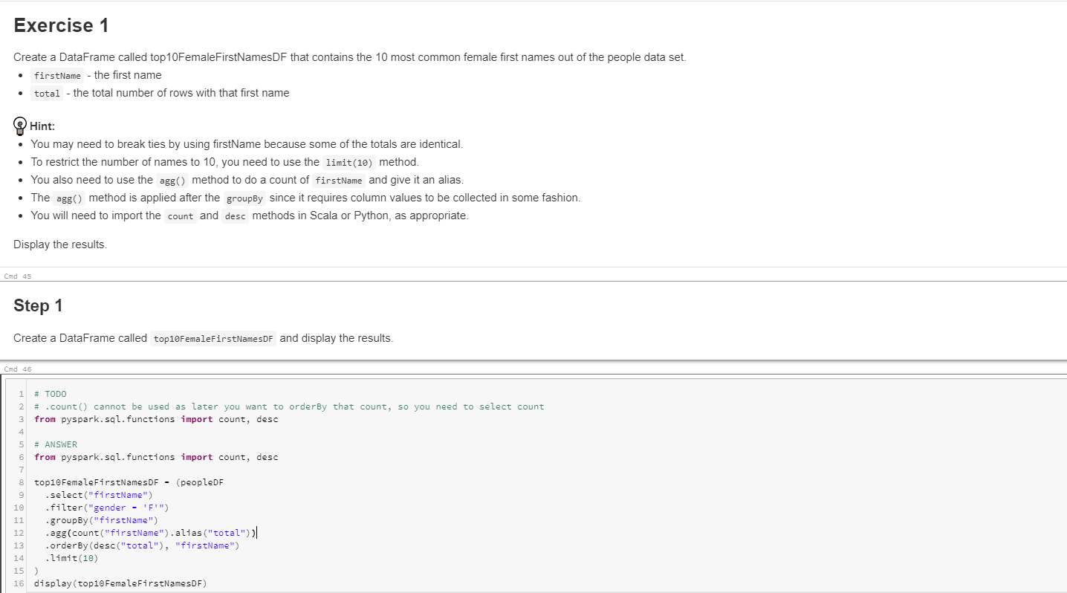

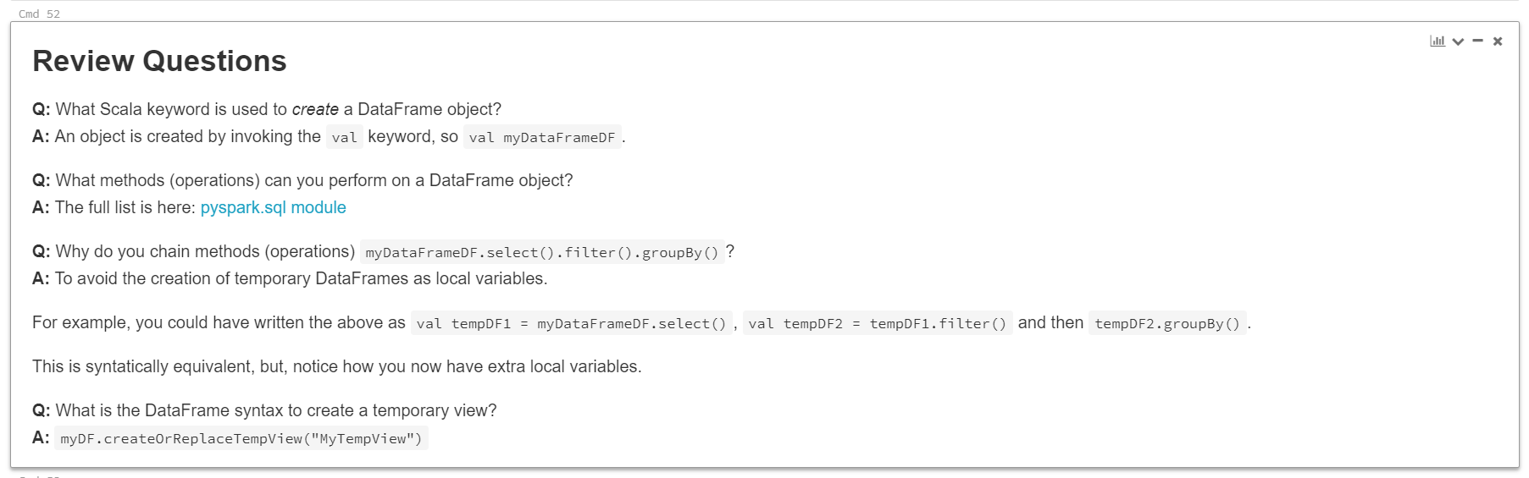

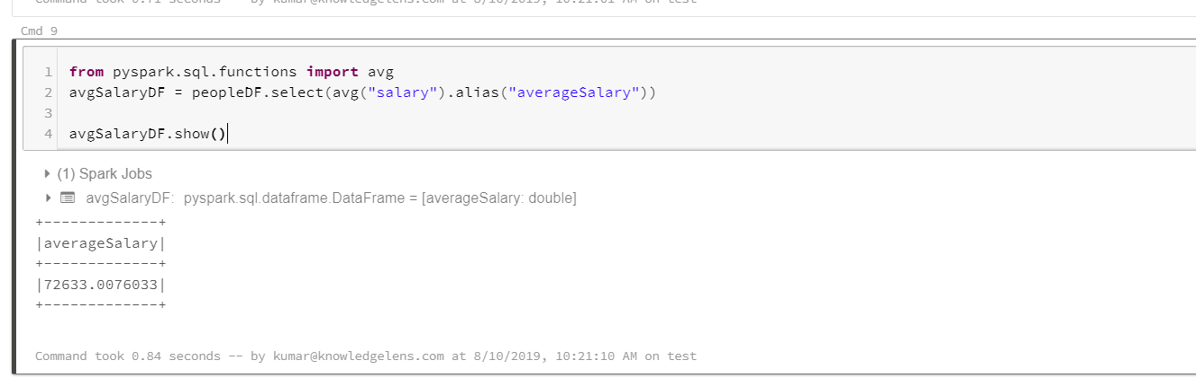

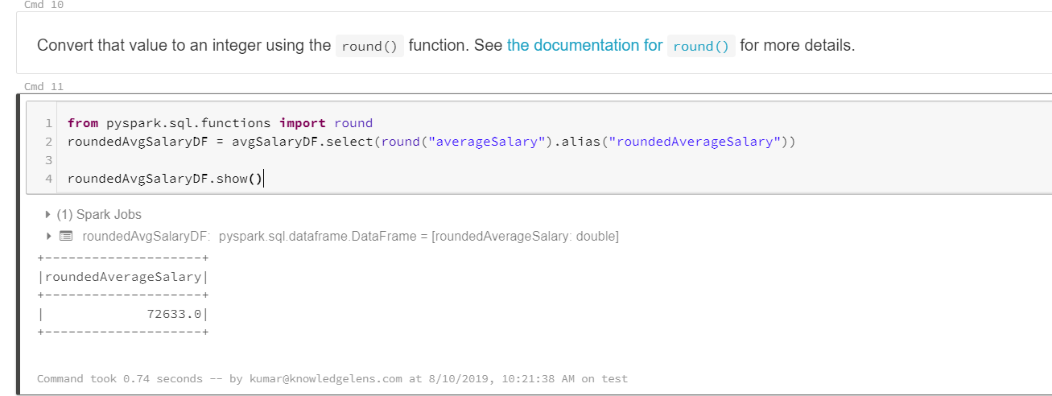

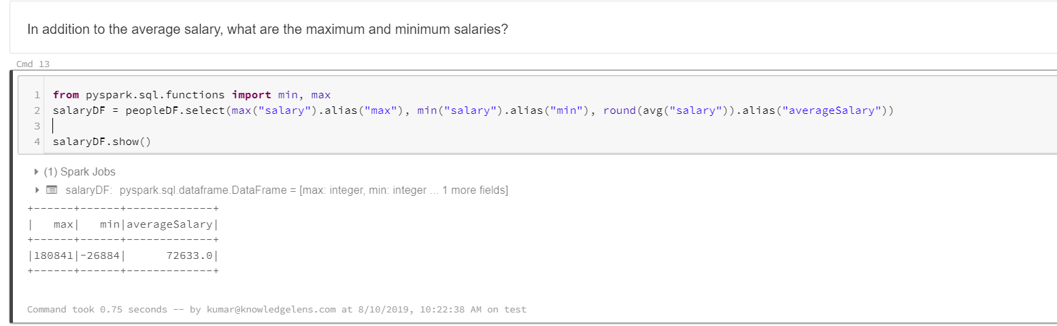

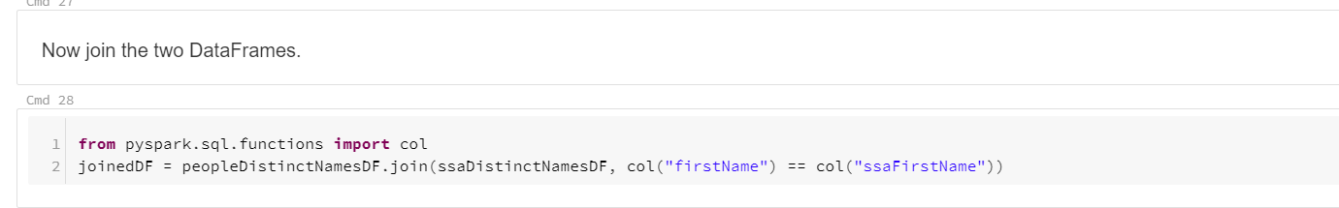

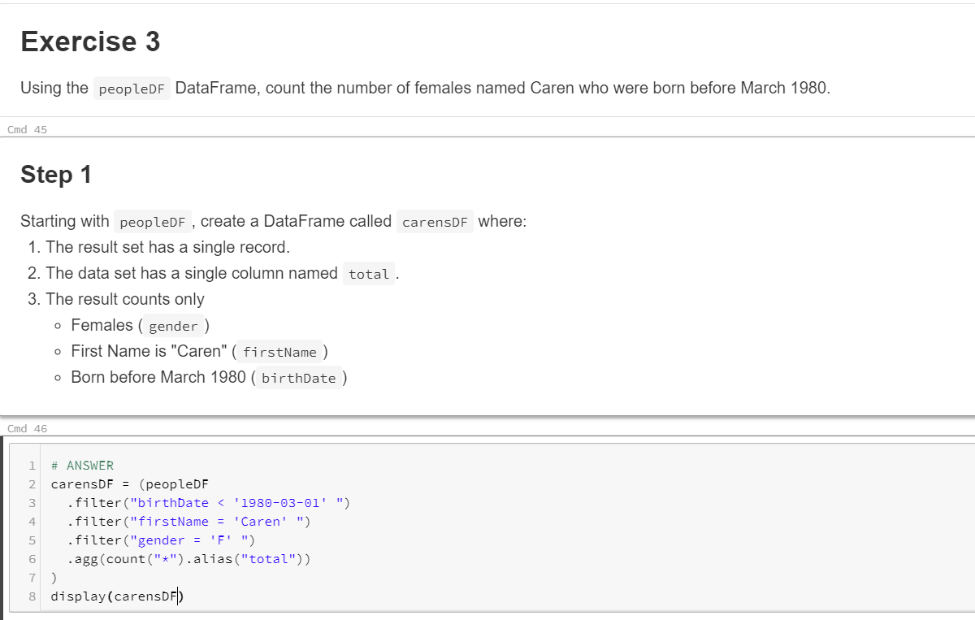

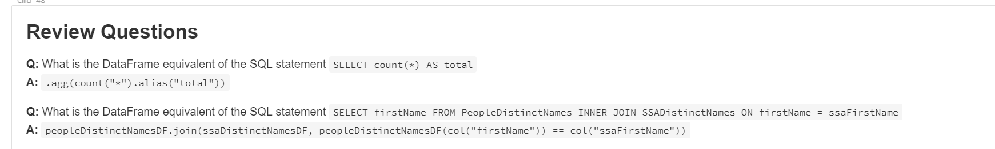

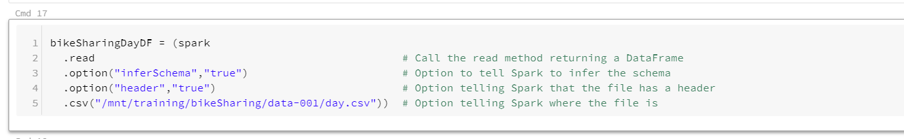

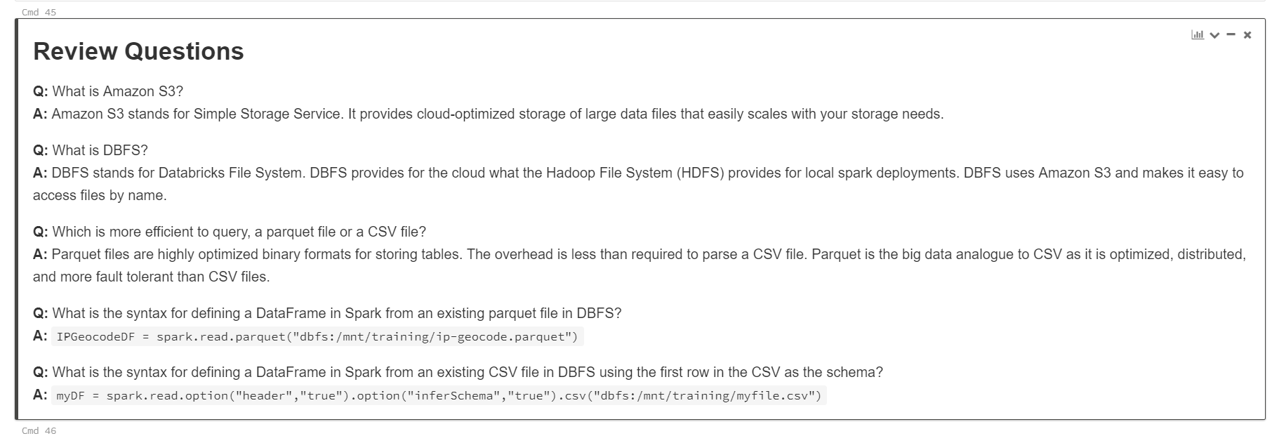

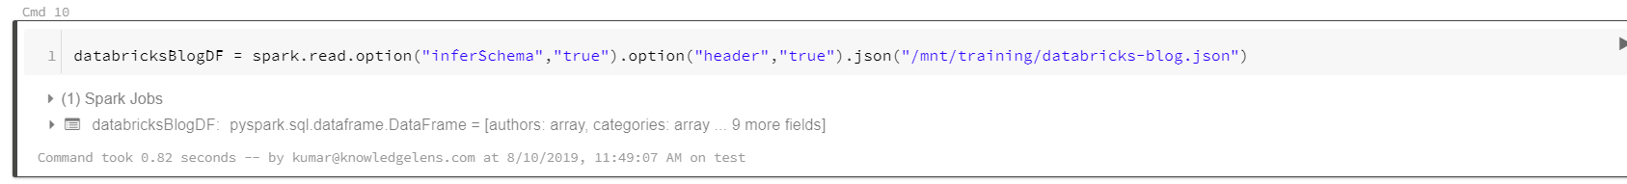

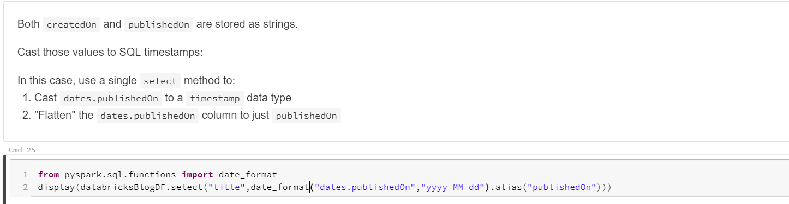

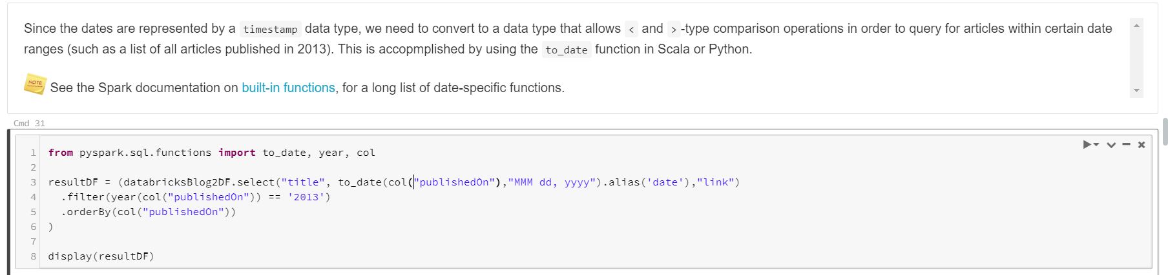

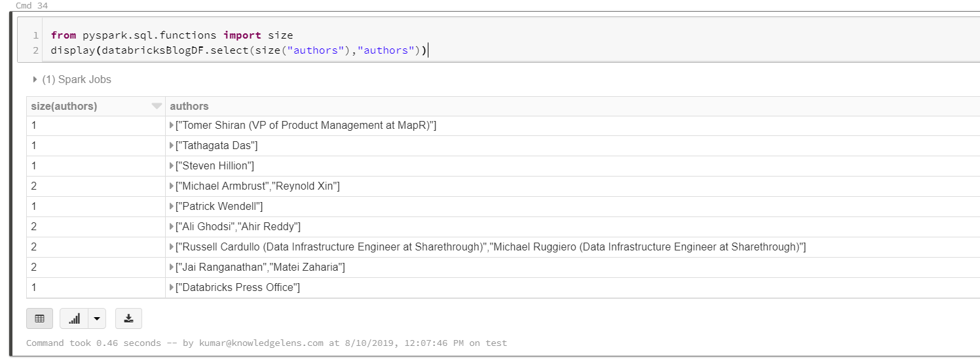

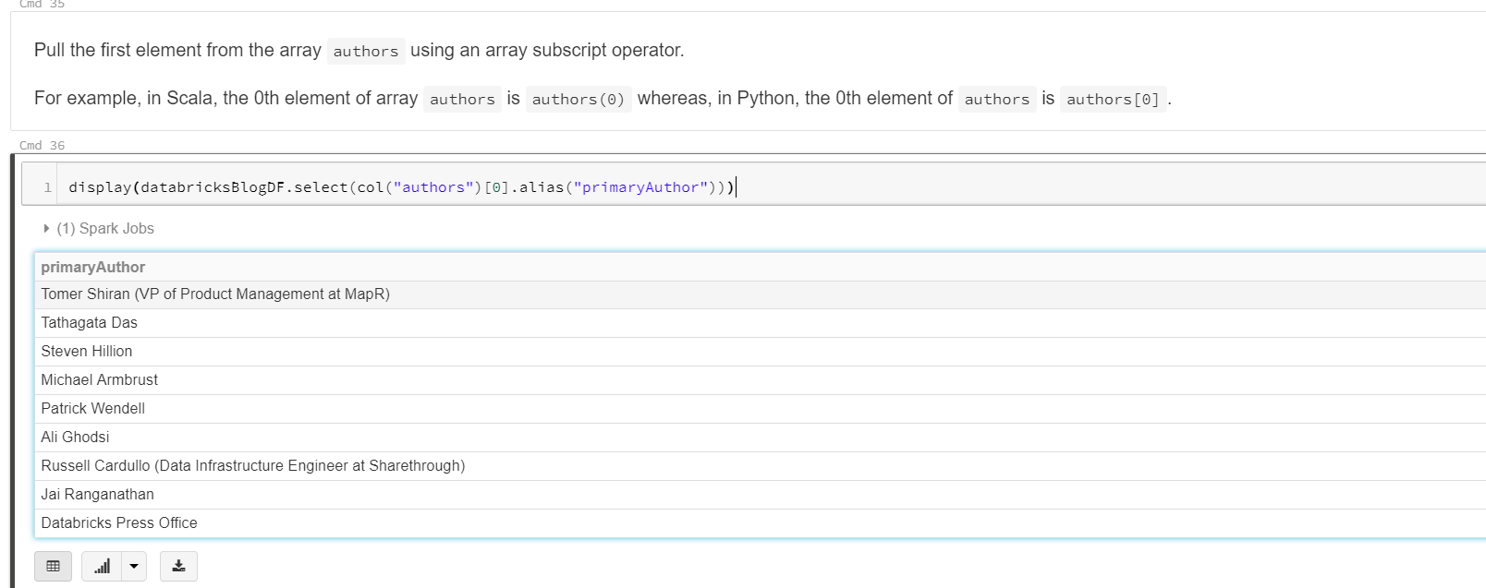

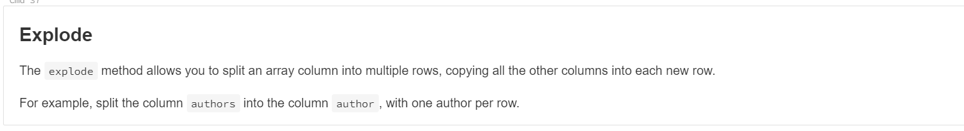

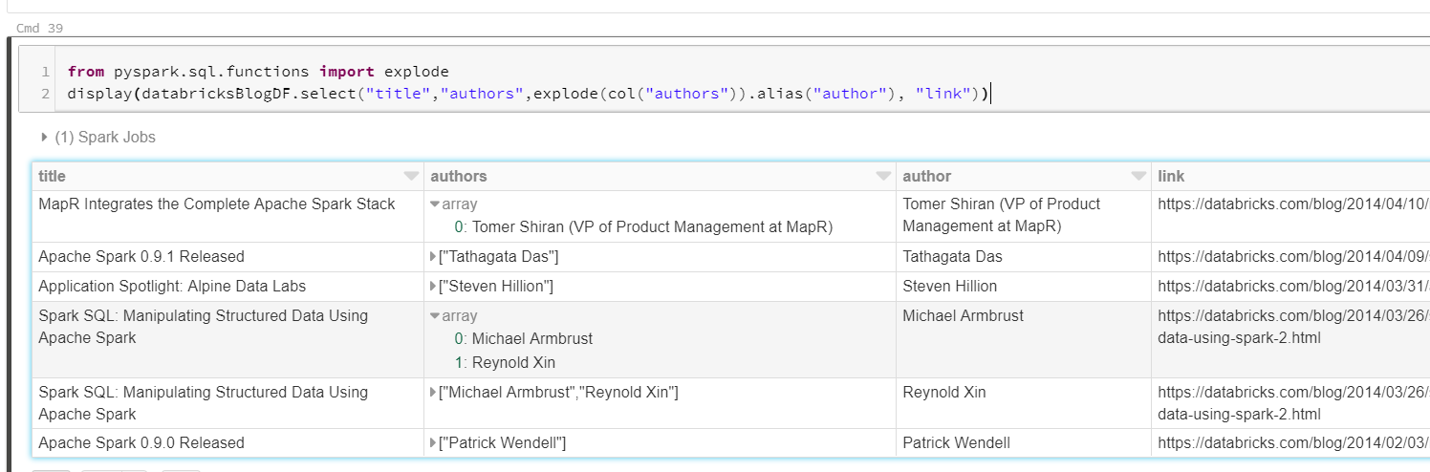

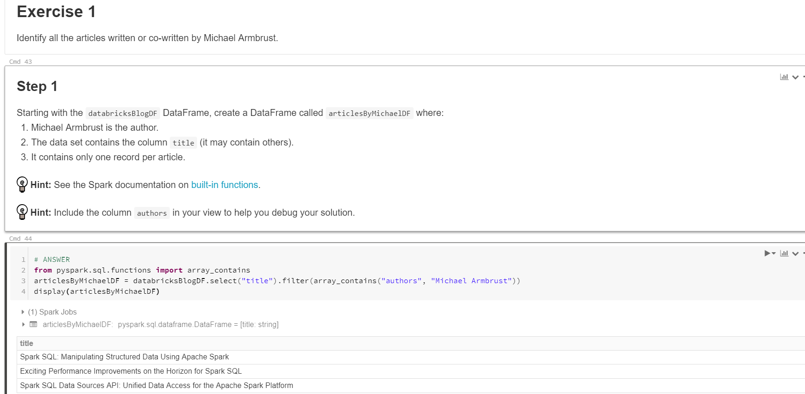

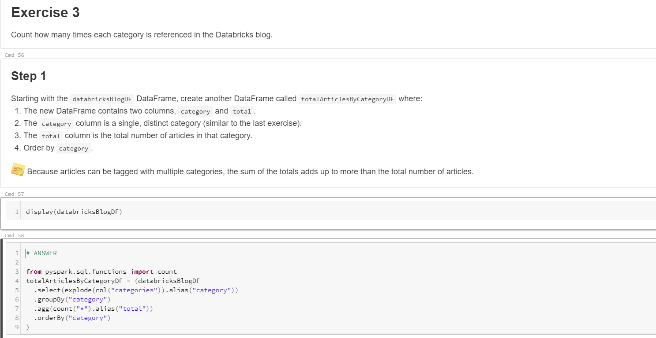

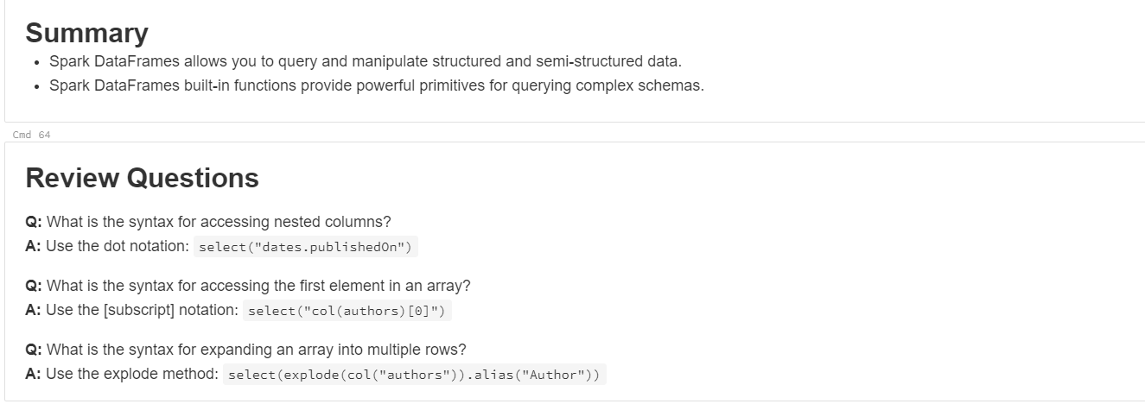

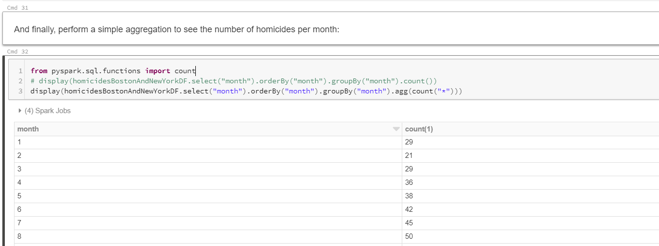

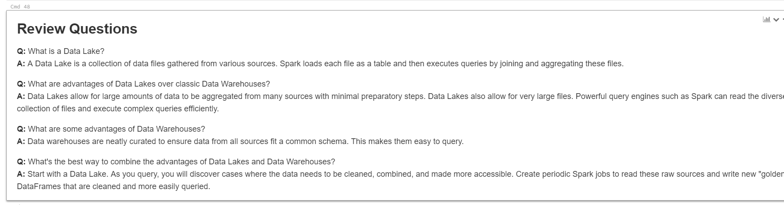

select abc, count(*) from table group by abc order by abc

.select("abc").groupBy("abc").agg(count("*")).orderBy("abc")

